4 BIT ROTARY ENCODER FOR POSITION ENCODING

Term paper submitted for the partial fulfillment
of the Mechanical Measurements Lab course.
Biswanath Dutta (9924118)
Ritesh Kumar Dwivedy (9924119)
Pankaj Bhomia (9924120)
Abhijeet Hembram (9924117)
Prashanta Sarkar (9924116)

ABSTRACT:
The following report is about the construction of a 4 bit rotary encoder. Detailed design, development and construction stages of the rotary encoder have been discussed in the paper along with special reference to probable applications.

KEY WORDS:
Encoder, Closed loop control, Gray code, Combinational Logic, Infrared LED, Infrared sensor.

INTRODUCTION:
With the world becoming more dependent on automatic positioning systems the use of position encoding devices has become a commonplace activity. Rotary encoders are mostly used in closed loop control systems where position information is fed back to the control circuit which takes decisions on the basis of the information thus fed back.
Rotary encoders by some means generate a decimal or binary code depending on the position the system is in. This can be done in various ways.
- Mechanical means
- Magnetic means
- Optical means

Mechanical means use a type of bumper switching arrangement which makes and breaks contact every time a revolution is completed thus generating pulse coded data.
Magnetic arrangements make use of a projection of a material of low reluctance which when brought near a circuit changes the overall reluctance and thus creating a pulse disturbance in the magnetic circuit which is then used to interpret information.
However the above two methods have disadvantages,
In mechanical systems the mechanical switching arrangements have the following disadvantages
- Making and breaking contact creates sparks which can be dangerous to the control circuitry.
- Also the mechanical switching arrangements can cause a hindrance to the free rotation of a machine or system
- Wear and tear of the mechanical switch leads to a low longevity

Similarly magnetic arrangements have the following disadvantages
- They are very sensitive to spurious electrical disturbances
- They may cause hindrance in performance of electronic gadgets placed near them
- they are usually bulkier

All the above difficulties can be overcome by using an optical rotary encoder. These are fairly accurate as well as precise.
While we talk of optical encoders, we can subdivide them further into infrared and visible light optical encoders. Of the two the infrared light is more reliable since it is less sensitive to the variation of intensity of ambient light.

The following report is the account of the stages of design and development of the infrared rotary encoder.

DESIGN OF THE ROTARY ENCODER:

As mentioned below the optical rotary encoder functions by interrupting light beams as a pattern imprinted disk rotates.
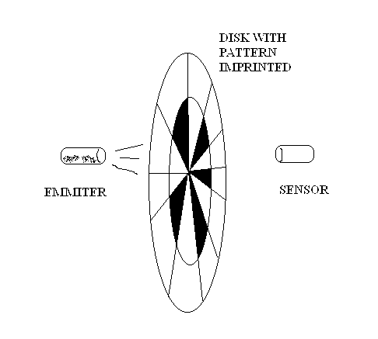
As we see in the above diagram the imprinted pattern on the disk interrupts the sensor beam in a particular sequence so as to generate a pulse. If the disk is divided in to tracks and for each tracks a sensor emitter pair is used then each sensor can be used to represent a bit of a binary or gray coded word.
In our case we have decided to use Gray code pattern for the following reasons:
Whenever the disk rotates there is an element of uncertainty in each state change. If we use a binary word in state changes, e.g. from 0111 to 1000 ,at a time three bits change. This significantly increases the level of uncertainty and is very unsuitable for optical encoding applications. In case of Gray code there is only one bit change in the word, this reduces drastically the level of uncertainty during state change.

Gray Code table is as follows
0000
0001
0011
0010
0110
0111
0101
0100
1100
1101
1111
1110
1010
1011
1001
1000

Development of the encoder pattern disk:
The infrared pattern disk is required to interrupt the light beam as discussed previously in a specific way so as to generate the gray code.
Although the decision to use Gray code pattern in the disk is explained but there is still another problem. If the sensor emitter pair is kept side by side in series, each sensor might interfere with the other.
So we decided to keep a 90▫ phase difference between each track to prevent interference among each other.
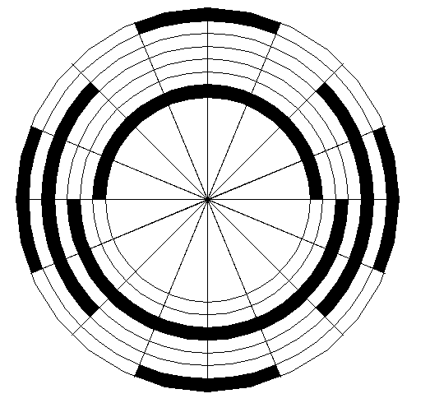

The above pattern illustrates how 90 degree phase lag is introduced between each track.

Design of electronic circuit for conversion of gray code to binary code.
Gray code as such is difficult to interface with most of electronic devices. So we have designed a Gray code to binary encoder which will generate equivalent binary code that can be easily interfaced with different electronic devices.
We have used simple combinational design method for this purpose.
The required truth table for this purpose is as follows.

Gray code Decimal Binary

G3 | G2 | G1 | G0 |  | B3 | B2 | B1 | B0
0 | 0 | 0 | 0 | 0 | 0 | 0 | 0 | 0
0 | 0 | 0 | 1 | 1 | 0 | 0 | 0 | 1
0 | 0 | 1 | 1 | 2 | 0 | 0 | 1 | 0
0 | 0 | 1 | 0 | 3 | 0 | 0 | 1 | 1
0 | 1 | 1 | 0 | 4 | 0 | 1 | 0 | 0
0 | 1 | 1 | 1 | 5 | 0 | 1 | 0 | 1
0 | 1 | 0 | 1 | 6 | 0 | 1 | 1 | 0
0 | 1 | 0 | 0 | 7 | 0 | 1 | 1 | 1
1 | 1 | 0 | 0 | 8 | 1 | 0 | 0 | 0
1 | 1 | 0 | 1 | 9 | 1 | 0 | 0 | 1
1 | 1 | 1 | 1 | 10 | 1 | 0 | 1 | 0
1 | 1 | 1 | 0 | 11 | 1 | 0 | 1 | 1
1 | 0 | 1 | 0 | 12 | 1 | 1 | 0 | 0
1 | 0 | 1 | 1 | 13 | 1 | 1 | 0 | 1
1 | 0 | 0 | 1 | 14 | 1 | 1 | 1 | 0
1 | 0 | 0 | 0 | 15 | 1 | 1 | 1 | 1

Derivation of combinational logic circuit for gray to binary conversion:

The above truth table can be represented in SOP form as shown below.

Say A=G3
B=G2
C=G1
D=G0

FOR B3

A.B.C’.D’ + A.B.C’.D + A.B.C.D + A.B’.C.D’ + A.B.C.D’ + A.B’.C.D + A.B’.C’.D + A.B’.C’.D’

A.B.C’( D’ + D ) + A.B.C( D + D’ ) + A.B’.C( D + D’ )
A.B’.C’( D + D’ )
= A.B.C’ + A.B.C +A.B’.C +A.B’.C’
= A.B( C + C’ ) + A.B’( C + C’ )
= A.B + A.B’
= A

FOR B2

A’.B.C.D’ + A’.B.C.D + A’.B.C’.D + A’.B.C’.D’ + A.B’.C.D’ + A.B’.C.D + A.B’.C’.D + A.B’.C’.D’

A’.B.C( D + D’) + A’.B.C’( D + D’) + A.B’.C( D + D’) + A.B’.C’( D + D’)
= A’.B.C + A’.B.C’ + A.B’.C + A.B’.C’
= A’.B( C + C’) + A.B’( C + C’)
= A’.B + A.B’
= A  B

FOR B1

A.B’.C.D + A’.B’.C.D’ +’ A’.B.C’.D + A’.B.C’.D’ + A.B.C.D + A.B.C.D’ + A.B’.C’.D + A.B’.C’.D’

A.B’.C( D + D’) + A’.B.C’( D + D’ ) + A’.B.C’( D + D’)
+ A.B.C( D + D’)
= A.B’.C + A’.B.C’ + A’.B.C’ + A.B.C
= C’( B’.A + B.A’) + C(B.A + B’.A’)
= C(AC)

FOR B0

A’.B’.C’.D + A’.B’.C.D’ + A’.B.C.D + A’.B.C’.D’ + A.B.C’.D + A.B.C.D’ + A.B’.C.D + A.B’.C’.D’

D( A’.B’.C’ + A’.C.B + A.C.B’ + A.C’.B) + D’(A’.B’.C + A’.B.C’ + B’.A.C’ + A.C.B)

Final result can be written in reduced form by using XOR gates.
=D.(ABC ) + D’.((A  BC)’)
= ( A  BC )  D

The above formula leads to the following circuit diagram

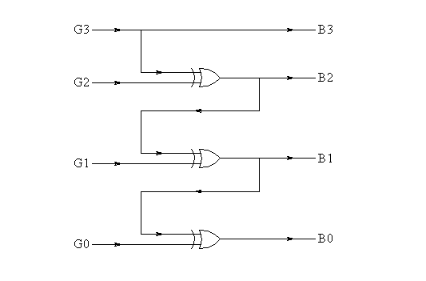

To implement the above circuit we used a CMOS integrated circuit with chip number IC4068

Design of the sensor circuits

For sensing the infrared beam we need 2 components
- Infrared light beam source – Infrared emitter
- Infrared sensing element - Infrared sensing diode

Properties of the infrared emitter and sensor are as follows

Infrared emitter:
The visible spectrum of electromagnetic radiation ranges from 400 nm (violet) to 700 nm (deep red). Wavelengths shorter than 400 nm are considered ultraviolet; those longer than 700 nm are considered infrared. While infrared radiation extends from 700 to 1,300 nm or longer, it is generally the so-called "near-infrared" region of 700 to 950 nm in which IR LED emitters and detectors operate.

These infrared devices rely on the same GaAs or GaAlAs technology as visible-light LEDs, but with differences in doping to move the emission to 700 nm and more. Packaging includes a standard epoxy-cast clear lens with lead-frame construction.

Infrared sensor:
This is a special purpose diode which normally operates in the reverse bias region. When the infrared light falls on the sensor the reverse current increases. This property is used to sense infrared beams.

A circuit was developed that exploits the above properties to enable a beam detecting circuit.

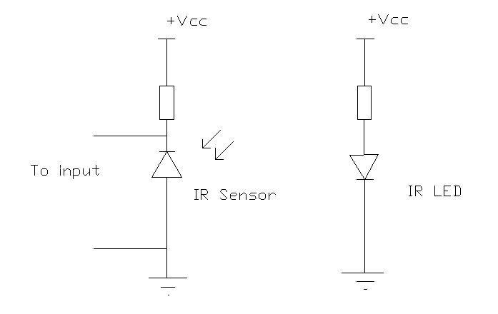

Mechanical Assembly:

This is the most critical part of the whole project. This involves the mechanical aspects of the whole construction like the shaft, bearings and the interrupting disk material.
The following are the list of the mechanical components used and their functions.

Shaft:
The shaft was carefully machined out of steel so that there is no eccentricity or bending. This will enable the coupling of the encoder with the machine

Bush:
The bushings were rings made out of brass. Brass was chosen for its antifriction properties.

Interrupting disk:
The interrupting disk is where the gray code pattern is to be pasted on. This had to be such that it would normally allow infrared light to pass through. So we chose acrylic since it is light weight and strong.

Body:
The body was made of Perspex as well as steel parts.

Results:
The whole set up was tested in ambient fluorescent lighting conditions, the circuit and the assembly worked in perfect conditions to give the desired results.

Scope for further improvement:
The assembly could have been coupled with a microcontroller for realtime acceleration and velocity display. Although the work was undertaken but could not be completed for logistical problems and lack of time.

For better accuracy and precision the bit size could have been increased. But this can only be possible with good manufacturing support and tools.

Problems faced:
Most of the problems were faced in the assembly fabrication process. This required skills of an experienced mechanic which none of us had. So we had to rely mostly on the institute workshop training shop. But again the project was unnecessarily delayed because of the lack of cooperation shown by them.

Acknowledgments:
We are indebted to Prof J.K.Dutta for his valuable lectures in the course of the Lab.
We are also indebted to Mr. C.R.Sarkar for his valuable technical guidance which made this project possible.
The following labs need mention for their support:
1. Electro physical process lab, Mechanical Engineering Dept.
2. Workshop training centre.
Bibliography:
- Digital Electronics – Malvino
- Computer Control of Manufacturing Systems – Yoram Koren
- Introduction to electronics – Boylstead

MECHANICAL ENGG. DEPARTMENT
IIT KHARAGPUR

