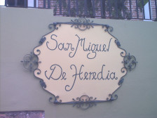
San Miguel de Heredia
Hostel

Located in the city of Tegucigalpa within walking distance of one of the biggest shopping malls in the city and other commercial facilities.

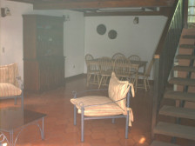
Our service includes:
18 beds (dorms), room lockers,
cable tv, common areas, fax,
internet & laundry services,
hot water, small shop nearby

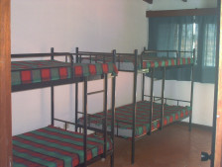.
Col Lomas del Mayab, Avenida Costa Rica #1617.
Tegucigalpa, Honduras.
Tel (504) 239-9670,

Tel Fax: (504) 239-9671
mailto:hostelsanmiguel@multivisionhn.net

