Literature Review: Technologies and Methodologies

In this chapter, I first have introduction of e-Maintenance architecture and the philosophy of e-Maintenance system. Information and knowledge are two focuses.
In addition to covering the relevant theory, techniques and methodologies in maintenance engineering, I also provide several case studies and examples illustrating the successful application of the principles and techniques outlined in industries other than marine vessel.
Critical enabling technologies for shipboard automation include:
- Fiber optics; (may not necessary for merchant ship)
- Smart sensors;
- Expert systems;
- Distributed processing and Local Area Networks (LANs); and
- Computer-Aided Logistics Systems (CALS).

  - Fundamental Requirement
Development of intelligent agents for continuous, real time, remote and distributed monitoring of devices, machinery and systems to predict machine’s performance status and to enable capabilities of producing quality parts.
Development of a system platform that is scalable and reconfigurable for data transformation, prognostics, performance optimization and synchronization. The idea is to use information technology to prevent downtime on machines before they break and cause expensive delays.
The functionality of the underlying technologies and system methodologies must be complete the shift from “Fail and Fix” to “Predict and Prevent”
It shall also provides the opportunity to use information technology to marry the machinery system maintenance with the entire supply chain, all the way from advanced design and engineering to delivery of goods to customers.
UML is a simple but thorough graphical language for visualizing, specifying, constructing, and documenting systems.
Use case diagrams depict the various actors (actual users or perhaps other systems), the things the actors do (the use cases themselves), how actors interact, and even how the system responds.

  - Distributed Networking
Today’s systems are often a mix of architectures and technologies. What most of them have in common is that they’re of a distributed nature. A distributed system is a dynamic collection of computers linked by a network, running software designed to provide an integrated computing environment to users. Given these complex tasks, a distributed system must be designed and developed in levels of abstraction or architectures.
    - Network Basics
OSI networking model: Physical/Data-Link/Network/Transport/Session/Presentation/Application layer and how data travels through the OSI model
- Discuss network hardware component: Servers, Hubs/Routers/Switches, Cabling
To understand how rings compare to stars and buses, you must first understand a basic concept of how original Ethernet networks worked. These Ethernet networks managed all the needed signals on the network using a technique CSMA/CD, which stands for Carrier Sense Multiple Access with Collision Detection. CSMA/CD allows each nodes on a segment to transmit data when it likes. If you’re designing a new LAN, generally your best bet is to use Ethernet in a star topology. You’ll find network equipment for this choice is readily available, inexpensive, and many qualified installer are available for 10Base-T, 100BaseT, or 1000Base-T. always choose Cat5e cable even if you are only going to initially use 10Base-T, so that you have a ready upgrade path to the faster standards.
If network wiring constitutes the nervous system of a network, then the devices represent the various organs. Hubs (or more often these days, switches) are used to connect network nodes to network backbones. Nodes are connected to hubs in a physical star fashion, whether they are used for a star topology or a ring topology network.
- Compare cable topologies: Bus/Star/Ring
Network protocol: TCP/UDP, IP, DHCP, FTP, HTTP, NNTP, SMTP
Network security
    - Client/server computing
CS computing is at the heart of the information Technology (IT) industry today. As organizations have moved from a centralized computing environment to client/server, the very description of client/server computing continues to evolve. Generally speaking, client/server computing is the splitting of process into two or more parts, the client and the server.
To facilitate communication between the client and server across a network, client components must be able to locate and invoke functions on server components.
Users are connected to a local network and share network resources, such as file and print services. Applications share data from an RDBMS. Modern business systems increasing extend this local distributed model by integrating Web and other Internet access with the local resources, as well as opening up access to external networks for geographically separated business units or for integration with customer or supplier systems. This orchestration of disparate components and resources creates unique design issues and goals, which you must address in the distributed system
Distributed CS components have unique issues and goals, which must be addressed in their design. some of these goals and issues are
- Support for resource sharing
- Concurrent processing.
- Scalable processing
- Openness
- Fault tolerance
- Transparency
    - Web-enabled methodology
XML
Internet and tele collaborative environment enable global operation
View proposed system as an extension of existing matured shipboard automation design in the perspective of the tele collaborative integrated system. Web-enabled intelligence is key to achieving true e-Maintenance nature with regard to automation processes. With emerging use and applications of internet and wireless communication technologies, e-maintenance technologies will not only prolong ship’s life spanning nut also bring innovation to enable shipping companies to support their customers with timely delivery and service.
    - Wireless Technologies - VSAT Satellite Network Communication
Fundamentals: in any communication between two places, first of all we need a medium through which our signals can get transmitted and received. If we don’t have basic infrastructure facilities such as cables, satellite communication is being used. In satellite communication, sky is the medium through which our signals travel, get reflected by satellite and reaches the other end. The communication medium for VSAT is Radio Frequency (RF). Satellites use electromagnetic waves for communication.
There are few technologies available in this satellite communication system. They are the legacy TDM/TDMA, SCPC/DAMA-PAMA technology and lastly FTDMA technology.
TDM/TDMA technology is known as Time Division Multiplexed / Time Division Multiple Access. The satellite receives message from VSAT in the stipulated time period and it sends that to the hub where the Master Earth Station is located. The hub collects all the messages from the various VSATs and adds them up, multiplexes them and transmits it back to the earth through satellite. This is useful for data communication only, not for fax, voice communication and video conferencing because one gets into the network only during the time slot allotted to him.
SCPC known as Single Channel Per Carrier is a highly improved and sophisticated technology for network communication. The major advantage is that the hub is bypassed and the VSATs talk to each other with the satellite standing in between them. Because of Frequency Division instead of Time Division, two frequencies will be allotted between two VSATs for full duplex communication. The allotted frequencies stay attached to the VSATs as long as the service is needed. The user will get a clear channel for the message transfer. Therefore it supports all digital communications that is Voice, Data and Video.
In new F/TDAMA technology the multiplexing concept is brought back. The data, voice and video are multiplexed and transmitted by a single satellite modem. The total bandwidth is split into number of slots each with 16 kbps bandwidth and a total of 8 slots give the customer a net bandwidth of 128 kbps.
The outdoor unit is common across technologies, which comprises of RF unit and Antenna. The power of RF unit is normally 5 W and depends on the bandwidth handled by the VSAT. The antenna diameter is 3.8 m in all these various technologies.

  - Agent Technology
    - DAI and Agent Classification
The Distributed Artificial Intelligence (DAI) paradigm can be viewed as a collection of intelligent agents (actors) interacting to solve goals within a common task environment. Such concept is also commonly referred to as a multi-agent or multi-actor system.
Agent refer to a component of software and/or hardware that is capable of acting exactingly in order to accomplish tasks on behalf of its user.
Firstly, agents may be classified by their mobility, i.e. by their ability to move around network. This yields the classes of static or mobile agents.
Secondly, they may be classed as either deliberative or reactive.
Thirdly, agents may be classified along several attributes which ideally they should exhibit, e.g. autonomy, learning, and cooperation. They are collaborative agents, interface agents, & truly smart agents.
Fourthly, agents may sometimes be classified by their roles, which referred to as information or internet agents.
Fifthly, the category of hybrid agents that combine two or more agent philosophies in a single agent.
    - Agent Interaction in eMaintenance System Environment
Several MAS characteristics are directly related to the group of agents: Co-operation. Co-ordination, Planning, Negotiation.
These circumstances require a different approach to control systems. Particularly in the maintenance sector new control architectures have to be introduced. Decentralized or heterarchical control has been recently proposed as a way to overcome the limitations that traditional hierarchical and centralized control shows in such a highly dynamic environment. The central controller is replaced by several controllers, usually referred to as autonomous agents, each one devoted to a small portion of the overall system. Each agent is a software entity that has a set of protocols which govern the operations of every physical entity, a knowledge base, an inference mechanism and an explicit model of the problem to solve.
Agents communicate and negotiate with the other agents, perform the operations based on the local available information and may pursue their local goals. However, the overall performance of the so-called agent-based system has to be satisfactory even from a global point of view and depends primarily on the protocol that regulates the negotiations among the agents (negotiation protocol) and on the quality of the data used to make these decisions. Once an appropriate selection of the entities to be modelled as autonomous agents and of the most suitable negotiation protocol has been made, such agent-based systems may yield a global performance which is extremely flexible, robust, adaptive and fault tolerant and which is exactly what is needed to satisfy the requirements mentioned above.
Remote monitoring and diagnostics technology using agents

  - Computer-Aided Logistics Systems (CALS)
The eMaintenance paradigm must be coupled with a effective logistic system, which is focused on data transaction for onboard inventory control, global supplier locating and tendering, geographical consideration in term of cost and time, Etc.
The Components of CALS: 1) Electronic tendering management of spare parts orders; 2) Direct transfer of machinery operational data details to related personnel and equipments vendors; 3) Tight electronic connections to shipping company and charter etc; 4) Streamlined customer relationship.

  - e-Diagnostics (SEMATECH)
The fundamental purpose of e-Diagnostics is to increase the availability of production and facilities equipment, reduce mean time to repair and provide significant reduction in field service resources/costs. This capability must be available for 200mm and 300mm fab equipment, Probe/Assembly/Test equipment, and key Facilities equipment.
e-Diagnostics definition:
Capability to enable an authorized equipment supplier’s field service person to access any key production or facilities equipment from outside the IC maker’s facility/factory via a network or modem connection.

  - e-Manufacturing & e-Maintenance
Methodologies and Practices
In today's business environment, reliability and maintenance drastically affect the three key elements of competitiveness - quality, cost, and product lead time. Well-maintained machines hold tolerances better, help reduce scrap and rework, and raise consistency and quality of the part in addition to cutting total production costs. Today, many factories are still performing maintenance on equipment in a reactive manner due to a lack of understanding about machine performance behavior. To improve production efficiency, computer-aided maintenance and diagnostic methodology must be applied effectively in manufacturing. This book focuses
A large amount of research work into e-Maintenance has emerged, and various aspects of e-Maintenance have been extensively documented. One important research work is done by Jay Lee. He made researches focus on the fundamental principles of predictive maintenance and diagnostic engineering.
He examines various methods in modern computer aided maintenance including machine monitoring, fault detection and fault diagnostics. A perspective maintenance by monitoring the degradation of manufacturing equipment and systems is presented and illustrated. If the behavior of manufacturing equipment and systems can be monitored and measured adaptively then an early warning of possible faults can be generated. By doing this, maintenance personnel can perform early diagnostics and part replacement during regular maintenance hours. He also addresses the research needs based on the industrial perspective. He believes that the development in-progress monitoring of machine degradation and faults is one of the most important research tasks for increasing machine uptime and improving production quality.
Preventive maintenance, predictive maintenance and proactive maintenance.

  - The Fundamental of Maintenance
Generally speaking, the operational performance of components, machines and processes can be divided into four states: the normal operational state, the degraded state, maintenance state and the failure state [19]. Figure 3-1 shows these states. At a gross level, a component is described as degraded whenever deterioration occurs but does not cause loss of its function. Detailed degradation is associated with a given range of characteristics of the components, or performances of the component. Defining more detailed degradation states enable us to accurately predict impacts on the failure of the component. When aging occurs, the component and machine generally progress through a series of degradation states before failure occurs. If a degradation condition can be measured and detected, then the proactive maintenance activities can be performed before a worse degradation condition or failures occur.
Fault detection is the identification of a component or set of components in the system which caused the fault. Fault diagnosis requires collecting and processing large amounts of often incomplete data to determine the nature and severity of equipment and system malfunctions.
A maintenance state is the stage of maintenance performed either before the failure (preventive) or after the failure (reactive).

MAINTENANCE STATE
DEGRADED STATES

FAILURE STATE

OPERATION STATE
FAULTS
1
2
3
n
…
BEHAVIORAL CHANGE
OPERATION ERRORS
HUMAN ERROR
Figure 3-2. Definition of machine performance states

A failure state is caused by degraded components, faults, or human errors. Generally, there are two kinds of failures: (1) soft failure: a failure that can be corrected shortly after it occurs; and (2) hard failure: a failure that causes the machine to be down for a long period of time.
Today, many factories are still performing maintenance on reactive, or breakdown, mode, since traditional process monitoring systems can detect machine or process faults only when they occur. Reactive maintenance is expensive because of extensive unplanned downtime and damage to machinery [2,9]. In high performance systems one often cannot tolerate significant degradation in performance during normal system operation. To avoid machine down time, some companies have used preventive and predictive maintenance approaches by either using historical maintenance data or by sensing machine conditions. However, there are no maintenance data available for many newly developed machine or advanced manufacturing systems. Adding sensors to monitor machine conditions will also increase machine complexity and will require more highly trained personnel.
Figure 3-3 shows the conventional machine performance monitoring system paradigm which includes sensing, process fault detection and diagnostics. Typically, the sensing parameters are sensors, actuators, and time.
In many manufacturing systems, on-line fault detection is often based on methods using threshold value, logic, state-table, time-window and simulation. The off-line fault detection and fault diagnostics are normally performed by gathering the data from the sensors and the symptoms from the system, and then the problem is diagnosed through signature analysis. Today, neural networks and expert systems are two most popular approaches in fault diagnostics. The following sections summarize the related research work in monitoring, fault detection and fault diagnostics.
    - Methods For Detecting Faults
The conventional fault detection methods are: (1) modeling and parameter estimation; and (2) discrete observation.
      - Modeling And Parameter Estimation Approach
Measurable input signals and output signals can be directly used to monitor changes in a process. The limit and trend checking technique is the most straightforward method in fault detection. The limits are set such that a large enough distance to the appearance of damage is retained. The limit check can also be applied on the trend of the signal. To predict the signal, mathematical models of deterministic signals, or stochastic signals, or a deterministic process and a stochastic signal model need to be used. On-line fault detection and diagnostics have been explored by using real time knowledge-based reasoning, parameter estimation and dynamic data system (DDS) modeling approaches.
If process faults are indicated by internal, non-measurable process state variables, attempts can be made to reconstruct or estimate these state variables from the measurable ones by using a known process model.
      - Discrete Observation Approach
Fault detection through modeling and estimates of parameters is used for continuous systems. However, a discrete state system or event-based system needs a discrete dynamic description. The inputs and outputs of these systems are seen as sequences of events over time or states over time or states over time. Most process control for manufacturing application is for discrete event based control: a programmable logic controller (PLC) is a typical example. This controller can detect faults based on the ladder diagram. …. Therefore it is very difficult to perform fault-tolerance control and management. The following summarizes the conventional fault detection methods for discrete processes.
- Finite automata state machine
In this method, a particular sequence (or set of sequences) of actuator and sensor signals is monitored by using state followers. The state machine uses a finite state language to track the sequences of observations based on a graph of the operation. The real-time control system (RCS) developed by Barbera et al. is based on task decomposition and a state table to use an “if-then” type of monitoring command in detecting faults in a manufacturing system.
- PLC-based logic diagram
Most flexible manufacturing systems use PLC because it is user-friendly. However, for a sophisticated manufacturing system, the PLC has a limited capability because of the inflexibility of the programming system. Recently….
- Simulation
A simulation approach to fault detection uses process inputs to drive a simulation of acceptable system behavior in parallel with the actual system operation. Many researchers have used simulation models, such as a Petri net model. The model represents the processes of the system and acts as a state observer which listens to interprocess messages and sensors in the manufacturing processes.
- Event-based time-window approach
Event-based control is a discrete-event form of control logic in which the controller expects to receive confirming sensory responses to its control commands within preset time windows that are determined by a discrete-event model of the system. The conventional approach in signature recognition for fault detection has several degrees of difficulties.
    - Methods For Diagnosing Faults
Most of the fault diagnostics research work is based on signature analysis of the process of component. To diagnose a fault from these recorded, sampled and analyzed data, expert systems and neural networks are two most popular approaches to searching for the faults.
- Neural Networks Approach
Automated fault detection and diagnostic systems based on neural networks have been implemented for jet and rocket engines by Dietz et al. In this approach, fault diagnosis is performed by mapping or associating patterns of input data to patterns representing fault conditions. The expert system, called the integrated expert system (IES), employs neural networks to analyze patterns of engine behavior, and create a set of hypotheses regarding anomalies of engine behavior. The hypotheses generated by the neural network model are then given to the knowledge-based inference model to perform reasoning on the basis of engine design knowledge, heuristic knowledge and fault and repair history.

- Expert Systems Approach
Expert systems have been used extensively to diagnose manufacturing equipment. General motor…
This approach consists of capturing data from the process and passing selected signals from it through two-level decision-making system.

Intelligent & Knowledge. Through the interpretation of expert system, the acquired data is transformed into Information; information is transformed into knowledge. Finally, achieve Real time decision / Synchronization
The major advantages to using knowledge systems include: 1) they are always available, not affected by distraction, sickness etc; 2) for many expert tasks, they will perform as well as or better than the human expert who contributed the knowledge; 3) a more flexible use of knowledge is possible when compared to a similar program built using conventional techniques.
Backward chaining: start with a goal, find the fact to support it
Forward chaining: start by collecting facts, see if any goals apply along the way

In general, much research has been done in the area of fault diagnostics and fault detection. Little research has been done in the area of in-process machine degradation monitoring for manufacturing systems. Some related research work in machine or system degradation and its impact to proactive maintenance are reviewed and summarized as follows.

Perspective on proactive maintenance through degradation monitoring – a new thinking paradigm
The proactive maintenance approach is to use integrated, integrated and corrective practices to significantly extend machinery life. The goal of proactive maintenance is to eliminate failures of equipment forever. If the behavior of a machine can be monitored adaptively, then a early warning of possible faults can be generated. By doing this, maintenance personnel can perform early diagnostics and part replacement during regular maintenance hours. Therefore, the mean-time-between-failure can be extended to an unlimited length. Figure 5 shows the concept of the proposed proactive maintenance implementation technique. When aging or wear occurs, the component and machine generally progress through a serious of degradation states before failure or fault occurs. If a degradation can be measured and detected, then a proactive and corrective maintenance activities can be performed before a worse degradation condition is reached that could cause component failure and machine downtime.
Methods for monitoring degradation
Degradation is defined as a decreased performance level when a parameter is measured over in a specific deviation. Typically, a component can go through a series of degradation states before it fails. There are two types of components
Most recently, Lee and Kramer [57] proposed a methodology in using the CMAC (Cerebellar Model for Articulation Controller) neural networks to monitor the machine behavior. A Pattern Discrimination Model (PDM) was used to measure the performance degradation quantitatively. Figure 6 shows the system concept of the proposed methodology, an integrated learning, monitoring and recognition technique, for a proactive maintenance system. The CMAC is used to adaptively learn machine behavior and a PDM based on the CMAC is used to monitor, recognize and quantify behavioral changes. The PDN serves as a watchdog to monitor the behavior of the machine by using a confidence value that represents the conditional probability of degradation. The fault then can be detected by comparing the confidence value of the PDM output with a threshold confidence value.
(Figure 6. System concept of machine degradation monitoring and fault monitoring and fault detection using neural networks approach)

4. Parametric modeling methods: theory and a case study; J. Spoerre, B. Wang.
5. Machine performance estimation and reliability modeling; Chang-Ching Lin, B. Wang.
6. Design methodology for self-maintenance machines; Y. Umeda, et al.
7. Integrated prognostics, maintenance, and life extending control of continuous-time production processes; A. Ray, S. Phoha.
8. Integrated automated root cause identification fuzzy neural network reasoning for quality control; F. Tadayon, J. Lee.
9. Activity-based costing (ABC); A.S. Tsai.
10. Life cycle maintenance management; S. Takata.
11. Life extension of operating machinery using the National Information Infrastructure (NII); S. Phoha, A. Ray. Part Two: Case Examples.
12. Case Example 1: Motor incipient fault detection using artificial neural network and fuzzy logic technologies; Mo-yuen Chow, et al.
12. Case Example 2: Data analysis for diagnostics and process monitoring of automotive engines; B.D. Bryant, K.A. Marko.
14. Case Example 3: Measurement of machine performance degradation using a neural network model; J. Lee.
15. Case Example 4: Detection and isolation of faults in the stamping process using the Haar transform; C.K.H. Koh, W.J. Williams.
16. Case Example 5: Fault monitoring in manufacturing systems using template models; L.E. Holloway.

3.2 Intelligence Maintenance – Infotronics Technologies
The trend of the future with regard to manufacturing, according to Dr. Jay Lee, director for IMS center [3-3], is intelligent maintenance. E-maintenance is a major pillar that supports the success of the integration of e-manufacturing and e-business. Web-enabled and infotronics technologies play indispensable roles in supporting and enabling the complex practices of maintenance by providing the mechanisms to facilitate and manage the integrated system discipline with the higher system levels such as SCM and ERP. The concept of intelligence maintenance focuses on customer solutions, and working collaboratively on a global basis. With the use and applications of internet and wireless communication technologies, infotronics-based e-service technologies will bring innovation to enable companies to support their customers with guaranteed product uptime and sustainable quality. That’s called Total Predictive Maintenance.
IMS has developed a low-cost embedded smart chip and software - smart infotronics technologies trademarked as Device-to-Business (D2B) and the Watchdog Agent - that will trigger service when a factory device, office machine, or household appliance starts to show signs of a problem. The data is processed locally, thereby reducing the amount of diagnostic information sent, which means something as simple as a cell phone could be synchronized with the device. The vision for the IMS is to achieve near-zero breakdown of products and systems through the advancement in web-enabled predictive intelligence. The development and deployment focuses on enabling technologies on e-monitoring, Web-intelligence, and Internet user interface, and Java-based e-maintenance tools.

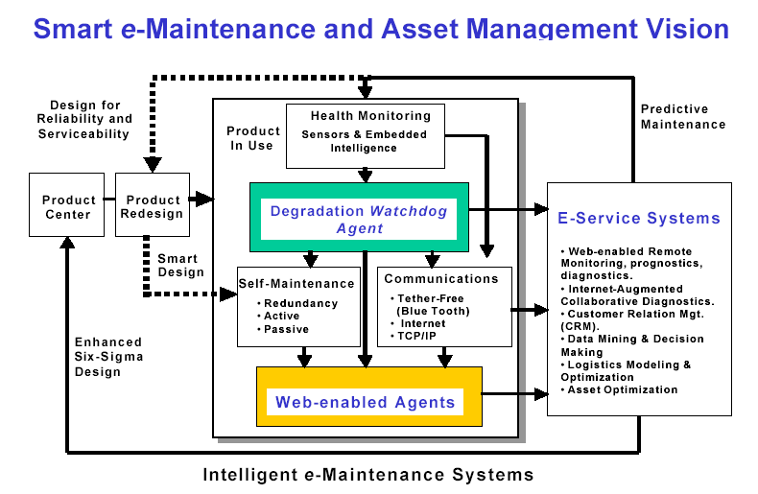

3.2.1 Smart Computational Prognostics Agent - Watchdog Agent™
The Watchdog Agent monitors and predicts degradation in devices and systems. It provides product degradation assessment and prognostics, and enables manufacturers and customers to rapidly assess a product's performance and instantly figure out required maintenance activities. Drawing from biological perceptual systems and machine psychology theory, this watchdog agent is a neural network-based “digital doctor” equipped with embedded computational prognostics algorithms and toolbox for predicting the degradation or performance loss of devices and systems. The watchdog agent and its working principle is shown in figure 3.
E-intelligence can also be used to get maximum performance from the assets--equipment, products, process--by monitoring, analyzing, comparing, reconfiguring and sustaining the system via the Internet.
With the growing manufacturing globalization activities, companies to looking for ways to assess the performance of their manufacturing operations and products in remote sites. Digital maintenance diagnostics and maintenance tools such as “watchdog” type information mechatronics with integrated media will improve the effectiveness of the engineering practices on maintenance activities. There are three critical emerging technologies involved in the proposed teleservice engineering system. Such "prognostic" capabilities enable companies to achieve innovative aftermarket service to guarantee product and operations performance. These tools include smart and reconfigurable monitoring agents to reduce or eliminate production downtime, and reduce dimensional variation due to process degradation. Smart software and NetWare can provide proactive maintenance capabilities such as performance degradation measurement, fault recovery, self-maintenance and remote diagnostics. These features allow manufacturing and process industries to develop proactive maintenance strategies to guarantee the product quality and process performance and ultimately eliminate unexpected system breakdowns and unnecessary periodic maintenance practices.

- Behavior Assessment and Performance Degradation Evaluation
Watchdog Agent can predict the degradation or performance loss, in other words, it predicts the failure of a system in advance, not the traditional diagnostics of failure or faults. A complete understanding and interpretation of states of degradation is necessary to accurately predict and prevent failure of a component or a machine once it has been identified as a critical element to the overall production system. The degradation is assessed through the performance assessment methods.
With advanced prediction methods and tools, the performance loss of a machine (or implication of failure etc.), its behavior and associated information from operators and its working environment is measured and assessed adaptively to provide on-line composition and reasoning.
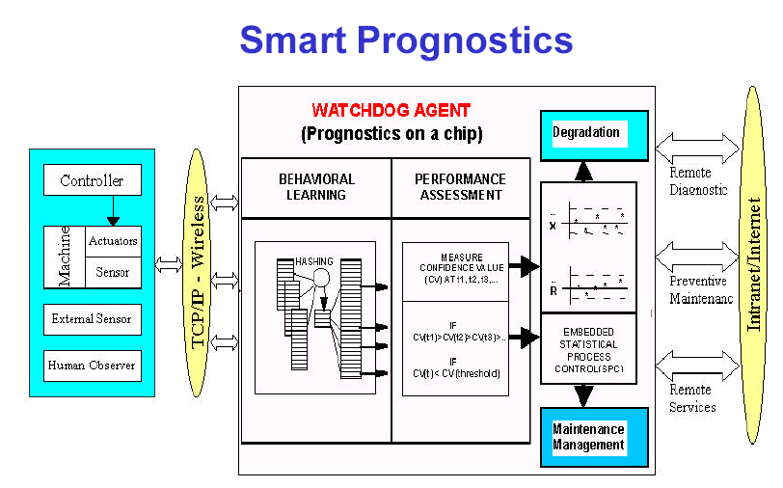
- Knowledge Learning (reconfigure itself to sustain functional performance?)
Knowledge-intensive intelligent tools are required for the acquisition and organization of data in machine and its working environment to track the behavior of machine at any given time.
- Remote and Distributed Monitoring
Watchdog agent is web-enabled. Not only remote machine calibration can be performed, but also experts from machine tool manufacturers can assist users to analyze machine calibration data and perform prognostics for preventive maintenance. Users from different factories or locations can also share this information through these web tools.
Moreover, by knowing the degradation of machines in the production floor, the operation supervisor can estimate their impacts to the materials flow and volume and synchronize it with the ERP systems. The revised inventory needs and material delivery can be synchronized with other business tools such as CRM system.
Multimedia-based tools are required to support remote users for maintenance assistance. Interactive and collaborative tools will enable the technical personnel to perform diagnostics from a remote distance. Digital maintenance diagnostics and maintenance tools such as smart helmet with integrated media will improve the effectiveness of the production equipment through collaborative maintenance and diagnostics. Smart glove would enable operators to perform machine maintenance and performance adjustment collaboratively.
- Intelligent Computational Tools
Due to the complexity of today's products and machines, process knowledge data from many different applications needs to be correlated for autonomous performance assessment. The principle of watchdog agent relies on biometrics computation rather than a model-based computation. It can correlate multiple relevant inputs and compare them to a set of weight tables. Its output represents the quantitative measures of product or equipment performance at a given state. By comparing performance values at different states, it can predict and assess the condition and performance of complex and sophisticated machine systems. To effectively apply this methodology in various kinds of products and machines, its integration with working environments (i.e. sensors, actuators, controllers and human interfaces) needs to be further developed.
- Self-Maintenance and Recovery
Self-maintenance and recovery features also should be considered for improving the reliability of the overall system and for determining what to do in case of product or equipment malfunction. A watchdog agent could also serve as a black box for these purposes. In case of failure, operators can use the black box to access the last several minutes of information about the root-cause behavior of the machine breakdown. As a result, faults can be located quickly and the system can be recovered rapidly. This knowledge-based information also can be shared with other users.
3.2.2 Web-enabled Device-to-Business (D2B™) Platform
Data gathering and transformation has been already done at various levels. However, massive raw data is not useful unless it is reduced and transformed into useful information format (i.e. XML) for responsive actions. Hence, data recognition and mining tools for data reduction, representation for plant floor data needs to be developed. Device-to-Business (D2B™), an infotronics platform, has been developed to connect web-enabled agent to e-business tools (such as customer relation management systems, ERP systems and e-commerce systems) to achieve smart and effective service solutions. It’s solved the problem that existing structure of the ERP and MES cannot informate (i.e. communicate the information in real-time) the decision across the supply chain systems.
In a nutshell, the system methodologies enable (a) transformation of machine/product data into more useful formats, (b) optimization of maintenance and production/service scheduling, and (c) synchronization with other business systems, suppliers and customers. To make pervasive impacts to different industrial applications, existing industrial standards was used (i.e. IEEE 802.xx standard committees, MIMOSA, etc.) [3-4]
E-maintenance cannot exist without e-commerce. That is the premise behind the Watchdog Agent and the D2B platform development. The D2B platform including the agent can not only monitor itself but order maintenance and parts at the same time that makes e-commerce a reality."
The Web-enabled Device-to-Business (D2B) Platform transforms machine and product data into more useful formats, optimizes maintenance and production scheduling, and synchronizes with other systems, suppliers and customers.

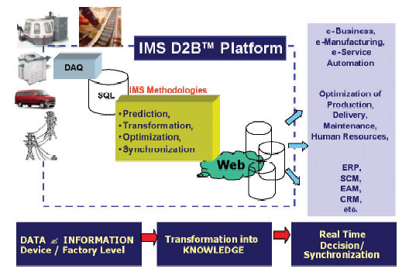
3.2.3 Applied Wireless Systems and Development of Embedded Peer-to-Peer Networking Technology
tethefree (Bluetooth) is an enabling technology of connecting the watchdog agent-like to networking and internet in addition to wiring connection.
— Focus on enabling technologies for remote monitoring, wireless communication tools, and evaluation
of wireless systems in production and service environments.
- Deliverables: device to internet/tether-free interface technologies, and embedded health assessment devices.
- focuses on deployment of wireless systems, embedded or hybrid watchdog algorithm/chip, and internet/tether-free/device interface Technologies
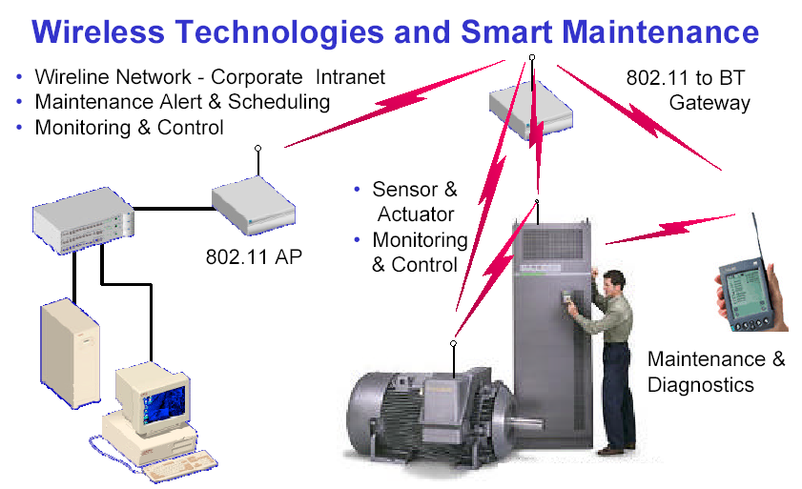
3.2.4 Research Challenges and Opportunities
Tomorrow's manufacturing industries must cope with the global enterprise competition. Information technology will play an indispensable role in supporting and enabling the complex practices of design and manufacturing by providing the mechanisms to facilitate and manage the integrated system discipline. The need to improve the understanding of a product's performance for aftermarket service will lead to e-intelligence for quality maintenance. With the proper integration of e-intelligence into products, manufacturing, and service systems, manufacturers and users will benefit from the increased equipment and process reliability.
Research challenges and opportunities
1. sensing system standardization
in-process and in-machine sensing are the foundation of a teleservice system. Due to the complexity of a machine and its associated environment, different types of sensors may be used, requiring different data acquisition protocols and systems. As releservice practice expands, more machine/processes will be linked within the remote diagnosis system. The standards should include the selection of sensor type for typical signals, sensor signal output ranges, protocols, etc. there are several industrial standards currently available. Research efforts are needed to develop synthesis tools for sensory system design and implementation.
2. adaptive sensor fusion and affordability
one physical machine fault (e.g. an unbalanced shaft) may generate different symptoms (e.g. vibration, temperature changes, motor load variation, etc.) can be measured by different sensors (e.g. an accelerometer, thermal couples, motor current, etc.). Similarly, one sensor may sense different types of machine faults occurring simultaneously, and its sensitivity may vary as the operation condition changes. Thus, adaptive sensor fusion should be emphasized, which will improve the reliability of the diagnosis strategy. However, affordability should also be emphasized in the research. The issue of affordability will lead to cheaper sensing techniques, less demands on sensing data accuracy and high requirements on the noise rejection capability of the algorithms. In addition, optimal, objective-oriented sensor placement strategy needs to be investigated. Remote diagnisis provides a better opportunity to develop the aforementioned techniques by implementing knowledge and experience sharing and self-learning.
3. data compression, feature extraction, and task allocation
4. collaborative maintenance and diagnostics
collaborative maintenance and diagnostics can be achieved from two aspects: (1) fault condition data collection: the remote diagnosis system provides an opportunity to accumulate more machine/process fault conditions. Thus, a better diagnosis algorithm can be developed from the fault conditions in various remote sites; (2) fault diagnosis: the information is available in the server and can be accessed by experts at various locations. Thus, knowledge distributed over various sites can be integrated to perform more complex collaborative diagnosis. However, significant research efforts on how to manage the information and distributed decision making components are required. Topics such as distributed AI, competitive decision making, risk management, etc, should be researched in the context of collaborative diagnosis.
5. self-learning and supervised learning for smart service agent
even though the topics of supervised learning and self learning have been studied by various researchers, they become more critical in a remote diagnosis environment. Due to the nature of remote diagnosis, process data from many different locations can be accessed. Updated knowledge will be acquired much faster than with traditional diagnosis techniques. Thus, supervised learning (or self learning) is more critical. Furthermore, it is anticipated that fewer well-trained supervisors may perform the task due to the availability of new information. Another challenge is how to assess new information before using it for the purpose of learning. The information assessment stage can be integrated as part of the supervised /self-learning research.
6. integrated performance assessment
the teleservice system will provide several categories of information together, such as online process/machine sensing data, historical fault/degradation, machine design information, etc. All information should be integrated together when conducting a performance evaluation. It focuses on behavior-based computation rather than on model-based computation for machine performance degradation assessment without using machine fault condition information. In addition, knowledge of machine performance can be learned and modeled, eventually being used in machine performance compensation. Thus the performance of a typical machine may not necessarily degrade over time, but instead be improved by the learning-modeling-compensation techniques.
7. self-maintenance and dependability
a backup strategy should be considered for overall system reliability improvement and for determining what to do if the internet system malfunctions. Under various conditions, the system should be operate and perform basic functions, albeit with deteriorated performance. For example, if the internet is not available for data transfer and remote diagnosis, local data processing should be executed to conduct essential tasks that nominally carried at the remote site. How to design a redundant system with minimum cost and high performance is a challenge. This is also related with task allocation and analysis, simplified diagnosis algorithms, decision making under incomplete information, etc.
8. Reconfiguration and transferability
the remote system is a complex system involving intensive hardware and software development. The systems developed for different applications should share common modules. Furthermore, the computer/internet technology and the diagnosis methodologies are advanced rapidly, the developed system should be able to incorporate those advancements easily without major modifications. Thus, reconfigurability and transferability are important in all aspects of the system development.

3.3 e-Diagnostics in Semiconductor Industry
Echoed such concept, e-Diagnostics guidelines are defined by International SEMATECH, a global consortium of leading semiconductor manufacturers that represent about half the world’s semiconductor production. e-Diagnostics is about the capability to enable an authorized equipment supplier's field service person to access any key production or facilities equipment from outside the IC maker's facility/factory via a network or modem connection. Access includes ability to remotely monitor, diagnose problems or faults, and configure/control the equipment in order to bring it into full productive state rapidly, within security, safety, and configuration management guideline.[3-6] The e-Diagnostics solution is closely related to semiconductor industry and consists of equipment and auxiliary hardware and software applications. Its system concept is shown as Figure 4.
Leading OEMs are deploying e-Diagnostics solutions (100s of tools) and reporting significant benefit. The goal is significant reduction in equipment support costs.
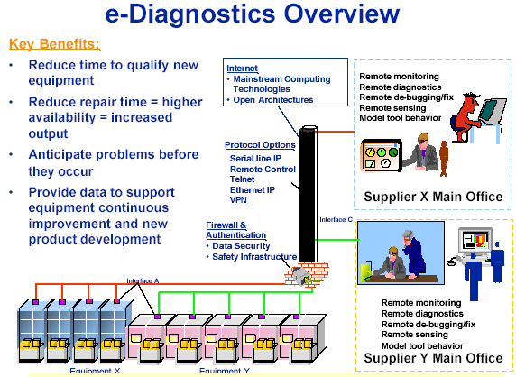
In order to implement the e-Diagnosis infrastructure, the guidelines and standards with regard to the supplier sites and IC Maker sites are set up to satisfy those need. It includes: supplier capability guidelines, data encriyption guidelines, network security guidelines, controlled access point guidelines, data interface standards and ICMaker capability guidelines.
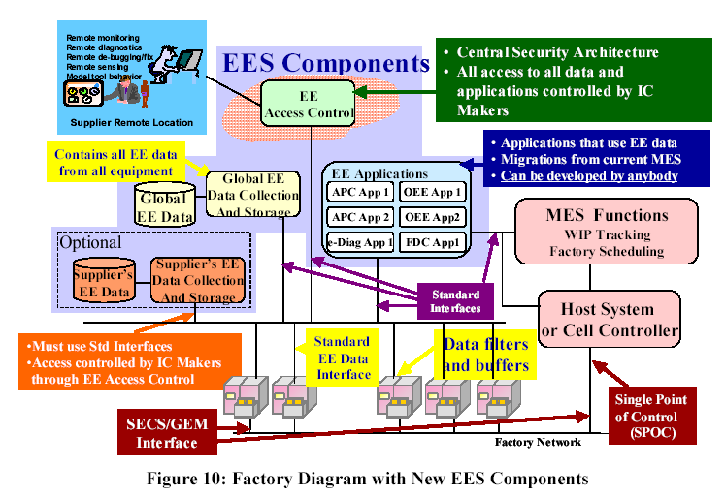Collaboration: 1) The solutions must provide the same equipment monitoring/diagnostics data at the local and remote sites. Identical representations and user interfaces at both sites are highly desired. 2) The solutions must enable run-time data collection, storage, and retrieval. The e-Diagnostics system must enable analysis of this data and decision support capability. 3) The solutions must allow audio-visual collaboration such as video teleconferencing or video over Internet Protocol to enable remote experts to view/diagnose equipment and sub-assembly problems in real-time and communicate with factory personnel.
The architecture of e-Diagnosis in SEMATECH’s version is: 1) The solutions must support remote accessibility of equipment diagnostic data from outside the IC maker's firewalls. Two-way communications between these two locations is needed to support interactive problem solving. 2) The solutions must permit sharing of key diagnostics and monitoring data between multiple factory and supplier sites on an as-needed basis to enable remote detection of issues and proactive troubleshooting. 3) The solutions must enable predictive maintenance, including notification when equipment will need service or repair. 4) e-Diagnostics solutions must be implemented using an open architecture based on mainstream computer technologies, non-proprietary standards and data models.
Focus is improved data.
- SECS/GEM – still the primary equipment control I/F
- Interface A – equipment data interface (getting more & better data from the equipment
- Interface B – among applications and to FICS/MES
- Interface C – External access to e-Diagnostics
3.3.1 e-Diagnostics and EEC
e-Diagnostics is established upon Equipment Engineering Capacity (EEC). Equipment Engineering System (EES) provides a framework that supports EEC, as shown in Figure 10. They’re all addressed under the context of Equipment Engineering (EE). EEC should augment and enhance legacy factory CIM and/or MES systems. EECs are described by four levels (0-3). Each level is intended to build on the previous level, each bringing increased capability. Equipment that a supplier defines as “Level 3 Capable” necessarily has levels 0 through 2 capabilities as well.
- Level 0 – Access & Remote Collaboration: remote connectivity to the tool and remote collaboration
Remote Connectivity to the tools from outside the IC company's firewall must be through a central aggregation point to allow for security administration, compatibility with factory network topology /security requirements, and scalability.
The e- Diagnostic system must be capable of effective Remote Collaboration sessions to bring two or more individuals working together in a joint intellectual effort. These individuals must be capable of real-time sharing and exchange of information (document/text and images) to achieve the objectives of e- Diagnostics.
- Level 1 – Collection & Control: Remote Performance Monitoring and Tool Operation
Remote equipment configuration: This capability includes the ability to remotely log on to a tool or tool environment to analyze and, if authorized, to modify software aspects of the tool. Only authorized client will be able to perform tasks that include adding, changing, updating, editing, and deleting information, files, or registers that are located on the remote object.
Remote operation of equipment: Level 1 of e-Diagnostics requires that a person be able to operate the tool remotely to diagnose specific tool health issues. This functionality includes the ability to remotely view and actuate user interface functions as if standing at the tool. This includes the ability to remotely access, load, download, execute, and analyze results from tool diagnostics, calibrations, recipe, and user programs.
Remote Performance Monitoring in Real Time: The tool must support real-time equipment availability tracking (e.g., Semiconductor Manufacturers International [SEMI] equipment performance tracking [EPT] standard).
Data Storage: Equipment e-Diagnostics data must be stored in a database at the IC company site for future analysis and reporting. The database must be accessible from a remote supplier location. Data must be transmitted and stored during host control or off-line states.
Data Collection: The supplier must be able to collect tool data in near real-time by a standard protocol using an Ethernet connection. Remote data collection must be possible while the tool is under host control or off line.
- Level 2 – Analysis: Automated Reporting and Advanced Analysis With SPC Capability
The e-Diagnostics system must have the ability to automatically produce reports that provide sufficient detail to understand the operational and exception state and parametric performance history of the equipment on a per wafer, per lot, or periodic basis. The reports should be resident at the IC company's site.
The e-Diagnostics system must provide several types of statistical analysis capabilities. On-tool data pre-processing must be provided to extract salient information associated with larger data sets like trace data. Off-tool analysis must be provided enabling statistical comparisons of numerical data representations. Pattern recognition capabilities must be provided on large data sets. Typical features might be expressed as peak-to-peak, root mean square (RMS), standard deviation, mean, average, peak, rise time, frequency, etc.
Compression can be accomplished by statistical techniques, in which the associated statistics represent the “compressed” data, or via modern file compression algorithms, such as PKZIP. In the case of file compression, associated means for conveniently “unpacking” information also have to be provided. Evaluating statistical information and automatically uncompressing data for further analysis or decisions are level 3 capabilities.
- Level 3 – Prediction: Predictive Maintenance, Self-Diagnostics, and Automated Notification
Level 3 e-Diagnostics tools must be capable of self-diagnosis. This implies that tools know what diagnostics or health checks can be executed as well as when it is safe and appropriate to do so. By combining the capabilities of onboard diagnostic routines initiated by the tool itself, decision logic, and automated notification, the e-Diagnostics system will be able to make proactive decisions about maintenance and repairs.
The e-Diagnostics system must provide the ability to apply logic or rules to the output from data analysis or data from the database to make simple decisions and initiate secondary actions.
Based on established decision logic, the e-Diagnostics system must provide notification of failures, excursions, or negative trends to supplier and company.
3.3.2 Diagnostic Data Acquisition (DDA) and Security
Data (event/context information) is the basis from which equipment diagnosis is performed. Therefore, platform-independenent (of host on/off-line status) near-real-time data collection is called DDA. The data focus is through four Interfaces – SECS/GEM, Interface A, Interface B and Interface C. Refer Figure 10, SECS/GEM is still the primary equipment control I/F. Interface A is equipment data interface for new equipment data port. Interface B is between EE applications and FICS/MES. Interface C refer to external access to e-Diagnostics.
To address semiconductor e-Diagnostics architecture and DDA interfaces, sets of standards and guides are setting up.
- XML guide
Standard data transfer format of e-Diagnostics is XML. The set of XML related standards addresses the specification for XML message structure, style and code components. The scope of guide includes style and usage of XML, recommendation to use XML schema (not DTD’s); usage of elements and attributes; XML element/attribute naming and case convention; conventions for common structures; conventions for translating UML to XML schema.
- Data Collection Management
It is an abstract model of data collection plans, DCP management interface and state models, and DCP reporting formats. It provides a means for applications to organize all data needs (trace, exception, and event) into logical, named units that can be individually activated and described. Will define mapping for SOAP via HTTP, with interface specs defined in WSDL.
Simplifies setup of data collection for all applications (one message to define, one to activate); improves management of data collection needs through named DCP’s; factories will be able to detect equipment performance issues that may be due to data collection loads; non real-time applications can be utilize buffering features to collect data that need not be streamed.
- Data Collection Plan (DCP)
Equipment client authentication and authorization (DDA) – abstract model of authenticated communication and access control list management.
- Self-Describing Interface:
Equipment Self-Description is abstract model of equipment meta data describing units, types, equipment structure, state models and events, alarms/exceptions, etc. it provides a means for applications to discover via software the physical equipment structure, available data items, events and exceptions.
It will define mapping for SOAP via HTTP, with interface specs defined in WSDL. Equipment structure, implemented data models, available data items & types, events, exceptions, and alarms can be learned at runtime from the tool.
Enables automated data collection setup for SEMI-standard-compliant equipment; enable generic applications to provide “data menus” for engineers to assist in constructing data collection plans; enables an improved mechanism for keeping available tool data up-to-date over paper documentation.
- Data Security:
Data security is paramount. Potential solutions must address network, communications, data encryption and other relevant issues. Only factory-authorized applications are permitted to collect data, single point of control is enforced at factory level. Only authorized personnel are able to access the view based, relevant data to perform diagnosis. Remote data and control access must be selectively provided. Therefore the e-Diagnostic system must have built-in capability that determines when to allow specific remote functions to be executed based on specific states or condition of the equipment.
‘baseline’ process control data: all data currently accessible to SECS-II host, with improvements in the ability to collect sample data for up to 50 parameters per process chamber at a frequency 1% of shortest recipe step (worst case assumption is 1000 scalar parameters at 10Hz)
equipment operational data: visibility into module- subsystem- and potentially actuator-level activity for facilitating equipment health monitoring and diagnostics/troubleshooting
3.3.3 Model Implementation
There are four typical use cases:
- Authentication and authorization: provide a means for factories to control, in software, which applications are permitted to communicate with the equipment; provide a means for factories to control, in software, which equipment services applications are permitted to use. EDA communication technologies only (SECS-II communication will not be addressed). Implementation for design options including SSL/X.509, SPKI, password-based schemes, etc. Benefits: help factory protect equipment from unauthorized data collection loads; help control the flow of equipment data by control legal clients; enable controls necessary to enforce factory single point of control policies;
Authentication model: session management. app authenticate to equipment;
Authorization Model:
- Common Equipment Model:
Provide a means for suppliers to describe the physical equipment structure using common attributes and terminology, therefore provide a basis for enabling data collection targetd at specific equipment components with usefulness in diagnostics, troubleshooting, utilization tracking, and process control application. In addition, it also provide a means for SEMI standards that depend on information about equipment structure to have a basis for doing so using common attributes and terminology. It includes constructs for modeling linked equipment, multi-chamber equipment, etc. down to the actuator/sensor level. Its implementation will define an XML schema for the XML representation of these constructs.

Discover: app queries tool metadata, presents available data to engineer;
Define: engineer establishes data needs according to factory policies or troubleshooting scenario, builds requirements into a DC plan, app sends plan to tool.
Activate: app activates plan, collects data, performs intended function

Therefore e-Diagnostics eventually leads into EEC and e-manufacturing through standardizing the interface A Data port. E-manufacturing is automated, data-driven, productivity optimization.
3.3.4 Success of e-Diagnostics at LSI Logic
LSI Logic and INFICON have worked together to develop and integrate e-Diagnostics capabilities over six-to-nine months at the LSI Logic facility in Gresham, OR. The installation includes INFICON FabGuard PCs at individual Applied Materials 200mm Endura PVD-CVD tools. These FabGuard real-time analysis systems are connected to:
- each tool through the Endura's secondary SECS port to monitor process-critical status variable IDs (SVIDs), such as process start triggers, DC power, and gas flow rates;
- scanning laser particle counters through an Ethernet connection;
- residal gas analyzers (RGAs) on individual chambers; and
- the fab-wide network.
Through the fab network, each PC connects to an SQL server database and an executive program. The latter handles data transfer, data backup, e-mail and instant messaging services, scheduled reports that are delivered electronically, and communication with the web server (Fig. 1).
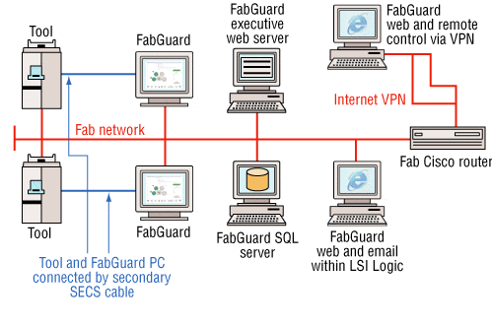
Figure 1. e-Diagnostics installation at LSI Logic
The web server is a key component that allows the use of Microsoft Internet Explorer to mimic most of the functions of working at the FabGuard PC next to the tool. This includes the ability to view real-time data from each sensor, check alarms, load database reports, load multiple runs for viewing, and start or stop acquisition. This web-based functionality permits process engineers, from any desktop, to look at their tool's real-time and historical data.
All of these functions are not limited to inside the fab. Using a virtual private network (VPN), LSI Logic engineers, INFICON applications engineers, and other technical experts can log onto the manufacturing network and assist with problems that may occur, answer questions the customer may have, and create customer reports. The VPN also allows INFICON engineers to install routine feature upgrades and bug fixes as soon as they become available, thus providing a high level of customer service.
A new program from LSI Logic made this VPN connection possible. Sponsored by LSI Logic Corp.'s Global Network Services, the request for non-LSI employee access allows vendor-partners, such as INFICON, the opportunity to justify remote access and sign confidentiality agreements. Once completed, an account is set up and Cisco Systems VPN client software is distributed for installation. Upon launch of the VPN client, a secure tunnel is made through the Internet that allows users' PCs to be remotely connected to the LSI Logic network.
A New Level of Data and Control
Armed with SVIDs, RGA readings, particle counts, and statistical process control (SPC), LSI Logic engineers can actively control fab tools by way of alarms and shutdown limits. Process critical SVIDs have been determined by process engineers for each chamber, and are checked weekly through automatically generated SPC reports.
SVIDs were chosen for redundant monitoring where possible, to reduce dependence on tool gauge accuracy or inadvertent system constant changes. For example, on a PVD chamber, monitoring both the forward power signal from the power supply and the DC bias on the target will avoid missed deposition-rate changes due to a drifting power supply. In addition, target bias monitoring can detect changes in pressure. By coupling these measurements with captured signals from a pressure gauge and MFCs, all gauges are independently kept in check and the root cause of out-of-control signals can be quickly determined.
At LSI Logic, RGAs monitor chambers in real time and are continuously looking for changes in chamber and gas integrity. They are also being used to detect photoresist, look for changes in low-k film quality on incoming wafers, and for monitoring chamber out-gassing levels after any preventative maintenance shutdown. They have also used RGA analysis to confirm the results of SVID monitored parameters.
To facilitate automated data analysis and control, mathematical algorithms and Boolean logic evaluate SVID and RGA data and check for measured parameters between high and low limits after a certain trigger point. A trigger point is a step in a recipe or change in signal, such as a throttle valve moving to process position. For related SVID signals that signify gauge drifts and for complex RGA analysis, parameter sets have been created that are the results of mathematical manipulation of individual signals. The manipulations may be ratios or weighted sums, depending on the physical interpretation of the data being evaluated. The algorithms also check for data persistence to avoid problems with false alarms due to mis-polled data or polling latency.
Particle count data are also being used to determine when enough conditioning wafers have been run after preventive maintenance on a chamber or after an idle period, and to determine process chamber kit life. For particle excursions, which are detected mid-life of the process kit, SVID and RGA data have proven useful in determining the root cause (Fig. 2).
e-Diagnostics advantages
One of the main advantages from their experiences with this e-Diagnostics setup is that it allows alarms to equipment users and suppliers. The computers that are involved in the installation are equipped with their own instant messaging capabilities as well as their own simple mail transfer protocol (SMTP) server. This allows real-time fault monitors to send information to fab engineers, such as daily reports or errors via instant messaging (IM) and e-mail as well as sending e-mail to application engineers if there are hardware, software, or communication issues with systems.
In addition, suppliers are able to respond faster to tool and sensor issues. With VPN technology, engineers responsible for fab equipment installations are able to respond no matter where they are located. Each can utilize VPN client software built into Windows to log in and view his or her own installation. This way, the person who knows the most about a given application and setting is the one who diagnoses problems. The time saved by not having to share and transfer specific details is invaluable, not to mention the money saved on airfare and travel time.
An extension to providing a higher-quality product is its ability to perform remote software updates. By using remote VPN, equipment supplier engineers can remotely perform software updates that include both new features requested by users as well as bug fixes, without requiring an applications engineer to enter the fab or asking a user to perform the task.
The VPN also allows vendor software modifications such as remote FabGuard recipe and analysis changes. Real-time and run-to-run FabGuard analysis recipes are an evolving process during the course of an installation and the maturing of a process tool. e-Diagnostics allows for collaboration between users and suppliers' applications engineers onsite, but also for the assistance of off-site specialists who can help fine-tune an installation. Modifications to these important parameters can take place during an installation; process engineers may request assistance and advice for tighter tolerances on certain parameters that can then be fulfilled remotely using the same VPN connections.
e-Diagnostics can also help a supplier offer the service of its expertise to a user. Whether for requested assistance or for paid consulting, a remote link allows work to begin immediately when a problem needs resolving. The same remote help that can be offered to a customer by a supplier's technical experts can also be given to onsite supplier engineers. For example, recently an INFICON onsite engineer experienced a problem beyond his experience. Using the remote VPN connection, an applications engineer, elsewhere, was able to diagnose and repair the problem by taking over control of the FabGuard PC while teaching the onsite engineer at the same time.
An extension of this is how the e-Diagnostics link allows suppliers to acquire real-time data to provide technical reports that can assist users in improving overall efficiency. This also helps a supplier show a higher value in its products without increasing costs. A simple example of this is when a tool or process has a problem. The real-time analysis engine will notice an anomaly and alert equipment and process engineers as well as supplier engineers. By way of this remote link, INFICON can be aware of the problem and offer assistance. Together, they can use their process and tool expertise to diagnose and remedy the problem.
One such instance where this took place was soon after LSI Logic implemented an integrated liner barrier process. One of the tools began experiencing frequent cryo-pump crashes in the transfer chamber that resulted in significant reduction in tool availability. Upon implementing e-Diagnostics, it was soon noticed that small amounts of helium were entering the transfer chamber. The additional analysis of SVID data showed that helium was escaping from one of the CVD TiN chambers when the slit valve opened after processing was completed. Cryopumps' low tolerance for helium can cause their efficiency to decrease quickly. This information was relayed to LSI Logic's process and equipment engineers, who were able to make corrections and improve tool availability.
Implementation Challenges
A big challenge of an e-Diagnostics installation compared to a standard sensor or tool installation is the added complexity necessary to enable components, such as network access, data storage, host or manufacturing execution system (MES) connectivity, e-mail capability, and remote access. Another problematic requirement of an e-Diagnostics connection is the use of remote VPN access. This is undoubtedly the most difficult aspect, not in terms of complexity, but more in terms of a manufacturer's policies.
VPNs have been around for a long time and offer a highly encrypted connection between points through the Internet. The hardware requirements typically consist of an Internet connection through a router designed to accept private connections and perform the encryption necessary to make it safe. The difficulty with using a VPN is in changing corporate policy to allow outsiders to access the fab network and to set up the infrastructure to maintain accounts and the proper confidentiality agreements.
LSI Logic dissolved this barrier to entry by developing corporate policies that allow the company to better take advantage of the expertise that suppliers, such as INFICON, can offer on a daily basis.
Wide acceptance of e-Diagnostics and the integration and connectivity that is required for it is going to necessitate an improved ability to prove that mathematical models and data-monitoring algorithms are capable of detecting a greater range of anomalies, such as instability, changed ramp rates (up or down), and overshoot in brief process recipe steps or intermediate steps. Many of the difficulties do not lie within the software itself, but in how the data is acquired from equipment. Modern real-time analysis software is capable of detecting most types of problems through specialized analysis techniques, but many manufacturing tools do not have the ability to send data often enough for proper monitoring. In many cases there are also significant problems with polling-latency (i.e., data not being sent when it is requested) under high-traffic situations.
3.4 Intelligent Prognostics

References
[3-1]
[3-2]
[3-3] Center for Intelligent Maintenance Systems (IMS), USA
www.imscenter.net
[3-4] Muammer Koc, Jay Lee, Pulak Bandyopadhyay, Introduction Of e-Manufacturing, NAMRC e-Manufacturing Panel 2003
[3-5] http://sst.pennnet.com/Articles/Article_Display.cfm?Section=ARTCL&ARTICLE_ID=185346&VERSION_NUM=4&p=5
[3-6] e-Diagnostics Guidebook Version 1.5, International SEMITECH October 2002
[3-7] Equipment Engineering Capabilities (EEC) Guidelines (Phase 2.5), an international SEMATECH & JEITA Collaboration, Equipment Engineering Capabilities (EEC) Guidebook Version 2.5, July 2002

(Not available)
* Lee, J. and Kramer, B.M., Analysis of Machine Degradation using a Neural Networks Based Pattern Discrimination Model, J. Manufacturing Systems, Vol. 12, No. 3, pp. 379-387, 1992.
* * Lee, J., Machine Performance Assessment Methodology and Advanced Service Technologies, Report of Fourth Annual Symposium on Frontiers of Engineering, National Academy Press, pp.75-83, Washington, DC, 1999.

