ACCOMMODATING GLOBAL POLICIES AND USER PREFERENCES IN COMPUTER SUPPORTED COLLABORATIVE SYSTEMS

BY HELMUTH TREFFTZ

A thesis proposal submitted to the

Graduate School – New Brunswick

Rutgers, The State University of New Jersey

in partial fulfillment of the requirements

for the degree of

Doctor of Philosophy in Computer Engineering

Written under the direction of

Dr. Ivan Marsic

Dr. Richard Mammone
Dr. Manish Parashar
Dr. Joseph Wilder

And approved by

_________________________________
_________________________________
________________________________

New Brunswick, New Jersey

May, 2001

Abstract

A Multi-channel Collaborative System is a program that enables collaboration between users that are geographically dispersed, allowing them to share information that is conveyed through multiple channels. In such a system heterogeneity arises because of differences in computational power among the participating nodes as well as differences in users’ preferences regarding the multiple channels. On the other hand, a certain degree of homogeneity is necessary to accomplish effective collaboration. Homogeneity is enforced by globally defined policies that every participating node must comply with. Conflict arises between the need to cope with heterogeneity and the need to maintain homogeneity. This thesis proposes a way to map both the individual users’ preferences and the global policies from the system domain to a mathematical model. Mapping the resulting solution of the mathematical model back to the system domain provides for an objective way to accommodate individual users’ preferences while maintaining the global policies. A Client-server architecture is proposed for implementation. In order to increase the scalability, the proposed architecture makes use of multicast communications, grouping together users interested in a specific level of representation of a specific channel.

1. MOTIVATION

Real-life collaborative systems are likely to be complex applications in which several tasks have to run simultaneously. These tasks might be related to:

- Output modalities: Information can be presented to the users through multiple modalities. Example: a system that presents video, audio and force feedback. There will be at least one task to control each modality.
- Input modalities: Commands or information from the user can be captured through multiple devices. Example: a system that records video, audio and mouse input from the user. There will be at least a task to control each input device.
- Computational tasks: Depending on the collaborative system, there might be other tasks running. Example 1: a system in which the users collaborate as the simulation evolves, and the simulation runs distributed among the nodes. Example 2: in a collaborative interactive visualization, each node has to render the visualized data set from the user’s perspective.

Homogeneity: In order to achieve collaboration, the distributed system must present a reasonably consistent image of the working space to all the participants; there is a need for a certain level of common ground in order to achieve effective collaboration. Example: in a battle simulation the designer might dictate that each system must display at least 15 frames per second. This is a global policy established by the system designer. All nodes taking part of a session must comply with these policies at all times in order to enable the desired degree of commonality that enables effective collaboration.

Diversity: On the other hand, the system should be able to accommodate the individual preferences of each user. Example: In a teleconference system a user might be more interested in a frequent video frame at the expense of the sound quality, while other user might be interested in higher fidelity 3D sound, at the expense of the video frame rate.

Users’ preferences also change over time. Example: while observing a 3D visualization of a data set, a user might be interested initially on the general structure, choosing a wire-frame representation. But later on, in order to observe a detailed region, the user might choose a Gouraud-shaded representation [Foley 1990].

Diversity might also originate in the dissimilar computing power of the nodes participating in a collaborative session. Example: A high-end workstation might present high quality video and sound simultaneously, while a low-end workstation might need to render the information with a compromise in fidelity.

Computer capacity, whether measured in processor speed, main memory, available bandwidth, etc., has grown exponentially in time, as first predicted by Gordon Moore in 1965 [Moore 1965]. According to this trend, the capacity difference between computers of consecutive generations will also grow exponentially, see figure 1. This means that, outside of lab controlled environments, the computers likely to be used in a collaborative environment will grow more and more dissimilar in time.

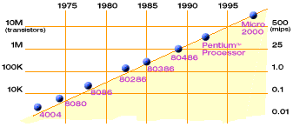

Figure 1. Number of transistors in a processor, as predicted by Gary Moore in 1965.

In this work we propose a general framework that enables building distributed collaborative systems that enforce global policies while accommodating individual preferences. This is achieved by expressing policies and preferences as parts of a mathematically formulated model. The concurrent tasks that handle the different types of information become variables and the different levels of representation for each type of information become the values that the variables can take. The solution of the mathematical model is a particular combination of levels of information representation, particular to the computational power available at a given node, which accommodates the user preferences while complying with global policies.

The rest of this document is organized as follows. Section 2 describes collaborative systems that have dealt with diversity in computing power or user preferences. Section 3 describes the solution we propose. Section 4 describes the experimental setup we will use. Section 5 describes partial results we have obtained. Section 6 describes the work we propose to conduct during the thesis development. Section 7 summarizes the proposed work.

2. RELATED WORK

This section describes how different fields in Computer Science and Engineering have coped with heterogeneity among networked computers.

Using several computing nodes in order to increase the performance and exceed the limitations of a single node gave rise to parallel and distributed computing [Hwang 1998]. Parallel and distributed computing has been widely used, especially among the scientific community, for several decades. One of the most interesting problems in Parallel Computing is “load balancing”, which arises from the way the problem is partitioned, the availability of the computing nodes, the available bandwidth and other factors. Kumar [Kumar 1994] analyzes the computational complexity of several load balancing schemes for a Parallel Depth-First search.

Later on, networks of computers were used to solve large, complex, Artificial Intelligence problems. In order to cope with the asynchronous production of results and the heterogeneity of the nodes, several architectures were devised, among them the Blackboard architecture, in which partial results are posted on a common “black board” [Durfee 1988]. Partial results can then be used by other nodes to pursue the global goal.

Computer Supported Collaborative Work came about with the realization that networked computers should allow teams of human beings to collaborate. All collaborative systems provide a common, shared element for humans to interact on. Collaborative systems have been built in which the common element is a simple text document. Others use a whiteboard, video, sound, and recently, multi-user virtual environments [Benford 1995].

When the number of users of a collaborative system have to scale up to the hundreds, as sometimes is the case in battlefield simulations, the systems architects have to deal with scarcity of resources, both computing power and available bandwidth. In his Ph.D. thesis, Michael Macedonia [Macedonia 1995] describes a way to map multicast groups to geographical regions. As the user traverses the simulation field, he/she leaves some regions and enters others, changing thereby the multicast groups he/she uses to exchange messages.

Myers [Myers 1998] created a collaborative application in which users could control a whiteboard running on a PC from remote PDAs. The main challenges he dealt with were the large disparities in bandwidth and display real estate.

Greenhalgh [Greenhalgh 1999] proposes a Quality of Service scheme that allows users to exchange video streams in a virtual environment. The scarce multicast groups are assigned to the users bases on the interest of the users and their proximity in the virtual environment.

In his recent Ph.D. thesis, Michael Capps [Capps 2000] proposes providing different level of detail for the objects in the virtual environments. The user annotates the relative importance of the objects and the system decides what level-of-detail to use for a specific object such that the general use of computing power and available bandwidth are optimized.

As digital communications continue to grow connecting dissimilar computing devices, it is necessary to come up with software architectures that allow the designers of collaborative applications to cope with the growing differences, while attending to the individual user’s preferences. This is, in general, the objective of our proposed work.

3. OUR APPROACH

Our thesis statement is the following:

It is possible to express global policies and individual users’ preferences in collaborative multimodal systems as a formal mathematical model. Solving the mathematical model, including performance measurements taken at each participating node, guarantees enforcement of the policies while allowing individual users to adjust their interaction with the system.

The system administrator of a collaborative system should provide a system that enables effective collaboration among participants. In order to enable collaboration, certain levels of service must be defined and maintained. Similarly, fairness is an important criterion for resource allocation among participants. These objectives lead the system administrator to establish a set of rules and constrains that have to be enforced in the system.

On the other hand, users want to have a system that can be configured according to their preferences.

These two opposing tendencies: the constraining role of the administrator and the dynamic and changing role of the users, can often conflict; and then the need for an objective and fair solution arises. Our system provides a mapping from the subjective and informal administrator-user domain, to the objective and formal domain of math. This mapping is accomplished by modeling the user preferences and the administrator constrains as equations. Since a mathematical correspondence can be defined between these two domains, solving the model in the mathematical domain provides for an objective and fair solution in the administrator-user domain. These relationships are depicted in figure 2.

Policies vs. Preferences
Mathematical
Model
Mathematical
Solution
Solution

Figure 2. Finding a solution to the mathematical model is equivalent with finding an objective and formal solution to the conflict between global policies and individual preferences.

The next paragraphs explain how the mapping between the two above-mentioned domains can be accomplished.

The different performance characteristics that can be tuned by the user and, possibly, be enforced by global policies in a distributed collaborative system, are called variables. Example: Number of video frames per second, quality of the visualization (wire-frame, shaded, etc.) quality of the sound (mono, stereo, 3D, etc.). Variables take discrete possible values within a certain range, determined by the computing power of the nodes taking part in a session. The Cartesian product of the possible values of the different variables forms an n-dimensional search space, n being the number of variables. Assigning a fixed value to a variable can directly affect the amount of computing power dedicated to process data related to it. Variables that are fixed in this manner are called independent variables. The designer might allow the operating system to freely allocate computing power to other variables, which will then take values depending on the fixed-value variables and other factors. These are called dependent variables.

If a hard real time (HRT) operating system is available, the computing power available in a node can be precisely split among the variables. However, relying on a hard real time would make any scheme impractical, since HRT Operating Systems are not widely used. Our approach works by controlling certain variables and letting the OS assign all remaining computing power to the dependent variables. The amount of computing power dedicated to the dependent variables will depend on the total computing power of the node, availability of specialized processors and Operating System scheduling policies. The value of the dependent variables will change from one node to the other. The values that the dependent variables take in a particular node, for a set of values of the independent values, depend on the performance of each node. This mapping is called the performance mapping. The performance mapping is determined by a set of experiments run at each participating node before the beginning of the collaborative session.

Global policies can be expressed as inequalities over certain variables. An example of a global policy might be: “Each system must be able to display at least 2 video images per second”

Individual’s preferences can be expressed as a linear combination of the variables. The normalized coefficients of the variables determine their relative importance. Normalization of the coefficients must be done carefully, taking into account the ranges of the involved variables.

Global policies partition the space into valid subspaces. The intersection of these valid subspaces is, in turn, either a finite or an infinite n-dimensional space. In order to enforce the global policies, variables at each node are limited to taking only values that lie inside the intersection of valid subspaces.

The points of the search space that lie inside the intersection of valid subspaces form the valid search space.

The linear combination of variables that describes the individual preferences becomes the objective function, which needs to be maximized. The function is evaluated at each point of the valid search space looking for a maximum. The values of the dependent variables are assumed to be the results of the performance mapping at the point that maximizes the objective function. The coefficients of the objective function can be presented to the user as a panel with one sliding control for each variable. The slider related to a specific variable will have as many positions as possible values the variable can take. Moving up the slide for one variable means assigning more computing power to it, at the expense of another variable(s).

Our approach works in two phases.
- Off-line: Prior to actively joining the session, each node runs a series of tests. During the tests, the system is set to work under the Cartesian product of the independent variables, and the values of the dependent variables are measured and recorded (performance mapping). In this way, the search space is predetermined for each node. Once the search space is created and the objective functions are defined by each user; the search for the initial maximum can start, and the independent variables are set according to the initial solution. Dependent variables are expected to behave in a similar manner during the collaborative session.
- On-line: During the collaborative session, the system needs to adapt to several changes that can take place:
- General policies might be adjusted, changing the shape of the valid space. If new points are introduced, it is necessary to recreate the valid space. If the point of maximum becomes invalid, a new search for a maximum has to be conducted.
- The user might change her preferences, thereby changing the relative importance of the variables. A new search for the maximum value inside the valid space search has to be conducted.
- A condition might appear that implies changing the shape of the search space. For instance, a new user might join the session and the number of messages in the network might change in a way that was not predetermined.

The type of problems that can benefit from the framework we propose can be characterized as follows:
- A number of users are collaborating around a common representation of information.
- Participating nodes have diverse degrees of computing power.
- The shared information can be represented with varying degrees of fidelity in space/time dimensions.
- The mechanism for sharing information can be represented with varying degrees of fidelity in space/time dimensions
- There is not enough computing power at all nodes to represent at the same time:
- the shared information at the highest degree of fidelity
- the collaboration mechanism(s) at the highest degree of fidelity
- the other tasks involved in generation/rendering of the shared information

In such an environment, our solution allows the following to happen in a controlled manner:
- Users can choose the fidelity or the modality for information presentation to meet their preferences (within globally specified restrictions or policies).
- Information can be presented to the user through different modalities (output modalities).
- Input from the user can be acquired through different modalities (input modalities).
- The user can control the amount of computing power assigned to each modality, according to her preferences.
- A global administrator may define global policies regarding minimum requirements for information representation/sharing.
- Global policies to limit the maximum amount of available resources at the server can also be defined.

Now that the problem has been stated, it is pertinent to compare it the well-known problem of load balancing [Kumar 1994]. In the classic load-balancing problem, there is a predetermined task to be performed. The task is usually a large simulation or mathematical problem that takes a large time to be computed on a single machine. A set of nodes is available to work on solving the problem in a parallel fashion. The problem is then, how to:
- Partition the computing task into sub-tasks. The sizes of the individual sub-tasks define the granularity of the partition.
- Assign the sub-tasks to the different nodes. The assignment can be done either statically or dynamically.
The general objective is to minimize the total time to solve the original problem by a proper division of the work and by a proper assignment of sub-tasks.

The load-balancing problem and our problem share several similarities:
- A group of networked computers work towards a common goal.
- The computational power of the different nodes is directly or indirectly taken into account when scheduling the work division.
On the other hand, there are several dissimilarities that make our problem essentially different from the classic load-balancing problem:
- In our problem there is no predefined computational task to be performed. The information to be shared and processed is created on the fly by the users.
- One key aspect in our problem is to give the users the ability to change their preferences while the program is executing. In the classic load-balancing problem there is no equivalent to user preferences in this sense.
- In our problem the shared information can be represented in multiple levels of fidelity (partial resolution). In the classic load-balancing problem the computation must be completed. Partial solutions are, generally, not useful.

4. EXPERIMENTAL SETUP

This section describes the collaborative system that will be built as a test bed for the ideas proposed in the thesis.

Three users with cameras and microphones meet virtually to discuss over a common visualization data set. The users have a shared space in which they can observe a graphical representation of the visualization data. The users can use telepointers to show the other participants an interesting area.

Independent variables:
- “Video” frame rate: how many updates per second to receive from the other participants’ cameras.
- Graphics complexity of the visualized data set (wire-frame, Gouraud shaded, texture mapped…). The user can determine this setting at each node.
- Telepointers: how many remote telepointers position/orientation events to receive per second.
- Visualization Data Set Updates: how many updates of the visualized data set to receive per second. The updates of the data set can be, for instance, movements of the data set. Only one user can move the data set at a given time.

Dependent variable:
- Visualization data set frames per second: how many times per second the data set is rendered in the local node.

In this particular instance, only one 3D object is rendered (except for the telepointers, which are also represented as 3D objects but serve mainly a collaborative purpose). But the idea could be generalized to a case where several objects are part of the simulation. That is the case in most collaborative virtual environments, as described in [Singhal 1999].

Sound will be present but will not be a variable because we are not controlling it. It will be a separate window running “Paltalk” [Paltalk 2001] or a similar program.

In order to allow for a more controlled distribution of the messages in the network, a Client/Server architecture will be adopted. Each node will send its updates to the server asynchronously, but the server will send packets to each client based on the frequency determined by each client. The desired frequency will be meta-data sent between each client and the server.

A very important aspect of any collaborative system is that it must scale well as the number of users increases. One resource that is particularly sensitive to the number of users is the bandwidth utilization. One scheme that we will explore is the use of multicast groups. Since the number of variables and possible values is relatively small, we will assign a different multicast group to each point in the Cartesian product of variables and values. Depending on the solution of the system, each node will subscribe to (or dynamically unsubscribe from) a specific multicast group for each variable. The server will then send updates only to multicast groups to which at least one node is subscribed. The server acts, then, as a switchboard (figure 3). Each “plug” in the switchboard corresponds to a specific level of fidelity representation of a given type of information. A separate multicast group is the embodiment, in the system, of each plug.
Server
Client 1
Client n
Var 1
Var 2
Var n

Figure 3. The server as a switchboard. Each plug corresponds to a specific combination of variable and information fidelity.

This approach can be easily extrapolated to systems with many objects, such as battlefield simulations. In this case, different types of objects would be assigned to different multicast groups. One type of objects might be, for instance, fast moving airplanes; whereas another type would be slow-moving tanks. A similar approach is described in [Singhal 1999], chapter 7, where they propose aggregation of messages according to types of objects. In order to make the solution even more scalable, a separate server could be assigned to each variable or type of object.

A possible scenario for the application follows:

Independent variables:
- V: Video frame rate. Number of times per second the pictures of the other participants are updated in the local screen. The server can send the updates in quantums of 50 milliseconds. This results in values for V of: 20, 10, 6.6, 5, 4, 3.33, 2.86, 2.5, 2.22, 2, … 1,
- G: Graphical complexity of the visualization data set. Can take the following values: 1 (wire frame), 2 (Gouraud-shaded) or 3 (texture-mapped). A multi-resolution model of the visualization data set can also be used. A low resolution has less detail and therefore fewer polygons, while a high resolution has more detail. In his recent Ph.D. thesis, Michael Capps [Capps 2000] optimizes the use of multi-resolution models based on the user interest on different objects.
- T: remote telepointers update rate. Number of times per second the position of the remote telepointers is updated in the local scene. T can take the same values V can (20, 10,…, 1).
- M: remote movements of the data set update rate. Number of times per second the position and orientation of the data set, moved by a remote user, is updated in the local scene.

Dependent variable:
- F: Frame rate at which the scene is drawn locally. This is a variable that results from the performance mapping. We expect it to take real values between 1 and around 30.

Preferences of user n will be represented by the following linear combination of the variables (objective function):

O_{n} = C_{Vn} V + C_{Gn} G + C_{Tn} T + C_{Fn} F + C_{Fn} M

The coefficients serve a double purpose. First, they help scaling down the values of the variables so that they are comparable. On the other hand, the coefficients should express the relative importance of the variables according to the user’s preferences. One way of accomplishing this is defining the coefficient as a ratio:

C_{i} = N_{i} / D_{i}

D_{i} (denominator) is the maximum numeric value the variable can take.

N_{i} (numerator) is a value between 0 and 1 expressing the relative importance of the variable

Global policies can be of two types:

- Locally determined. This type of policies can be expressed by inequalities that each and every variable of a certain type must comply at each node. For example, “All nodes must display at least 10 frames per second” can be expressed as:

F_{n} >= 10, for all n.

- Globally determined. This type of policies can be expressed by inequalities that involve a linear combination of all the instances of a specific variable across all nodes. For example, “The total number of video frames the server can send per second must be less than 1000” can be expressed as:

V₁ + V₂ + … + V_{n} <= 1000

Note that globally determined restrictions establish an upper limit on the number of exchanged messages. If multicast groups are used, the actual number of messages sent to the network is reduced. If several users are subscribed to the same multicast group at a given time, some bandwidth is freed and can be split among the other participants. Due to the dynamic nature of subscriptions, we will not cope with this issue in the first version of the software.

If the system consists of only locally determined policies, the objective function at each node can be optimized locally, that is, taking into account only local variables at each node. But the presence of globally determined policies implies the need to solve the problem in a global manner; otherwise a combination of locally valid values might violate the globally determined policy. An important result of the proposed research will be how to allow for a distributed search of the problem space while maintaining the globally determined restrictions.

A solution is a set of values for the different variables (V_{n}, G_{n}, T_{n}, M_{n}and, indirectly, F_{n}), such that the values of each objective function (O_{n}) are maximized, and the restrictions are not violated. In the presence of globally determined variables, a compromise must be made between conflicting objective functions. The compromise must be done in a fair manner, avoiding affecting a user or set of users. Additionally, this introduces the possibility of several valid solutions.

The mathematical model describing the preferences and global policies at a particular node might look like this:

i) Max (0/20)V + (.25/3)G + (0/20)T + (.25/20)M + (.50/30)F

ii) V >= 1
G >= 1
T >= 5
M >= 1
F >= 2
- SUM (V_{I}) <= 30
SUM (G_{I}) <= 3
SUM (T_{I}) <= 30
SUM (M_{I}) <= 30

Type i) equations express the preferences of a specific user. In this case the user favors F (rendering rate) with a relative importance of 50%, M (data set movement) and G (graphic resolution) are next with relative importance of 25% each. V (video) and T (telepointers) are assigned minimum priority (0%).

Type ii) equations express the global policies that guaranty a minimum level of performance that each participating node must comply with.

Type iii) equations express values that limit the total number of updates the server can handle. Given the small number of users we will have in the system, these limits are artificially low. But in a system with hundreds of users these limits would be necessary to maintain a consistent Quality of Service.

The objective functions (i) are specific for each node. Restrictions expressed in (ii) and (iii) are global and the same for all participant nodes.

Figure 4 shows a screenshot with three video widows showing the other participants; a window with the visualized object (a futuristic space ship) and the sliders allowing the user to express the relative importance of the variables.

Note that the sliders serve as input controls, allowing the user to specify the relative importance (weights) to be assigned to each variable. In the next version of the system, a second set of sliders will be added that will serve as output controls. Those new sliders will tell the user the current actual settings, which result from the local performance mapping and the solution to the mathematical model.

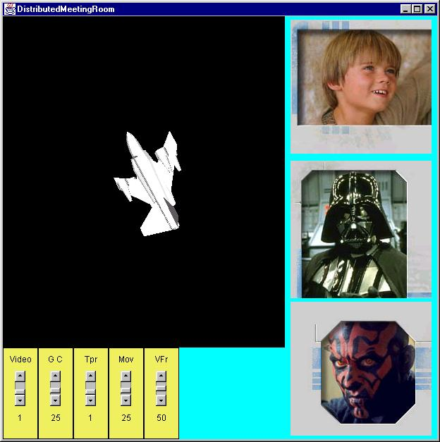
Figure 4. Screenshot of the proposed system.

5. PRELIMINARY RESULTS

In our recent research [Trefftz 2000], we have implemented a collaborative virtual environment in which messages are cached in order to avoid faster computers flooding slow computers with too many messages. Measurements show that the resulting balance of resources allows for a better usability of the system, especially in slower computers. As an important side effect, the overall bandwidth requirement is reduced.

First set of experiments

Part of the proposed system has been built and basic experiments have been conducted. In the current system, the server sends predetermined updates to the client. The client displays a visualization data set and a telepointer, which serves the purpose of showing what some other user would be pointing at. The server generates events to rotate the data set, move the telepointer and/or refresh the video images.

As described above, a separate multicast group is defined for each combination of variable and frequency update. In the initial system, there are three variables:
- The visualized data set
- The telepointer
- The video images

The server can update each of these variables at the following periods:
- Each 1000 milliseconds
- Each 500 milliseconds
- Each 200 milliseconds
- Each 100 milliseconds
- Each 50 milliseconds
In the initial system, there are therefore 15 different multicast groups (three variables times five periods). The client and the server share a common table that defines the appropriate constants (port numbers among others). Each multicast group is handled by a thread that we call a sentinel. Each client-side sentinel communicates with one server-side sentinel, as described in Figure 6 and Figure 7.

The server has a unique timer that generates timing events, which are fired to a list of subscribers for each period. Each sentinel subscribes to the appropriate timing even generators depending on its update period.

On the client side, multicast sockets are defined in accordance to the server side.

Once the setup is complete, the client can start subscribing to specific combination of variables/periods. These messages are sent through a TCP connection, in order to avoid lost messages. The multiple utilized protocols are depicted in figure 5. The server proceeds to subscribe the client to the appropriate sentinel. Next time the sentinel is triggered by the timing event, update events are generated and sent through the multicast group, since the list of listeners of the specific sentinel is no longer empty. Whenever the client subscribes to a particular period of a variable, it must be removed from any other subscribed period of that particular variable (if any). On the client side, a new thread is created to listen to messages coming to the multicast group. The thread blocks until a message arrives. When an update message arrives, the thread fires events to the subscribed listeners, which are either the visualized object or a simulated telepointer or a video image update; and the screen is updated accordingly.
Subscription
Manager
Sentinel
Subscription
Manager
Sentinel
TCP
Multicast
Server
Client

Figure 5. Protocols between the Server and the Client.

Timer
Sentinel
Sentinel
Listener
Server
Event

Figure 6. Only sentinels with at least one subscribed client generate update events.

Client
Event
Sentinel
Variable 1
Sentinel
Variable 1

Figure 7. The client-side sentinel fires an update event to its listener(s), the actual objects in the Java3D scene or the video frames.

A timed script on the client was used to subscribe/unsubscribe to different variables and periods, switching every 5 seconds. The resulting performance mapping is described in figure 8. The axes marks in the figure are not correct. The value of 1 for both the telepointer and the object axis corresponds to an update period of 1000 milliseconds, the value 2 corresponds to 500 milliseconds and 3 corresponds to 50 milliseconds. The performance mapping shows the effect of the update periods on the ability to render the visualized data set. The impact is not very large probably because of the variables involved, both Java3D objects with very short update messages (3 doubles, one for each rotation angle). Choosing one Java3D object and video as the two independent variables was done next. We expected to have a larger impact on the performance mapping as the period changes because the image update messages were longer and because two different subsystems (Java3D and AWT) were updating the user window concurrently. The results are reported in the next section.

Figure 9 shows a performance mapping for a larger object on the same computer. Both experiments were run on a computer with 64Mb of main memory and a Pentium II processor. Observe the significant difference on the Z-axis scale between the two experiments. It is also important to note that the surface is not always monotonically increasing, which means that the performance of the simulation can be affected by factors that are hard to predict, such as garbage collection. This observation will have important implications on the mathematical model chosen to solve tune the system to the user’s preferences.
Another observation that becomes evident when comparing Figures 5 and 6 is that the complexity of the object has by far a larger impact on the performance than the times the scene is updated per second. This suggests that having different representations for the visualized data set will become a powerful tool to adjust performance in the case of less powerful nodes.

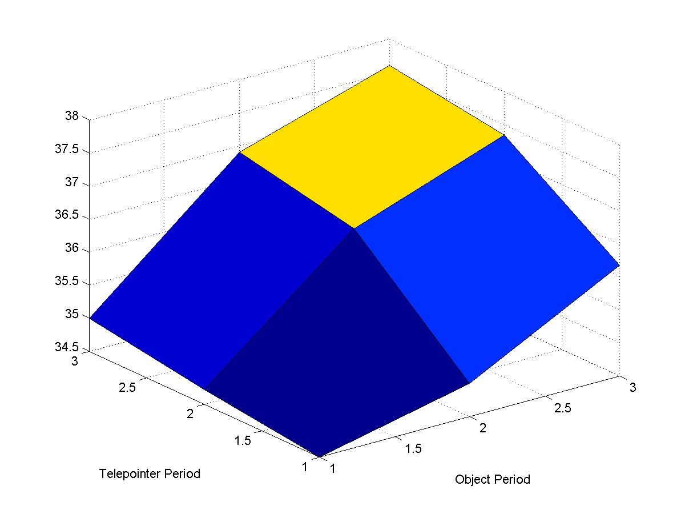

Figure 8. Performance mapping with nine combinations of variable/period. The Z-axis is the average time, in milliseconds, to render a new frame during the particular combination of variable/period.

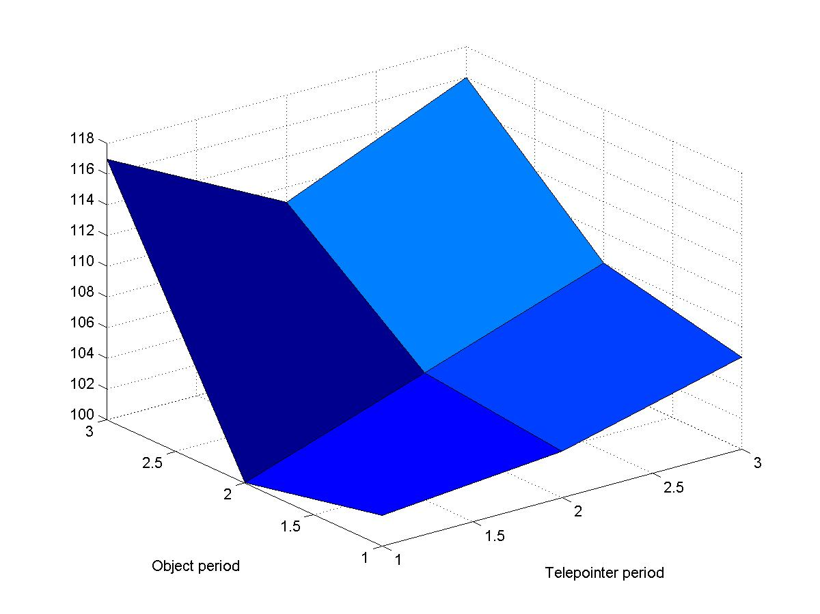
Figure 9. Performance mapping visualization data set with more vertices. The values on the Z-axes are much larger than those on figure 5.

Second set of experiments

Another set of experiments was conducted. In this set, two computers were used, with the following specifications:
- Dragonfire: Pentium II @ 350 MHz, 64 MB of main memory.
- Morlak: Pentium II @ 500 MHz, 256 MB of main memory.
Two visualization data sets were used:
- Skull: with 1,210 vertices. Depicted in figure 10.
- Guts: with 27,202 vertices. Depicted in figure 11.

Initially, the data sets were displayed on each computer without any remote events. The results are summarized in figure 12. Large differences are evident across the two computers with the same model, as well as across the two models on the same computer.
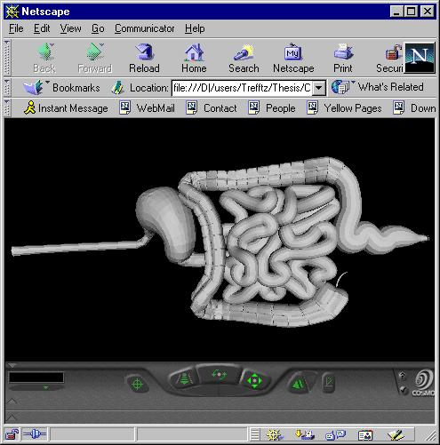
Figure 10. Guts data set. Contains 27,202 vertices.
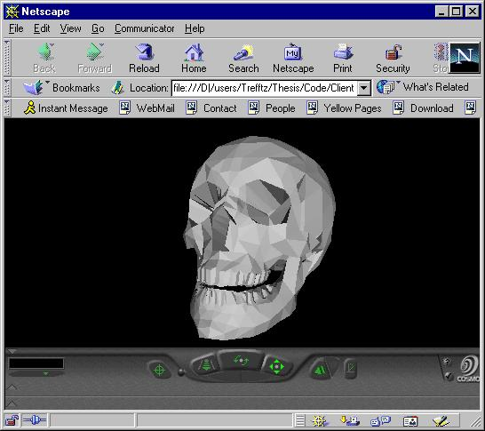
Figure 11. Skull data set. Contains 1,210 vertices

Figure 12. Visualization Frames per Second with no remote updates.

Then remote events were simulated from the server on one variable at a time. The events sent by the server during the different time intervals were as follows:
- 0 – 10 seconds: no remote events.
- 10 – 20 seconds: remote events generated each second
- 20 – 30 seconds: two events per second
- 30 – 40 seconds: five events per second
- 40 – 50 seconds: ten events per second

Figure 13 shows the results when video update events were simulated from the server. Figure 14 shows the results for video update events. The figures show how the performance is virtually not affected by remote object-movement events. But there is a noticeable decay in performance as the frequency of video events increases. This shows how the impact on performance of the different variables is highly variable.

Figure 13. Effect on performance of varying the frequency of video updates.

Figure 14. Effect on performance of varying the frequency of object-movement updates

Then the two variables (object-movement updates and video updates) were combined, forming the Cartesian product of the variable domains. The results are depicted in figure 15 and 16. Figure 15 shows the result for the “Skull” data set and figure 16 for the “Guts” data set. Both figures show surfaces in which the gradient along the axis corresponding to video updates is steeper than the gradient along the axis corresponding to object-movement updates.

Figure 15. Combined effect of object-movement updates and video updates on the “Skull” data set.

Figure 16. Combined effect of object-movement updates and video updates on the “Guts” data set.

6. FUTURE WORK

The next step is to implement the complete system. The key pieces of the collaboration part are:
- Capturing input from the user and sending the updates to the server.
- Implementing, in the server, the cache that keeps an ordered set of events to be sent through each multicast group.
- Creating the test program that will involve all the independent variables.

For practical purposes, the actual implementation will run on 3 nodes with varying computing power. A simulation of over 100 nodes will be created, based on the behavior of the dependent variables observed during the actual implementation.

An important aspect of the research is finding an efficient way to explore the search space. The mathematical model that results from expressing the objective function and the restrictions is very similar, in form, to a Linear Programming problem. But there are two main and essential differences:

- Variables in our problem take only discrete values. Variables in a typical linear programming problem are continuous.
- Relationships among variables in a typical linear programming problem are expressed as linear equations. The relationships between dependent and independent variables in our problem are determined experimentally, and are, most likely, not linear.

We will explore the possibility of applying Integer Programming techniques to our problem. In Integer Programming variables assume discrete values.

Regarding the non-linearity of the dependant variable with respect to the independent variables, several approaches might be taken.

One approach would be trying to find a known non-linear relationship that describes the relationship and then making it linear. An exponential function would become linear by taking the logarithm, a power function would become linear by taking the nth root, and so on. The “optimality” of the solution would depend from the accuracy on the fitting of the approximating function.

The other approach is based on the fact that the optimal solution to a linear programming function is (generally) found on a vertex formed by the intersection of the hyper-planes that bound the search space. In our case, the coordinates of each point in the search space are determined by the value of the dependant variables and the value of the dependant variable found by the performance mapping. If the search space has n dimensions, one can find a linear equation of a hyper-plane that passes through n neighbor points. By carefully covering all neighbor points with such hyper planes, an n-dimensional net is created that provides all the possible links that the simplex algorithm would follow in its search for an optimal value. This is not an approximation, and the solution that the simplex algorithm finds is actually optimal.

To better understand this piece-wise linear description, lets consider a problem with two variables, one independent and one dependent. Two neighboring points on the plane can be linked with a line; two non-equal points define a line. If the independent variable takes m values, m-1 lines are needed. In a problem with three variables, two independent and one dependent, three neighboring points on the 3D space can be linked with a plane: three non-collinear points define a plane. If the first independent variable takes n values and the second takes o values, (n-1) x (o-1) planes are needed. In general, in a problem with n variables, n neighboring points can be linked by a hyper-plane in n-dimensions. The total number of hyper planes needed would be:

∏ (C_{I} – 1)

Where C_{I} is the number of different values that variable “I” can take.

Another interesting component of the thesis is finding an efficient way to solve the whole model described in section 4. Parts i) and ii) of the model can be solved at each node, in a parallel fashion. But restrictions expressed in part iii) need a centralized solution that assures fairness for the participating nodes. Several approaches can be taken. Initially we will explore translating the global restrictions into local restrictions based on some predefined fairness criterion. For instance, if the limited resource that is bounded to a type iii) constrain is the number of messages the server can send per unit of time, it would be sensible to assign larger quotas to faster computers. Each node could only generate up to its quota of updates per unit of time, thereby guaranteeing that the global constrain holds. Since the result of the performance mapping is the number of times per second the visualized data set is rendered, this variable will be used as general indication of the computer speed.

In the presence of several individual functions to be optimized, several criteria can be assumed to optimize the problem as a whole [Ignizio 1994]. Let us call local_satisfaction_function_{i} or lsf(i) the polynomial that expresses the preferences of user “i”. How to define a global_satisfaction_function or gsf as a combination of the individual local_satisfaction_functions? Several approaches can be explored. For instance:
- Simply adding the local_satisfaction_functions to form the global_satisfaction_function. This approach is simple, but the fact that the sum of the functions is optimized does not imply any fairness. The outcome of the global optimization might favor a node that might have higher values of its lsf at the expense of other node(s) with lower values of lsf.
- Defining the gsf as a linear combination of the individual lsf’s. The weights on each individual lsf could be used as a priority of the user of the respective node. For instance a general would have higher priority than a sergeant.
- Instead of maximizing the sum of the individual satisfactions, another approach would be to minimize the sum of the dissatisfactions. Each local_dissatisfaction_function or ldf would be defined as k – lsf, where k is the maximum numerical value that lsf can take in ideal conditions (if all the coefficients are carefully normalized, k would be 1). The task would be, then to minimize the global_dissatisfaction_function or gdf, which is the sum of the individual ldf’s.
- Again, a linear combination of ldf’s could be formed with non-equal weights to assign priorities to different users.

After both the collaborative and the mathematical subsystems are implemented, the whole system will be tested in a controlled environment. In a “control-group” implementation, messages will be shared among participants without any mediation. We predict that faster nodes will overflow slower nodes with more messages than the slower nodes can process, making the system difficult to use. By definition, the control-group implementation will not allow users to tune the system to their preferences. On the other hand, in the experimental implementation the proposed architecture will be deployed. We predict that slower nodes will receive manageable amount of messages, making the system easier to use. Additionally, users will be able to tune the representation of information they receive in terms of their preferences.

A lower frequency of event updates results in jumpiness of the movements. In order to compensate for this effect, a dead-reckoning algorithm, as explained in [Singhal 1999] can be deployed.

7. Conclusions

We propose a framework to model mathematically the global policies and the individual user preferences in multi-modal collaborative systems. Finding a solution to the mathematical model is equivalent to finding an objective and fair solution to these conflicting aspects. The main assumption is that the users share information that is multi-modal and that can be represented with multiple degrees of fidelity along each modality. As long as the multiple modality streams can be handled appropriately by the local client (complying with the globally defined minimum requirements), the user can assign different weights to different modalities in order to favor the representation fidelity of the modalities that interest him or her the most at a given time. The server serves the purpose of collecting the different streams, reducing the fidelity when appropriate and delivering streams to the clients with the fidelity they request. In order to make the solution scalable, clients interested in a common fidelity representation of a specific variable matriculate to a multicast group. This solution could be easily extrapolated to handle different types of objects in complex simulations, such as battlefield simulations.
The resulting mathematical model is similar, in form, to a Linear Programming problem. But there are several important issues that have to be considered. First, the relationship between independent and dependent variables are experimental and are non-linear. Second, partial solutions to the model can be solved in parallel, but the general solution requires integration of the partial solutions. This lends itself to an interesting problem in parallel processing and operations research.

BIBLIOGRAPHY

[Greenhalgh 1999] Greenhalgh, C., Benford, S. and Reynard, G, A QoS Architecture for Collaborative Virtual Environments, ACM Multimedia (MM'99), Orlando, Florida, November, 1999, ACM Press.
[Benford 1995] Benford, S., Bowers, J., Fahlén, L., Greengahlgh, C., Mariani, J. and Rodden, T., Networked Virtual Reality and Cooperative Work, in Presence: teleoperators and virtual environments, MIT Press, 1995 .

[Hwang 98] Hwang, K. and Xu, Z., Scalable Parallel Computing. McGraw-Hill. 1998.

[Macedonia 1995] Macedonia, Michael. A Network Software Architecture for Large Virtual Environments. PhD thesis. Naval Post-Graduate School. 1995.

[Moore 1965] Moore, Gordon. http://www.intel.com/intel/museum/25anniv/hof/moore.htm.

[Capps 2000] Capps, Michael. Fidelity Optimization in Distributed Virtual Environments. PhD thesis. Naval Post-Graduate School. 2000

[Durfee 1988] Coordination of Distributed Problem Solvers. Kluwer Academic Publishers. 1988.

[Foley 1990] Foley, J., van Dam, A., Feiner, S., Hughes, J. Computer Graphics: Principles and Practice. 2nd Edition. Addison-Wesley. 1990.

[Ignizio 1994] Ignizio, J., and Tom Cavalier. Linear Programming. Prentice Hall. 1994.

[Kumar 1994] Kumar, Vipin, Grama Ahahth, Gupta Anshul and Karypis George. Introduction to Parallel Computing – Design and Implementation of Algorithms. Benjamin/Cummings Publishing Company Inc. 1994.

[Myers 1998] Myers, B., Stiel, Herb., Gargiulo, Robert. Collaboration using multiple PDAs connected to a PC. Proceedings of CSCW 1998.

[Paltalk 2001] http://www.paltalk.com.

[Singhal 1999] Singhal, Sandeep and Zyda, Michael. Networked Virtual Environments, Design and Implentation. Addison Wesley. 1999.

[Trefftz 2000] Trefftz, H., Marsic, I., “Message Caching for Global and Local Resource Optimization in Shared Virtual Environments”. Proceedings of ACM VRST, 2000.

