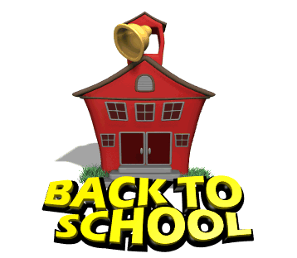

September 18, 2008

Dear Parents,

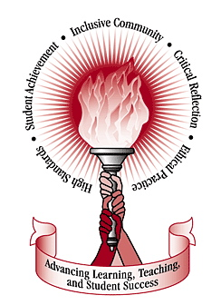
I and all of Napa Elementary staff are happy to welcome all students back to this new school year that should bring lots of progress and fun. As we embark this new school year I am excited to meet and learn about all my students. Although the school year is still young, as the year progresses it will get a lot busier. This is where the importance of parent and teacher communication plays its role. I believe that if we work together we can help our students achieve their goals academically, emotionally, and eventually pave their success through life. We will hold parent conferences throughout the year to discuss where your child stands but if necessary I can be contacted before or after school hours.

These are a few assignments/announcements that are available as of right now:

- I will send a homework packet for the week every Monday and will be due on Fridays. This allows the students to be responsible and learn to use time management at home when doing homework. This also allows the parents to ask me any questions about the homework throughout the week
- Open house information will be sent to you via your child’s homework packet
- Weekly assessments will be taken on Fridays
- Student progress reports can be accessed by contacting me in person
- Lunch and after school program forms should be turned in to the office

I see a progressive year and an enjoyable one too. With the help of the parents we can make this year a good one for our children’s education. I will be hearing from you soon.

I may be contacted before or after school in room #6, call me at (559)280-6000, or email me at eog78409@csun.edu

Respectfully,
Mr. Gomez


