Napa News

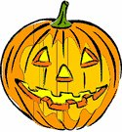
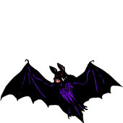
Halloween is around the corner. It is about that time to look for a scary costume and paint those faces. Napa Street will be having its annual Halloween Festival. Every year Napa staff organizes a day full of fun activities that include face painting, hula-hoop marathons, bowling, crazy hair paint, and others. There will be a costume parade which staff will award costumes according to different categories. Parents are more than welcome to join their children. The costume parade will be on October 31st at 1:30pm and continue until 4:30pm. Bring the family to enjoy this fun filled day. See all of you
there!

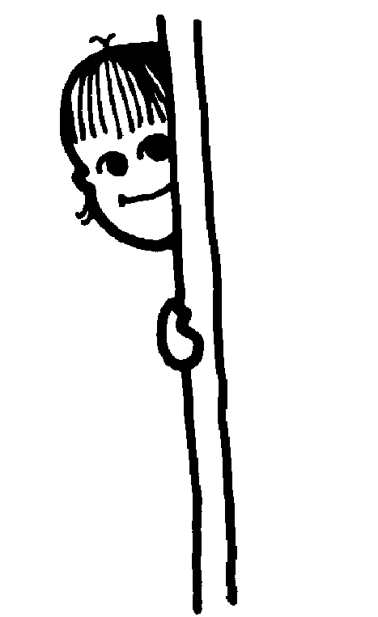
There was a good outcome the night of Open House. Napa staff will like to thank all the parents and students who participated that night. We are pleased to see parents involved in their child’s education. Here at Napa we believe that parents play a critical role in our student’s future. When parents get involved with their child’s education, it helps students to know that they are not alone in this education business. Events like Open House create a special connection between parents and the schools that their students attend.



Napa Street will be having a Candle Fundraiser. The fundraiser will help support families in special programs that need help financially to pay their bills. This fundraiser is a great way to give back to the community plus the students are able to receive selected prizes for those participating. There will be a special assembly to introduce the fundraiser. Representatives from the organization will be present to answer any questions. Every student will receive the fundraiser packet that includes the items they will be selling and the prizes they can win. Hope we are all exciting to make a difference in our community.



The Jaguars football team is undefeated for the 2nd year. Their biggest game of the year is coming up this Friday at 3:30pm. Come and support the Jaguars to another perfect victory.


Any questions or things you would like to see in our monthly newsletter…contact Mr. Gomez, the editor of Napa News. Contacting the editor; you can find me in room 17, or email me at eog78409@csun.edu
Enjoy the rest of the month!

