Ian Hubbard

1st year Meng

Experimental Methods

The Determination Of The Coefficient Of Steel On Steel

Course lecturer Dr Smart
Tutor Dr A.G. Starr

Introduction

This experiment aims to determine the coefficient of steel against steel by monitoring the forces required to move a thin steel strip against a steel cylinder.

Theory

If a thin strip of metal has a predetermined angle of contact with the cylinder then the reaction force of the cylinder can be measured by considering the tensions on the strip T1 and T2.
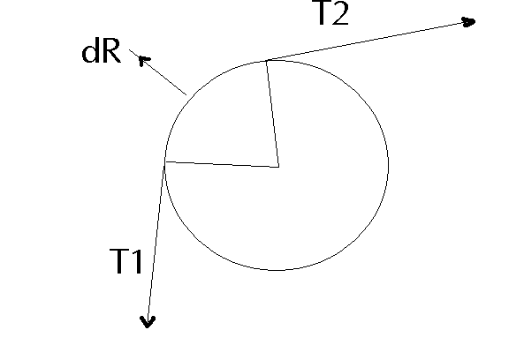

d
It follows that the normal reaction force dR = Td

When there is limiting equilibrium, the coefficient μ = d/dR.

This can be integrated and simplified to give the final equation

μ  Ln (M₂/M₁)/

Where m₂ and m₁ are the masses providing T₂ and T₁.

Apparatus

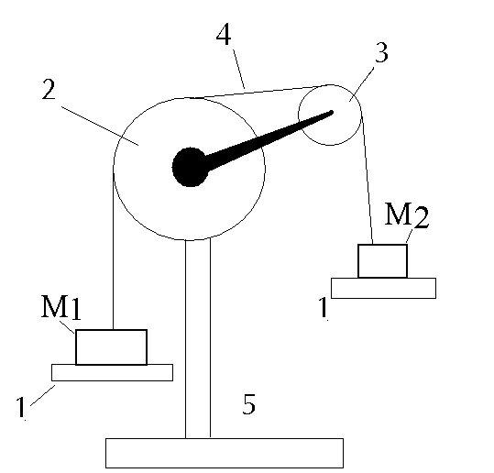1:Mass hanger =75g

2: Steel cylinder, mounted in supporting frame (5) with axis horizontal.

3: Pulley, attached so that the contact angle of the strip (4) with cylinder can be adjusted.

4: Thin steel strip

5: Stand.

Procedure

Clean the metal strip as to minimise dust or grease, which could seriously interfere with the friction values.
Adjust the position of the pulley for the angle of contact to be measured.
Place 200g on the hanger for M₁, add masses slowly to the hanger for M₂ and record the mass which just pulls the touching metals past the limiting equilibrium point.
Repeat for the other angles measured.

Observations and results

The gradient of the line of best fit in this graph gives us the value for 
$μ= \frac{δ\text{Ln}(Μ\text{2/}Μ1)}{\text{δθ}}=\frac{0\text{.}\text{565}−0\text{.}\text{075}}{7π/8−π/8}=0\text{.}\text{2058}$

Discussion

The results show a scatter graph with a line of best fit passing close to the origin.
A line through the origin would indicate that without any contact there is no friction, M₂ = M₁ and Ln (M₂/M₁) /   
The line did not pass exactly through the origin because in this experiment there is friction from the pulley slightly raising the values of Ln (M2/M1)

I believe there were many other sources of error.
Oil or Dirt on the sheet of metal or the cylinder could have seriously affected the results. This was limited by cleaning the steel involved. There was no indication of how accurate the weights were.
Human error including shaky hands when the weights were applied. Repeat readings were used to try and correct this. The cylinder may not have been uniformly smooth which would account for the starts and stops in the motion.

Conclusion

A typical value for the coefficient of steel on steel   = 0.2
This gives a 3% error in the calculations I have made this therefore is a satisfactory result

