Anthropology 02MAR05

(cont.) What defines complexity?
- Number of parts
- Number of different types of parts
- Interaction between those parts

What features of a society make it more or less complex than another?
- Inequality and Heterogeneity
  - Status distinctions (vertical social inequality)
    - Access to material goods
    - Access to knowledge
    - Access to decision making
  - Divisions of Labor (horizontal diversity)

- So called “simple” societies are not simple in most respects
- Stratification and/or inequalities do occur
  - However, most often these are temporary or non-institutionalized distinctions
  - Most social distinctions are “achieved” or “inherited”
  - Egalitarian (Denotation: Affirming, promoting, or characterized by belief in equal political, economic, social, and civil rights for all people) societies have a number of mechanisms to ensure general equality
- Current models suggest that complexity emerges when these mechanisms are circumvented

Example: Dividing a Pie
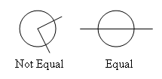
Models of Emergent Complexity
Most models contain one or more of the following criteria:
- Population pressure
- Managerial requirements

Complexity emerges to solve these problems.

These models explain “why” complexity is necessary and how it functions.

- Chaco Canyon as an example:
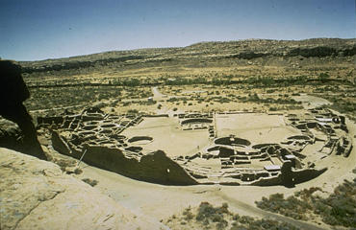

South Ease reconstructed Pueblo Village
- Called Pueblo Bonita
- Chaco “Great House” Architecture
- People joined loops to share crops
  - People who could spare would help those with out
- Needed people to organize this

Why study state formations?
- Understanding how and why states emerge helps us understand characteristics and condition of modern states
- Some societies never developed into states, why not?
- Understanding state origins helps explain inter actions (both modern and prehistoric)
  - Between one state and another
  - Between states and non-states
- Explaining state origins also provides clues to state collapse

