Anthropology 11FEB05

Bipedalism (cont.)

Changes in Body Structure (cont.):
- Legs angle inward toward each other
  - Allow humans to keep their center of gravity under them

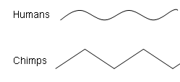
- Feet have robust ankles and arches
  - Robust ankles allow humans to place more stress and weight on their feet
  - Arches act to cushion legs and the rest of the body from repeated steps

Genus Australopithecus

- Approximately 7 species within this group
- Discovered in East and South Africa Only
- Dating to a time period referred to as the Pilo-Pleistocene (5 to 1 mya)
- African Ecology was changing at this time
  - From extensive tropical forests to savanna grasslands and woodlands
  - Not all the forests were lost, but the new eco-zones provided opportunities for species that could adapt to them
- First fully bipedal species
  - Miocene Anthropoids were capable of upright posture for short periods only
  - Bipedalism seems to precede many other developments such as tool use and larger brains
- Some of these species are grouped in to different genera (e.g. Paranthropus, Aridithecus)

Australopithecine Fossils:

- Raymond Dart discovered the first Australopithecine fossil
- Dart was an Anatomist at the University of South Africa
- Tried to collect fossils by having people send boxes of lime stone rocks to him
  - Looking for fossil at Taung
- He discovered the endocast of a small hominoid
- He was able to piece it together to for the face of a 3/5 year old child of Australopithecus Africanus

Gracile Australopithecines:

- 3 Species
- Australopithecine anamensis
- Australopithecine afarensis (Lucy)
- Australopithecine africanus

- These were the earliest of the Australopithecines.
- They were lightly built with less robust musculature than other Australopithecine
- Limited sagittal crest. These are the boney point on the top of the head where muscles attach to it. This determines how important chewing is to the species.
- Smaller zygomatic arches (cheeks)
- Dentition similar to modern humans

Australopithecine Afarensis – “Lucy”
- Discovered by Donald Johanson
- What is unique about Lucy is that she had odd curved fingers and toes
  - She also had long arms

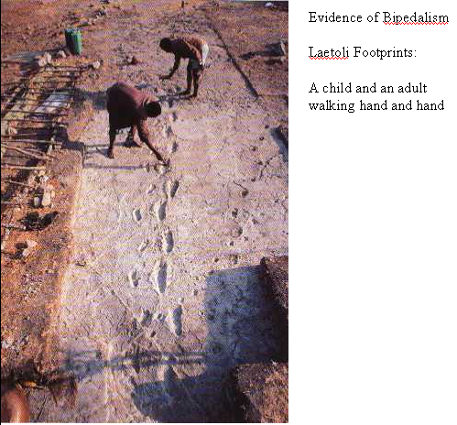

Robust Australopithecines:

- 3 Species
- Australopithecine aethiopicus
- Australopithecine robustus
- Australopithecine boisei

- Generally small cranial capacity
- Large, broad faces
- Heavy robust dentition
- Diet of seeds, nuts, roots, vegetal foods
- Heavy musculature

- Large sagittal crest and zygomatic arches
- Significant post-orbital construction
- Would be able to crush an arm

An example of a Robust Australopithecine would be the black skull (Australopithecine aethiopicus).
