Anthropology 14FEB05

Early Genus Homo:

Early Homining Tools and Tool Use:

- During the Plio-Pleistocene, two general species emerged
- Robust Australopithecines
  - Large, robust jaws
  - Ate roots, tubers, nuts, and seeds
- Gracile Australopithecine / Early Homo species
  - Small, gracile dentition
  - Ate softer foods like meat and began exploiting a new niche

Class discussion: What would be left after the lion kills some prey?
- There would be some flesh left on the bones of the animal
  - Lions are only able to eat chunks of meat and leave stuff behind
- There is also marrow in the bones that lions are unable to get to

- Why being to make and use tools?
- Allow for quicker and easier scavenging
- Add protein to the diet
- Helps to compete with other scavengers

Homo habilis: the first to use tools

- Probably a decendent of Australopithecine africanus or Australopithecine afarensis
- Name stands for “Handy Man”
- Made and used tools
- Associated with “Oldowan tool tradition”
- Dates from 2.4 to 1.8 mya
- Co-existed with Robust Australopithecine
- Increase in cranial capacity, 500 – 800 cc
- Round in East and South Africa
- A robust, but generally Human skeleton

- Rocks are tools:
- they have been modified
- need to be made

- Oldwan Chopper
- striking rock called hammer stone
  - makes sharp edge on the rock
  - rock flakes have an even sharper edge, used for slicing

- Choppers were used to get the marrow inside the bones.
- Flakes were used to scrap the meat off the bones.

Hard Hammer: rock
Soft Hammer: antler or bone
- more control over the shape of the flake with a soft hammer
Homo erectus: (Peking Man)
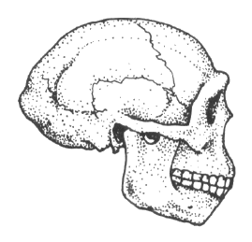
- The first species of hominids to leave Africa
- originated in East Africa
- Movied into Asia, Indonesia, and Europe
- Dates from 1.8 to 0.3 mya
- Smaller teeth than Homo habilis
- Even larger cranial capacity, 750 – 1250 cc
- Associated with Aschealean tools

