Anthropology 21JAN05

(cont. Evolution Theory > Darwin)

- Malthus suggested that life was red in tooth and claw

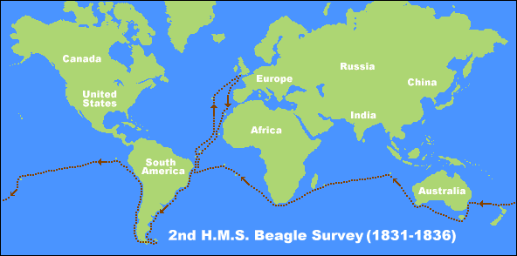
Voyage of the HMS Beagle

Slide Example: Galapagos Finch Beak

The Problem of Pigeons
- How to explain the variability and decent with modification noted all around him

Natural vs “Unnatural” Selection
- Variation under domestication
- Selective breading

Three Components of Evolution

- Variation – items or individuals must be different in their appearance, abilities, or behavior
- Inheritance – variation must be heritable, that is, offspring should be similar to parents
- Differential success in reproduction, individuals vary in the number of offspring they produce

Darwin understood variation and differential success, but he did not quite understand inheritance.
Gregor Mendal and Peas

- Austrian Monk studying variation in pea plants
- Peas have variations
  - Smooth/wrinkled
  - Green/yellow
  - Tall/short
  - Purple blooms/white blooms

    - He controlled the pollination
    - His interest was in exploring inheritance

Genotype vs Phenotype

Genotype – genetic make-up is inherited from parents and ancestors
Phenotype – the results of the interaction of a genotype with the environment

Genes and Alleles:
- Some phenotypic traits are controlled by a single gene within a chromosome
- Genes are made up of two alleles
  - 2 phonotypic expressions
  - dominant and recessive (Rr)
  - RR or rr = homozygous
  - Rr = heterozygous

