1.Introduction

Sensor array processing is the acquisition of information from the environment based on the data collected from several sensors spread through space. It is expected, that by processing data collected across several sensors, a better estimate of the environment is available than that due to a single sensor. In this way sensor array processing is a mapping that reduces the dimensionality of the data:

(1)

Here is a time varying signal carrying estimated information from our environment; is the sensor array mapping operator done on the data , which is a function of time t and of sensor m. Notice that the output is reduced in dimension (with some techniques or scenarios reducing the temporal dimension as well).
The applications of sensor array processing can be found in various fields: seismology, radar, and sonar [1], speech enhancement [2][3], astronomical imaging [4], hearing aids [5], and EEG source analysis [6]. It has also been suggested as a possible technique for locating emergency calls from cell phone users [7]. In addition to its practicality, the techniques for array processing are very similar to those from spectral analysis, leading to a symbiotic exchange between the two fields. In fact, high resolutions spectral analysis techniques have been successfully applied to sensor array source localization [8], and at least one robust beamforming technique has been applied in non-uniform sampling spectral estimation [9]. The main focus of this paper will be on uniformly space linear arrays (ULA) with isotropic sensors.

2. Mathematical Model for ULA

A common [10] model for the array processor in (1) with of M sensors is:

$y(t)=f(b_{m}^{}x_{m}(t))$ (2)

Where $b_{m}^{}$ is a complex parameter that already includes the physical array response, $x_{m}(t)$ the input signal at the $m^{\text{th}}$ sensor. The array output signal $x_{m}(t)$ is assumed to be complex and is modeled according to [8]:

$x(t)=\sum_{k=1}^{K}{s(t,k)}+η(t)$ (3)

Where K is the number of complex sources $s(t,k)$, and $η(t)$is additive noise that is not correlated with the sources. The general structure for the ULA is shown in Figure 1.

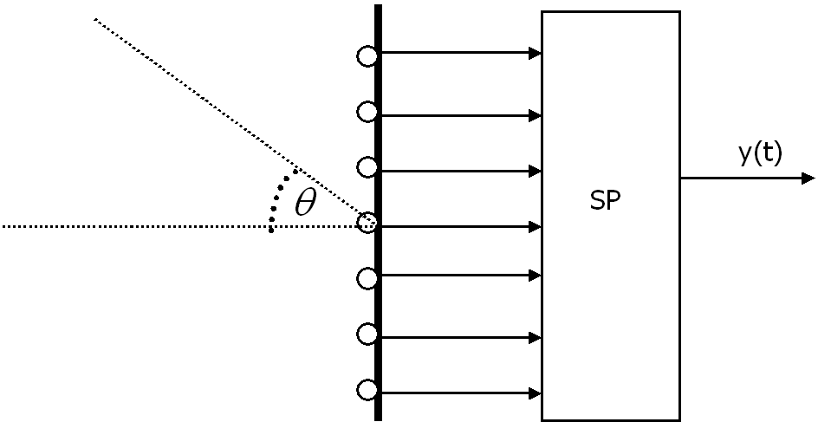
Figure 1- Schematic diagram of a ULA.

Any source $s(t,k)$ impinging on the array is referenced to an angle relative to the midpoint of the array (which might or might not have a sensor). This degree of arrival (DOA) $θ$, is defined as the angle between a vector normal to the midpoint of the array and a vector normal to the wave front of the source $s(t,k)$. Notice that due to the physical nature of the ULA, ambiguities will arise if the sources are not limited to within –90 < $θ$ < 90 (i.e., a source at 80 has the same delay pattern as a source at 100). The broadside region of the ULA is the region close to $θ$ = 0, and the endfire region is the region at the corners. A specific relation among the signals from each sensor (Equation (3)), can be obtained if we simplify the model further: the wave sources impinging on the array are narrowband with constant amplitude ($s_{k}$ $e^{{\text{jw}}_{k}t}$) and consists of planar waves; the isotropic sensors are LTI systems, and the media is non-dispersive where the superposition principle applies [14]. With these assumptions in place, and setting our first (top) sensor as a reference point Equation (3) can be written as [1][8]:
$x(t,m)=\sum_{k=1}^{K}{s_{k}H_{m}(w_{k})e^{{\text{jw}}_{k}t}e^{−{\text{jw}}_{k}τ_{k}(m)}}+ε(t,m)$ (4)
Where $s_{k}$ is the complex magnitude of a source k with frequency $w_{k}$, and $H_{M}(w_{K})$ is the frequency response of the $m^{\text{th}}$ sensor to frequency$w_{k}$. The parameter $τ_{k}(m)$represents the $k^{\text{th}}$source delay that occurs between the reference and the $m^{\text{th}}$sensors. The last term, $ε(t,m)$, is the white noise processed by the sensor. We can write equation (4) in a more concise manner if we use the following vector notation:

$$\vec{x}(t)=[\begin{matrix}x(t,1) & x(t,2) & ⋅ & x(t,M)\end{matrix}]^{T}$$
$$\vec{s}={\left[\begin{matrix}s_{1} & s_{2} & ⋅ & s_{K}\end{matrix}\right]}^{T}$$
$$\vec{ε}(t)=[{\begin{matrix}ε(t,1) & ε(t,2) & ⋅ & ε(t,M)]\end{matrix}}^{T}$$
$$D=\left[\begin{matrix}H_{1}(w_{1}) & H_{1}(w_{2}) & ⋅ & H_{1}(w_{K}) \\ H_{2}(w_{1})e^{−{\text{jw}}_{1}τ_{1}} & H_{2}(w_{2})e^{−{\text{jw}}_{2}τ_{2}} & ⋅ & H_{2}(w_{K})e^{−{\text{jw}}_{K}τ_{K}} \\ & & ⋅ & \\ & & ⋅ & \\ H_{M}(w_{1})e^{−{\text{jw}}_{1}τ_{1}M} & H_{M}(w_{2})e^{−{\text{jw}}_{2}τ_{2}M} & ⋅ & H_{M}(w_{K})e^{−{\text{jw}}_{K}τ_{K}M}\end{matrix}\right]$$

Than we can write equation (4) as:

$\vec{x}(t)=D\vec{s}+\vec{ε}(t)$ (5)

The columns of the matrix D are called the array transfer vectors (or array direction vectors) [8]. If the uniform array is properly calibrated [8], meaning that we know $H_{m}(w)$ for all the m’s, than we have the closed form for the transfer vector:

$a(w,τ)=[\begin{matrix}1 & e^{−\text{jw}τ} & ⋅ & e^{−\text{jw}τ(M−1)}\end{matrix}]^{T}$ (6a)
$A=[\begin{matrix}a(w_{1},τ_{1}) & a(w_{2},τ_{2}) & ⋅ & a(w_{K},τ_{K})\end{matrix}]$ (6b)

and we can write equation (5) as:

$\vec{x}(t)=A\vec{s}+\vec{ε}(t)$ (7)

Notice from (6) that the array transfer vectors resemble the DFT synthesis matrix, which has important orthogonal properties [8].

3. Sampling

The accuracy of the calibration is a key factor in array analysis. While it might be possible to estimate the DOA’s without calibration, or even from unknown array structures (i.e., assuming statistical independence between non-gaussian sources) [11], the more traditional and commonly used methods such, Capon and MUSIC, require proper calibration [33][9][12]. From equation (6b) we see that if calibration is done appropriately, than the matrix A, will be a Vandermonde matrix with M linearly independent rows [8], spanning a min(M,K) dimensional space, which is a key factor in more advanced techniques [1][8][28].
From Fig. 1 we see that the delay of a source at the $m^{\text{th}}$ sensor is related to the DOA of the source by [10]:

$τ_{k}=(m−1)\frac{d\text{sin}(θ_{k})}{c}$ for m = 1, 2, …., M (8)

Where d the uniform distance between sensors, $θ_{k}$ is the DOA of the $k^{\text{th}}$ source, and the speed c of the wave in the medium. From equation (8) we can now proceed to establish sampling criteria similar for appropriate sampling. Defining the wavelength of our source,$λ_{k}$and the wavenumber k as [8]:
$λ_{k}=\frac{c}{f_{k}}$ $k=\frac{2π}{λ_{k}}$ (9)
Than the sampling frequency can be defined as [8][10]:
$f_{s}=f_{k}\frac{d\text{sin}(θ)}{c}$ (10)
Equation (10) shows that the sampling frequency depends on four parameters. The effect of aliasing and sampling are better understood by looking at the spatial and temporal spectra of the wave field at in a two dimensional case, defining the Fourier transform of our wavefied as [14]:

$F(k,ω)=\int_{−∞}^{∞}{\int_{−∞}^{∞}{f(x,t)e^{−j(ω_{k}t−\text{kx})}\text{dtdx}}}$ (11)

Where $f(x,t)$ is our desired wavefield with a single spatial dimension x and temporal dimension t. The variables k and $ω_{k}$ are the spatial and temporal frequencies respectively. Now if sampling is done only in the spatial dimension with infinite number of sensors, then the spatially sampled version of (11) can be written as [14]:
$X(k,ω)=\sum_{m=−∞}^{∞}{\int_{−∞}^{∞}{f(x,t)e^{−j(ω_{k}t−\text{kmd})}\text{dt}}}$ (12)

Using the following relationship between discrete and continuous spectra [14][15]:

$S(u)=\frac{1}{d}\sum_{m=−∞}^{∞}{S_{c}}(u−\frac{2πm}{d})$ (13)

We can use (13) to rewrite (12) as:

$X(k,ω)=\frac{1}{d}\sum_{m=−∞}^{∞}{F(k−\frac{2mπ}{d},ω)}$ (14)

From (14) we can see that the spectrum of sampled wavefield is a periodic repetition of the spectrum of the continuous wavefield, with period $\frac{2π}{d}$. Thus, in order for no aliasing to occur, the spatial spectrum of $F(k,ω)$ has to be limited by |$k$| <$\frac{π}{d}$. The wavenumber k is related to the temporal frequency by [14]:

${\left|k\right|}^{2}={\left(\frac{2f_{k}π}{c}\right)}^{2}$ (15)

Using this relationship between the wavenumber and the frequency of the source along with the fact that |$k$| <$\frac{π}{d}$, in order to avoid aliasing, we have following conditions in order to interpret the signal uniquely:
$T_{\text{min}}=\frac{1}{2f_{\text{max}}}$ (16a)
$d_{\text{min}}=\frac{π}{k}=\frac{c}{2f_{\text{max}}}=T_{\text{min}}c$ (16b)

Where the first equation is the standard temporal sampling [15] and the second equation is obtained by imposing limitations on the spatial spectrum of the original wavefield from (12) along with the wavenumber relationship from (13). As pointed out in [1][8][10][14] and noticing that that the wavelength of the source is related to (14b) by (9), the spacing between the sensors have to be at least half the source’s wavelength in order for no ambiguities to occur in locating the DOA. Also, both the spatial and temporal frequencies are coupled by (16), but physical implementation of the array allows for different spatial and temporal sampling frequencies. So oversampling in one domain does not guarantee aliasing effects in the other [1]. In addition, decreasing the distance d between the array sensors beyond the required will result on a smaller array aperture, which in turn will affect the array’s resolving power [1][10].
Given that equations (16) are met, than equation (10) be used to uniquely recover the DOA (if the speed c is known), or the speed c (if the DOA is known) [14]. In this way delay information between sensors allow for either source location estimation or imaging analysis (based on variations on c) [1].
The connection between sampling and standard window operations in spectral techniques is clear when we consider a limited number of sensors in the ULA with equation (12). In this case the output of the ULA sensors can be thought as being multiplied by a spatial rectangular window with width equal to the number of samples, so that equation (12) becomes:
$X(k,ω)=\sum_{m=−∞}^{∞}{\int_{−∞}^{∞}{f(x,t)Τ(m)e^{−j(ωt−\text{kmd})}\text{dt}}}$ (17)
Where $Τ(M)$ is the window function, which for the case of the rectangular window (i.e, unprocessed array data) is:

$Τ(m)=u(m−1)−u(m−M+1)$ (18)

Where we are u(m) is a step function and the first sensor is set as reference. Because multiplication of a signal by a rectangular window in time domain is equivalent to a convolution in frequency domain, we can write (17) as [14]:
$\tilde{X}(k,ω)=\frac{d}{2π}\int_{−πd}^{πd}{X\left(l,ω\right)}Φ\left(k−l\right)\text{dl}$ (19)
Where $Φ\left(k\right)$ is the Fourier transform of the window. We can then relate the windowed and sampled signal from (19) with the original wavefield using (14) so that [14]:

$\tilde{X}(k,ω)=\frac{1}{2π}\int_{−πd}^{πd}{\sum_{m=−∞}^{∞}{F(k−\frac{2πm}{d},ω)}}Φ\left(k−l\right)\text{dl}$ (20)

4. Spatial Windowing on the ULA (Tapering)

Equation (20) shows that even if the array elements are correctly spaced apart to avoid aliasing the output will be related to the wavefield impinging on the ULA and a window function that weights the elements of the array. The spectral smoothing of the original wavefield due to windowing can be related to the spectral smoothing due to finite sampling of a temporal signal [15][8]. With this analogy in mind, we can improve the performance of our estimate (20), by borrowing windowing techniques from standard signal processing. Window design is in general concerned with two factors:
- Making the window main lobe as narrow as possible in the spectral domain, while passing the desired signal undistorted
- Reducing the side-lobe levels (leakage)

Mathematically, these conditions can be written as [8]:

$\begin{matrix}\underset{b}{\text{min}} & b^{}b & \end{matrix}$subject to $\begin{matrix} & b^{}a(θ)=1 & \end{matrix}$ (C1)

These conditions can be interpreted as trying to generate a window that approximates as closely as possible an impulse in the spectral domain (*but from finite data*!). Notice tapering an ULA can also been seen as a type of spatial FIR filtering [8][10] with the M $x_{m}(t)$ signals being the inputs to the system (2). From Fig.1 we can see that the ULA is similar to a Direct Form FIR structure (or transversal filter) with a linear phase of (M-1) $τ_{k}$ with the impulse response corresponding to the window coefficients [15]. Harris has done an extensive analysis on the effects of several windows for spectral estimation of finite data [16]. The rectangular window had the highest side-lobe level, -13 dB, as opposed to –46 dB (a = 2) from the Kaiser-Bessel window (one of his preferred windows). The rectangular window is notorious for it’s leakage [16][15]. The detrimental effects of any window can be reduced by increasing the numbers of sensors (i.e., samples), however in some situations, specially in array processing, this is not practical.
Figure 2 shows the ULA magnitude response for two types of window on a MATLAB simulation using the ULA model from (2) with no noise and 150 sensors. The two windows used were the Rectangular window and the Hamming window. In the first condition the array response was measured by varying a single source’s DOA across all ranges. From Fig. 2, the rectangular window has a narrower main-lobe but the relative peak of the main lobe to the side-lobes is small, resulting in large “leakage” (or ripples) on the DOA (a spatial version of the Gibbs effect [15]). The Hamming window has a broader main-lobe but the relative peak of the main-lobe to the other side-lobes are much more substantial. As expected, there is a general tendency of the ULA to favor signals coming from the broadside (DOA =0) as if it forms a beam at that angle. In the second condition two extra sources were added to the model at –9 and 9 DOA. Under this condition not only is the Rectangular window incapable of distinguishing between the two extra sources, but is also shows a very undesirable ripple effect. The Hamming window gives a much smoother response and better visible distinction between the sources.
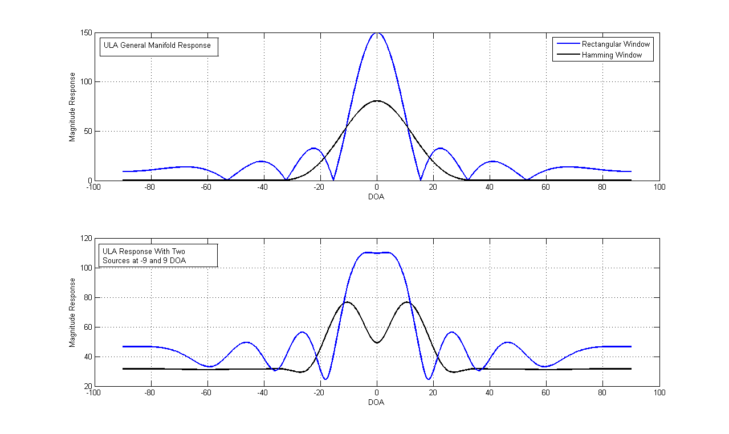
Figure 2- ULA Magnitude response vs DOA for a Rectangular and a Hamming windowing. The first graphs shows the response of the array for a single source across several DOAs (notice that in general the ULA favors DOA’s close to 0). The second graph shows the ULA response with two extra sources at –9 and 9 DOA. The rectangular window merges both sources in the response and also has extra ripples at the edges. The Hamming window has a much smoother overall response.

From the ULA response to the first condition in Figure 2, we can understand the concept of beamforming. The peaks of the ULA response can be thought as “spatial-beams” of the array in the sense that the array favors signals coming from those locations more than any other. In this way, the goals of beam-forming and spatial windowing are ultimately the same [8]. By windowing, or beamforming, one hopes to tune the ULA response to a single narrow beam corresponding to the location of the window’s main-lobe. Thus if one has the perfect narrowest beam (i.e., “pencil beam”), one can find the DOA of impinging sources by sweeping (beam-steering) this beam over several DOA and detecting significant peaks. Or if the DOA is known, the observed signal will have minimum spatial interference. Some drawbacks, however, are that very narrow beams are likely to be sensitive to modeling and calibration errors, and inappropriate for fast moving targets.

5. Beam-steering and Phased Arrays

One of the most common traditional implementations of array processing was directly related to beam-steering, which was accomplished by multiplying the output of the ULA by a vector corresponding to the desired DOA [1][10][8]:

$b(m)=a(θ)/M$ (21)

Where $a(θ)$ is the array transfer vector from (6). This is also known as a “phasing” the array and can be done after tapering the ULA[10]. Notice that (21) implicitly assumes proper calibration of the array. Cox did a study on calibration errors between the conventional phased array, and two other beam formers (Capon being one of them) [17]. While in normal (no miscalibration) conditions the phase array had less resolving power than the more advanced methods, the array was actually more tolerant to mismatch errors. Also, it was interesting that the higher resolution Capon method caused strong source signals “to be suppressed to such an extent that they have smaller output signal-to-noise ratios than weak signals with comparable mismatch”.
Going back to the phased array, if we use $a(θ)$ as our set of weights, the estimated signal can be calculated for a single source using (2) and (7) as:

$s(t)=b(m)^{}\vec{x}(t)=\frac{a^{}(θ)a(θ_{d})}{M}s(t)+\frac{a^{}(θ)}{M}\vec{ε}(t)$ (22)

Where denotes conjugate transpose and $\vec{ε}(t)$is a noise vector corresponding to the noise at each sensor. The parameter $θ_{d}$ is the true DOA of the source, which will be different from $θ$ if miscalibration or inaccuracies on location occur. From equation (22) we see that the output response involves a dot product, in the array manifold domain, between where we to steer the beam, $a(θ)$, and the exact source location $a(θ_{d})$. If the noise at the sensors are uncorrelated and zero mean, than the last term in (22) will be come small as the noise gets added out with itself. Figure 3 show the same Hamming tapered ULA from Fig.2 “beam-steered” across several DOA’s (one single source).

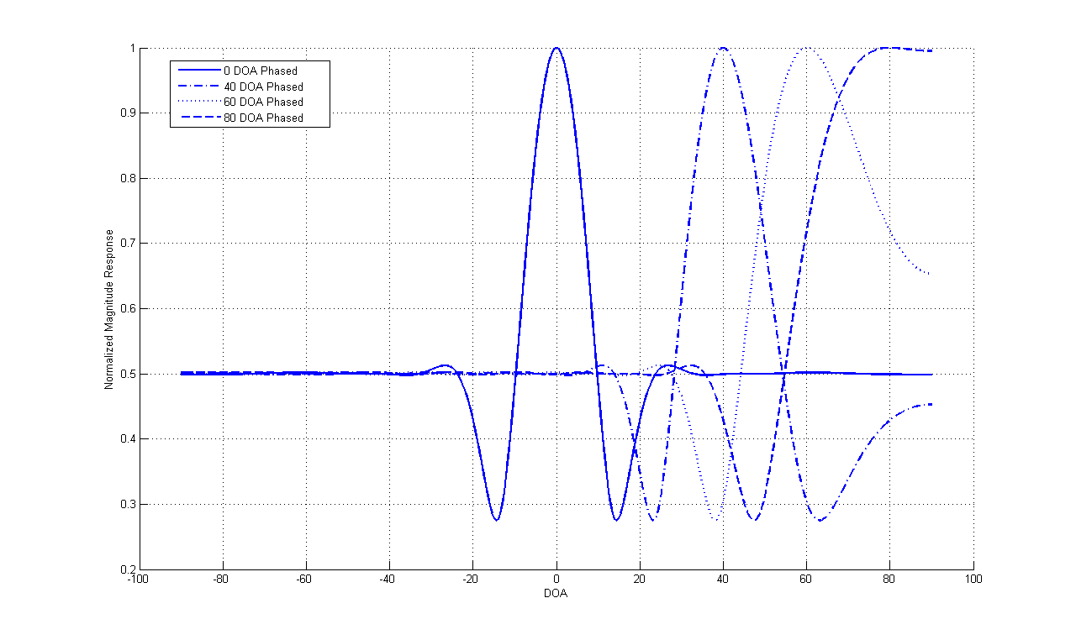
Figure 3- Hamming Tapered ULA phased steered to 0, 40, 60, and 80 DOAs. Notice that the window’s main-lobe get’s broader and skewed to endfire (DOA=90) as the ULA gets steered more to the endfire region. The inaccuracies in that region are a limitation of using ULA [17][24][25][33].

Figure 3 shows that the shape of the main-lobe broadens and become asymmetric as the amount of phasing increases (ie, as it reaches the endfire region). The loss of resolution at endfire region is also present in several other ULA techniques and seems to be more a limitation of the array structure than the method per se [17][24][25].
The phased array is an example of non-parametric processing in the sense that it makes no assumption on the decomposition of the covariance matrix of the data [8]. The obvious benefit of this method is that it can be robust to different data and it has relatively little computational complexity. But, like in spectral estimation, extremely significant improvements in the resolution can be achieved if you are willing to make modeling assumptions and if there are efficient estimators for the parameters of the model.

6. Assumptions on the Second Order Statistics of the Data

A common modeling assumption to make about the sources and noise impinging on the ULA is that they are independent and wide-sense stationary [10][1][8]. If we recall that our observed data model from (7) is:

$\vec{x}(t)=A\vec{s}+\vec{ε}(t)$ (7)

Than the M x M Hermitian covariance matrix of our data can be described as [1][18]:

$R_{x}=E[A\vec{s}{\vec{s}}^{}A^{}]+E[\vec{ε}\left(t\right){\vec{ε}}^{}\left(t\right)]={\text{APA}}^{}+{λR}_{n}$ (23)

Where $P$is the (K x K) covariance matrix between the sources (K< M-1), $λ$ a scalar, and $R_{n}$ is the (M x M) covariance matrix of the noise (which does not have to be necessarily white).
Using orthogonal decompositions of (23), powerful subspace techniques emerge. For instance, detecting the number of sources impinging on the array can be seen as the same problem of detecting the number of sinusoids in a time series. Fuchs was able to approach this detection problem by decomposing (23) into it’s SVD structure and estimating the number of sources assuming the noise was either white ($R_{w}=λI$) or spatially correlated ($R_{w}=$ band matrix) [19][20]. The final estimate was based on the series of nested likelihood ratio tests. Max and Kailath looked at the same problem by using an information theoretic criterion to find the number of sources present [21]. Their consistent estimator was a function of the ratio of the geometric to arithmetic mean of the smallest eigenvalues covariance matrix of the data (assuming white noise). In another study, Cardoso and Souloumiac were able to estimate sources in an arbitrary array manifold given (23) and non-gaussian independent sources [11]. In a similar use of the eigen decomposition of the data matrix, Bresler and Macovksi were able to come up with lower and upper bound limits on the number of signals resolvable by a ULA [22]. The ULA resolvability bound was found to be:

$\left[\frac{M−{\hat{ρ}}_{s}−1}{2}\right]≤ρ_{\text{max}}≤\left[\frac{2{\hat{ρ}}_{s}}{2{\hat{ρ}}_{s}+1}M\right]$ ${\hat{ρ}}_{s}≤M−1$ (24a)

$ρ_{\text{max}}=0,\begin{matrix} & & {\hat{ρ}}_{s}\end{matrix}=M$ (24b)

Where M is the number of sensors in the array and ${\hat{ρ}}_{s}$ is the estimated rank of the signal matrix P (23). From (24a) it is clear that the maximum number of sources that a ULA can resolve is M-1 the number of sensors in the array. This occurs when the sources are fully incoherent with ${\hat{ρ}}_{s}=M−1$. What the authors’ interestingly point out is that theoretical upper-bound in (24a) reaches this same value at the integer closest to half of this rank (${\hat{ρ}}_{s}=\frac{M−1}{2}$ ) . Unfortunately, the bounds do not tell us how to achieve such resolvability. In the complete coherent case,${\hat{ρ}}_{s}=1$, the resolvability of the array decreases to $M\frac{1}{2}≤{\hat{ρ}}_{\text{max}}≤\frac{2}{3}M$ (or the closest lower integer in each range).
The subspace techniques, as we shall see, also fit in well with the issue of DOA estimation, allowing for flexibility on the noise characteristics (i.e., Paulraj and Kailath were able to estimate the DOA’s from noise by only assuming that the unknown noise field was invariant to rotation and two rotated sets of data were available [22]). A crucial step in most subspace techniques is the estimation of the covariance matrix from a limited number of data points.
The estimation of the covariance matrix from the data is usually done with either one of the following estimators [8]:
${\hat{R}}_{x}=\frac{1}{M}\sum_{m=1}^{M}{\vec{x}(t)}{\vec{x}}^{}(t)$ (25a)

${\tilde{R}}_{x}=\frac{1}{2}\left({\hat{R}}_{x}+J{\hat{R}}_{x^{T}}J\right)$ (25b)

$J=\left[\begin{matrix}0 & ⋅ & 1 \\ & ⋅ & \\ 1 & ⋅ & 0\end{matrix}\right]$ (25c)

Equation (25a) is the standard estimate of the auto-covariance matrix of the output from the sensors (${\hat{R}}_{x}$ is M by M). The second estimate is the average of the forward-backward estimates of the covariance matrix of the data. The backward estimate is the given by transposing the forward estimate and pre and post multiplying by the exchange matrix J. The backward estimate is used for the least-square estimate of a backward predictor. The difference between the two estimators (25a) and (25b) is crucial at small sample sizes (which is a factor in array processing). At small sample sizes the estimate of (25a) has large variability in edges of the correlation matrix and can significantly degrade performance. For most subspace methods, equation (25b) is generally preferred for the estimation of the covariance matrix [8][26][32] (but in MUSIC, (25b) can lead to different DOA estimates [27]). A possible reason for the empirical superiority of (25c) over (25a), suggested by Rao and Hari, is that the estimate from (25c) is better conditioned (i.e., larger ratio between the biggest and smallest eigenvalues). And a larger condition number implies a more distinct noise space.

7. MUSIC and Array Processing

If condition (23) holds than a spectral estimation technique known as MUltiple SIgnal Classification (MUSIC) can be used to yield asymptotically unbiased estimates of: 1) number of source 2) DOA 3) cross correlations among the directional waveforms 4) polarization and 5) strength of noise/interference [28]. The basic concept behind MUSIC is similar to the idea of using an antenna with a very sharp. By measuring the antenna’s response over a wide range of DOA’s, source location estimates can be given from the peak of the inverted antenna’s response. From (23), if the number of K sources impinging on the array is less than M-1 sensors in the ULA, than the first term in (23) is singular with determinant:

$|{\text{APA}}^{}|=\left|R_{x}−{λR}_{n}\right|=0$ (26)

This is because ${\text{APA}}^{}$ has a degeneracy of M-K (since A is full rank, the rank of P determines the degeneracy) [13]. Using the standard eigendecomposition of our data covariance matrix$R_{x}$ [13]:

$R_{x}={vλ}_{i}{\text{Iv}}^{}$ (27a)
$R_{x}v_{i}=λ_{i}v_{i}$ (27b)

with (26) we have:

$\left|R_{x}−{λR}_{n}\right|=\left|λ_{i}v_{i}v_{i}^{}−{λv}_{i}R_{n}v_{i}^{}\right|=\left|λ_{i}v_{i}v_{i}^{}−{λS}_{o}\right|$ (28)

But because A is full rank and P is positive definite, ${\text{APA}}^{}$ is nonnegative definite, so equation (28) is satisfied only with $λ$=$λ_{\text{min}}$, the eigenvalues of the noise matrix. This allows us to write equation (23) as:

$R_{x}={\text{APA}}^{}+λ_{\text{min}}S_{o},\begin{matrix}\begin{matrix} & \end{matrix} & & λ_{\text{min}}≥0\end{matrix}$ (29)

In addition, the M eigenvectors of $R_{x}$ must also satisfy:

$R_{x}v_{i}=λ_{i}S_{o}v_{i},\begin{matrix}\begin{matrix} & \end{matrix} & & i=1,2,⋅⋅,M\end{matrix}$ (30)

Using this fact along with (29), we have:

${\text{APA}}^{}v_{i}=\left(λ_{i}−λ_{\text{min}}\right)S_{o}v_{i}$ (31)

So that:

${\text{APA}}^{}v_{i}=0,\begin{matrix}\begin{matrix} & \end{matrix} & & λ_{i}\end{matrix}=λ_{\text{min}}$ (32)

From the eigendecomposition of our data (i.e., equation (26)), we know that there are M-K eigenvectors $v_{i}$that satisfy (32). Thus the eigenvectors associated with the noise space in the metric of $S_{o}$ are orthogonal to the space spanned by the columns of A. In addition, because A is Vadermonde, with K linearly independent vectors, there will be K zeros in (32). The solution to the DOA estimation is obtained by determining the $v_{i}$’s from our data, and then performing a search on the array transfer vector $a(θ)$ that will minimize equation (32) K times. A geometric interpretation for the MUSIC concept can be seen in Fig. 4.

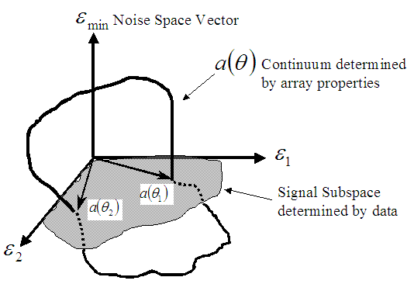
Figure 4- Geometric interpretation of MUSIC for three sensors and two sources [28]. See text for details.
Figure 4 shows a geometric interpretation of the MUSIC solution for the case of two sources and three sensors. Once the covariance matrix of the data is decomposed into its eigen-structure, an estimate of the sources impinging on the array can be done by performing a search with the use of the noise eigenvectors (which are assumed to be the ones with smallest eigenvalues). From (32) we know that the noise subspace is orthogonal to the column span of A (the signal subspace). Sources can then be estimated by looking for the DOA’s with minimum Euclidean norm in the noise’s eigenspace. Note from Fig. 4 that the search of DOA’s is performed on a continuum (i.e., the string $a(θ)$) that is determined by the array properties and calibration. The fact that this search can be computationally intensive, along with the storage requirements of the array properties (if there is no analytic expression), is one of the major criticisms of the MUSIC algorithm [29]. However, at the same time, if space storage is not a concern, MUSIC is very attractive because it can be used in an arbitrary array manifold, where other solutions might require an analytic form of $a(θ)$[28][30].
Two common ways of obtaining the minima (32), are through the root MUSIC and the spectral MUSIC approach, both of which can be used with ULA [8]. Root MUSIC, however is generally preferred for applications with ULA because it does not exhibit loss-of-resolution effects [33]. The general procedure for MUSIC is the following [28]:

- Calculate the eigenstructure of $R_{x}$ in the metric of $S_{o}$

- Decide the number of sources K (notice that there can be several ways to do this as in [19-21].

- Pick the K DOAs that yield the K peaks of the following equation evaluated over all the transfer vector continuum:

$P_{\text{MU}}(θ_{i})=\underset{θ_{i}}{\text{max}}\frac{1}{a∗(θ_{i})E_{N}E_{N^{}}a(θ_{i})}\begin{matrix}\begin{matrix}, & & \end{matrix} & \text{for}\begin{matrix}i=1,2,⋅⋅ & K\end{matrix}\end{matrix}$ (33)

Where $E_{N}$ is a M by N matrix whose N columns correspond the noise eigenvectors $v_{i}$ (which off course, will depend on the data). In terms of the geometrical interpretation of Fig.4, we see that the denominator of (33) is the squared dot product between the noise eigenvectors and the array manifold evaluated at a given DOA. In this sense, we are searching for vectors within the array manifold space that form minimum angles with the noise space (notice that to find an exactly orthogonal vector would require infinite precision/steps in the transfer vector continuum search).
The performance of MUSIC has been studied extensively (albeit in specific conditions) and it seems a top candidates for super resolution DOA estimation methods. More specifically Schmidt and Franks [30] showed that MUSIC is capable of detecting closely spaced sources in practical system hardware with error of only 0.05 degrees (for three sources located within a beamwidth). In addition they also mention that the estimate can be performed with arbitrary array manifolds and with multipath as large as 20 dB (mildly correlated signals, so P is not fully diagonal).
Several statistical measures of performance were also obtained for the MUSIC estimator. Stoica and Nehorai compare the MUSIC estimates with the Cramer-Rao (CR) Bound on the covariance matrix of an unbiased estimator DOA’s for plane waves (with white spatial and temporal noise) [31]. They conclude that MUSIC can only approach the CR Bound if the number of sensors and time snapshots is allowed to increase without limit, with fully incoherent and undamped signals (which are impractical conditions). They also mention that in case of correlated signals in an ULA, an improvement might be observed by using a sub-aperture smoothed covariance matrix. Clergeot and Tressens reached the same conclusion on MUSIC under additive white noise with high SNR, from a time series frequency estimation view [32].
In a different approach, Swindlehurst and Kailath compared MUSIC performance under modeling errors, and an approximation of the CR Bound. In this study it was assumed that the exact covariance matrix was available, but there were random errors in the array transfer vector [33]. They concluded that in these circumstances there were large differences between MUSIC and the approximate CR Bound, and suggested an improved version of MUSIC based on optimal weights. Friedlander also did modeling error studies with MUSIC (with exact covariance matrix available and nonlinear arrays) [34]. He observed particular sensitivity of MUSIC to modeling errors, which nonetheless, might be reduce by increasing array aperture. Just recently, Ferreol et al [34], also performed asymptotic modeling error analysis for MUSIC. They conclude that the MUSIC estimator has a bias that depends on the second-order statistics of the modeling errors [33]. The authors derive closed form expressions for the bias and the RMS errors in MUSIC and show that they do not rely on any assumption on the probability law of the modeling errors. Xu and Buckley also found significant bias in MUSIC at low SNRs (where the MUSIC resolution abilities break-down) or as the correlation between sources increase[25]. In addition, Martin also found bias in MUSIC for ULA when the DOA was close to endfire and under noisy conditions [24]. Therefore CB Bound analysis should take into consideration these biases.
Despite these issues, MUSIC still remains a strong preference for DOA’s, and has been further improved [8] [33]. A big factor of it’s appeal lies on it’s portability to an arbitrary array manifold and sharp estimates (as well as it’s geometric interpretation).

5.Sumary

Array processing was found to be applicable to wide range of fields. Part of the large interest in array processing techniques stems from the fact that it can be approached from a time series frequency estimation view. Thus most spectral estimation and DOA techniques can be interchanged with appropriate modifications. A particularly simple array structure, the uniform linear array (ULA), leads nicely to investigation and development of array processing techniques, some of which can be modified for arbitrary array structures.
The traditional ‘phasing’ (a method of beamsteering), and MUSIC methods were studied. Both methods rely on knowledge of the array transfer vector for DOA estimation. The phasing method is particularly easy to implement and can yield somewhat satisfactory results in conjunction with beamforming techniques (spatial FIR filtering. It has small computation complexity (relative to other techniques), and might be useful for low power consumption devices.
The more advanced MUSIC method can yield greatly improved results compared to phasing. This comes at the expense of more computational time and assumptions on the signal and noise second order statistics. The crucial assumption of MUSIC is that the sources are at most mildly coherent (no pair of sources with full correlation) and independent of the noise. These assumptions allow an orthogonal decomposition of the covariance matrix of the data into signal and noise subspaces. The orthogonality of the spaces allows a search for the sources’ DOAs by looking for minima in the noise subspace.
Statistical and empirical results on MUSIC have established it as a good estimator for DOA’s, albeit some issues with biases and modeling/calibration sensitivity. Under modeling errors, MUSIC performed poorly compared with the CR Bound, but an improved version of it was obtained from the same study. Area for improvement includes computational simplicity, multipath cancellation, and robustness to modeling errors. In the end though, MUSIC and its modified versions are still powerful tools for both array processing and spectral estimation.

[1] S. Haykin, Array Signal Processing, Prentice-Hall NJ, 1985

[2] Z. Yu, M. Er, “An Improved Array Vector Estimation Method and It’s Application in Speech Enhancement,”, EURASIP Journal of Applied Signal Processing, 18, p. 2930-2937, 2005

[3] B. Yegnanarayana, S. Prasanna, R. Duraiswami, D. Zotkin, “Processing of reverberant speech for time-delay estimation,” IEEE Trans. on Speech and Audio Processing, 13 (6), p. 1110- 1118 , 2005

[4] S. Tol, A. Veen, “Applications of Robust Capon Beamforming To Radio Astronomical Imaging,” Acoustics, Speech, and Signal Processing, 2005 Proc. (ICASSP ’05). IEEE International Conference on, 4, p. 1089-1092, 2005

[5] V. Hamacher, J. Chalupper, J. Eggers, E. Fisher, U. Kornagel, H. Puder, U. Rass, “Signal Processing in High-End Hearing Aids: State of the Art, Challenges, and Future Trends,” EURASIP Journal on Applied Signal Processing, 18, 2915-2929, 2005

[6] G. Van Hoey, R. Van de Walle, B. Vanrumste, M. D'Hav, I. Lemahieand P. Boon, “Beamforming Techniques Applied in EEG Source Analysis,” IEEE/ProRISC99, p 545-551, 1999

[7] J. Chen, A. Jaffer, Editorial, EURASIP Journal of Applied Signal Processing, 1, p 1-3, 2005

[8] P. Stoica and R. Moses, Introduction to Spectral Analysis, Prentice-Hall, NJ 1997

[9] T. Bowles, A. Jakobson, J. Chambers, ”Detection of Cell-Cyclic Elements in Miss-Sampled Gene Expression Data Using A Robust Capon Estimator,” Acoustic, Speech, and Signal Processing, 2004. Proc. (ICASSP ’04). IEEE International Conference on, 5, p. 17-21, 2004.

[10] B. Veen, and K. Buckley, “Beamforming: A Versatile Approach to Spatial Filtering,” IEEE ASSP Magazine, p. 4-24, April 1988

[11] J. Cardoso, A. Souloumiac, “Blind beamforming for non-Gaussian signals,” Proc. Inst. Elect. Eng., vol. 140, pt. F, no. 6, p. 362-370, Dec. 1993

[12] R. Lorenz, S. Boyd, “ Robust Minimum Variance Beamforming,”, IEEE Trans. on Signal Processing, 53 (5), p. 1684- 1669, May 2005

[13] W. Brogan, Modern Control Theory, Third Edition, Prentice-Hall NJ, 1991

[14] D. Johnson, D. Dudgeon, Array Signal Processing: Concepts and Techniques Prentice-Hall, NJ 1993

[15] A. Oppenheim, R. Schafer, Discrete-Time Signal Processing, Prentice-Hall NJ, 1999

[16] F. Harris, “On the Use of Windows for Harmonic Analysis with the Discrete Fourier Transform,” Proc. of the IEEE, 66(1), 1978

[17] H. Cox, “Resolving power and sensitivity to mismatch of optimum array processors,” Journal of Acoustic Society of America, 54(3), p. 771-785, 1973

[18] R. Schmidt, “Multiple Emitter Location and Signal Parameter Estimation,” IEEE Trans. on Antennas and Propagation, 34(3), March 1986

[19] J. Fuchs, “Estimating the Number of Sinusoids in Additive White Noise,” IEEE Trans. On Acoustic, Speech, and Signal Processing, 36(12), December 1988

[20] J. Fuchs, “Estimation of the Number of Signals in the Presence of Unknown Correlated Sensor Noise,” IEEE Trans. On Signal Processing, 40(5), May 1992

[21] M. Wax, T. Kailath, “Detection of Signals by Information Theoretic Criteria,” IEEE Trans. On Acoustic, Speech, and Signal Processing, 33(2), April 1985

[22] Y. Bresler, A. Macovski, “On the Number of Signals Resolvable by a Uniform Linear Array,” IEEE Trans. On Acoustics, Speech, and Signal Processing, 34(6), December 1986, p. 1361- 1375

[23] A. Paulraj, T. Kailath, “Eigenstructure Methods for Direction of Arrival Estimation in the Presence of Unknown Noise Fields,” IEEE Trans. On Acoustic, Speech, and Signal Processing, 34(1), February 1986

[24] G. Martin, “Degradation of angular resolution for eigenvector-eigenvalue (EVEV) high-resolution processors with inadequate estimation of noise coherence,” Acoustics, Speech, and Signal Processing, IEEE International Conference on ICASSP ’84, V9, p. 758-761, March 1984

[25] X. Xu, K. Buckley, “Bias Analysis of the MUSIC Location Estimator,” IEEE Trans. On Signal Processing, 40(10), p. 2559-2569, October 1992

[26] B. Rao, K. Hari, “Weighted Subspace Methods and Spatial Smoothing: Analysis and Comparison,” IEEE Trans. On Signal Processing, 41(2) p. 788-803, February 1993

[27] B. Rao, K. Hari, “Effects of spatial smoothing on the performance of MUSIC and minimum-norm method,” IEEE Proc. , 137(6), p. 449-458, December 1990

[28] R. Schmidt, “ Multiple Emitter Location and Signal Parameter Estimation,” IEEE Trans. On Antennas and Propagation, 34(3), p. 276-280, March 1986

[29] R. Roy, T. Kailath,”ESPRIT- Estimation of Signal Parameters Via Rotational Invariance Techniques,” IEEE Trans. On Acoustic, Speech, and Signal Processing, 37(7), July 1989

[30] R. Schmidt, “Multiple Source DF Signal Processing: An Experimental System.” IEEE Trans. On Antennas and Progation, 34(3), p. 281-290, March 1986

[31] P. Stoica, A. Nehorai, “MUSIC, Maximum Likelihood, and Cramer-Rao Bound,” IEEE Trans. On Acoustics, Speech, and Signal Processing, 37(5), p. 720-741, May 1989

[32] H. Clergeot, S. Tressens, and A. Ouamri, “Performance of High Resolution Frequencies Estimation Methods Compared to the Cramer-Rao Bounds,” IEEE Trans. On Acoustic, Speech, and Signal Processing, 37(11), p.1703-1720, November 1989

[33] L. Swindlehurst, T. Kailath, “A Performance Analysis of Subspace-Based Methods in the Presence of Model Errors, Part I: The MUSIC Algorithm,” IEEE Trans. On Signal Processing, 40(7), p. 1758-1774, July 1992

[33] A. Ferreol, P. Larzabal, M. Viberg, “On the Asymptotic Performance Analysis of Subspace DOA Estimation in the Presence of Modeling Errors: Case of MUSIC,” IEEE Trans. On Signal Processing, 54(3), March 2006

[34] B. Friedlander, “A Sensitivity Analsysis of the MUSIC Algorithm,” IEEE Trans. On Acoustics, Speech, and Signal Processing, 38(10), p. 1740-1751, October 1990

