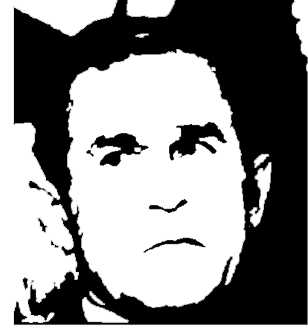  This Man IS the wrong vision for The United States of America.  Join us at a  Rally to Recall George W. Bush  Monday, November 3rd, 2003  Noon, Illini Union South Patio  Sponsored by Illinois Federation of College Democrats, UIUC College Democrats,  HELP TAKE OUR COUNTRY BACK | This Man IS the wrong vision for The United States of America.  Join us at a  Rally to Recall George W. Bush  Monday, November 3rd, 2003  Noon, Illini Union South Patio  Sponsored by Illinois Federation of College Democrats, UIUC College Democrats,  HELP TAKE OUR COUNTRY BACK
This Man IS the wrong vision for The United States of America.  Join us at a  Rally to Recall George W. Bush  Monday, November 3rd, 2003  Noon, Illini Union South Patio  Sponsored by Illinois Federation of College Democrats, UIUC College Democrats,  HELP TAKE OUR COUNTRY BACK | This Man IS the wrong vision for The United States of America.  Join us at a  Rally to Recall George W. Bush  Monday, November 3rd, 2003  Noon, Illini Union South Patio  Sponsored by Illinois Federation of College Democrats, UIUC College Democrats,  HELP TAKE OUR COUNTRY BACK

