
A Publication of the Calumet Chapter of the Institute of Management Accountants (IMA) (a group for anyone with an interest in accounting or finance serving Northwest Indiana and Southern suburbs of Chicago)
CALUMET ACCOUNTANT

www.geocities.com/imacalumet
Volume 65 No 1 June 2009

What you May Have Missed

On Tuesday May 19, 2009 The Calumet Chapter of the IMA gathered at Gino’s Steakhouse in Dyer Indiana for the Chapter Year End Celebration. On this night spouses, and guests were invited and the Chapter filled the room at Gino’s. The topic for the Chapter Year End Celebration was “Life is a Journey Will you have a Smooth Ride or Bumpy one?”

It was presented by Leanne Hoagland Smith , President of Advanced Systems. Leanne’s book Unlocking Sales Results: The Keys to Becoming the Red Jacket in a Sea of Gray Suits Unlocking Sales Results: The Keys to Becoming the Red Jacket in a Sea of Gray Suits was released earlier this month. You can learn more about the book or the speaker by visiting http://www.processspecialist.com

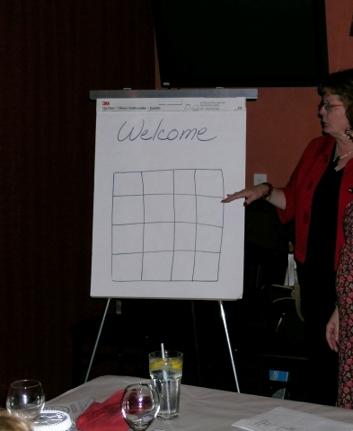

The main focus of the presentation was to help you have a smooth ride through life. Above you can see Leanne in the red jacket. The question is how many squares do you see on the paper? There was some audience participation to make sure that we could see more than 17 in fact many more. Do you see all the squares?

What you May Have Missed (Continued)
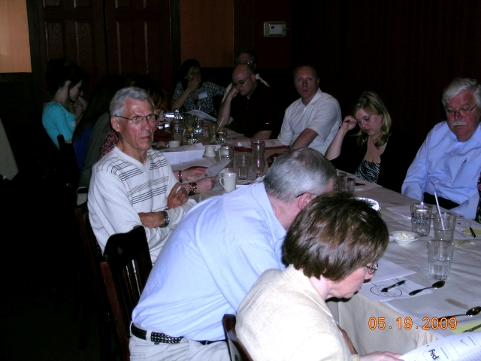

The group listened attentively as Leanne indicated there were three key things to help you have a smooth ride: Keep an open Mind, Accept Change, and Take Action. It was stressed the importance of writing things down. Most of the group indicated that a grocery list had some value yet most of the group had not taken time to write their life goals down.

We thank Leanne Hoagland Smith for Speaking at the Chapter Year End Celebration and we hope her book sells well. Leanne also has a column which is available online every Monday. You can subscribe to it by visiting http://www.processspecialist.com

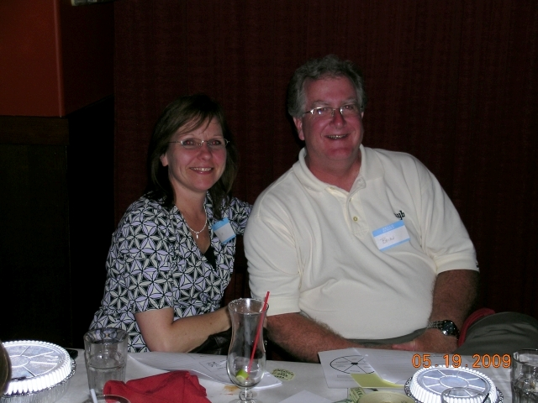

Calumet Chapter IMA Thanks our 2008-2009 Sponsors

Wermer, Rogers, Doran and Ruzon Certified Public Accountants home to our very own Howard D. Ellison, CMA, CPA, CVA http://www.wrdr.com

Miss Print Full Service Print and Sign Co.- http://www.missprintusa.com

Tranzact Technologies Inc. Logistics Management Solutions- home of President Mark T. Camarena, CMA http://www.tranzact.com

Supply Chain Edge LLC Cost Savings and Process Improvement Accelerators http://www.supplychainedge.com

Krieg Devault Attorneys at Law home to our very own J. Brian Hittinger, who practices general business and estate planning. http://www.kdlegal.com To contact Brian directly call 219.227.6114 or e-mail jbhittinger@kdlegal.com



President’s Message
By Mark T. Camarena, CMA

Dear Friends:

I want to thank you for your support during the Calumet Chapter’s 64th year. I believe it was a very successful year. At the beginning of the year we started with 72 members and at the conclusion of the year we had 96 members. Hopefully, in 2009-2010 we will surpass the 100 member mark. The success that the Chapter enjoyed this year was because of many people especially those of you who were able to attend the monthly meetings. We were very fortunate to have the support of Governor’s State University, Indiana University Northwest, Purdue University Calumet, and Valparaiso University in not only having academic members but encouraging their students to attend.

I am grateful to the board for their support and extremely glad that each and every one of them has decided to return to the board for the Chapter’s Historic 65th year in 2009-2010. For those of you who attended meetings later in the year you will recognize our director of special activities Brian Guse on the bottom right hand column. Special activities helped keep the Chapter afloat this year.

You know that I could continue on for a very a long time as there are so many people to thank. However, the light is flashing like at an awards show indicating I should wrap it up. Therefore, I have one last very important group that I must thank as we hope to count on their support in 2009-2010 and those are the 2008-2009 sponsors of the Calumet Chapter of the IMA. The best way to thank them is by utilizing their services and let them know you know about them because of their association with the Calumet Chapter of the IMA.

Robert Half International- http://www.accountemps.com or http://www.roberthalf.com

The Valpo MBA- http://www.valpo.edu/mba

Page 2

New Chapter Website Coming Soon

Earlier this year geocities which currently hosts the chapter website indicated they would be closing by the end of this year. This means the Chapter will have to find a new service to host the website so it will be moving. Geocities was a free hosting service and as such it did not allow advertising that was not provided by geocities on the website which for the time being will remain at http://www.geocities.com/imacalumet

It appears the Chapter will have to incur a monthly fee to host the website. However, if the Chapter does so it will be able to place advertisements on the website. Personally I have moved my website to yahoo web hosting which has all the tools of geocities and then some. The Chapter will therefore be looking for sponsor/or sponsors for the website so if you know any companies that may be interested please let us know.

Also, if someone would like to design the website and use it for their resume or an example of the service they could provide we would welcome such a partnership please watch the newsletter for more information about this issue.
Save the Date!
IMA's 10th Annual Student Leadership Conference
St. Louis Union Station Marriott – St. Louis, MO
November 5-7, 2009
In the current tough economy, it is more important than ever to develop the knowledge and skills you’ll need to land that first job! What are you doing to improve your credentials and create a competitive advantage? Join IMA at its 10th Annual Student Leadership Conference, and learn how to position yourself for future success. The Conference will be held at the St. Louis Union Station Marriott in St. Louis, Mo., on Nov 5-7, 2009.
As in past years, students will have an excellent opportunity to network with accounting and finance professionals, fellow students, and educators from across the country. Learn from the experts about management accounting career opportunities, the value of the Certified Management Accountant (CMA®) certification, leadership, ethics, forensic accounting, professional etiquette, and more. The Conference agenda is currently in the planning stages and will once again feature leading practitioners and professors as presenters. Students should bring a current résumé to provide to Conference sponsors and exhibitors as they are eager to find top talent for their organizations.

Please Consider Supporting the Calumet Chapter of the IMA

The prices for ads in the 2009-201 Roster Book are as follows:
Full page ad $150.00
Half page ad $100.00
Business card ad $75.00
Sponsorship Listing (this is a listing in the roster book with no ad) $25.00
The Back Outside, Front Inside, and Back Cover are available at a slightly higher price. The ad sizes can be modified from just about any size; the final ad sizes appear in the book as 3 1/2"(w) by 8"(h) or smaller, depending on content and layout of the ad
Ad sales for 2009-2010 roster books have already begun and we want to have all sales finalized by the end of July. The 2009-2010 GOAL IS TO SELL $1,500 worth of advertising in the roster book. This is a very aggressive goal but it can be achieved with your help. Last year we sold $1,000 worth of advertising. These funds were used to cover the cost of printing and to offer Member Appreciation nights and reduced pricing for college students.
The Chapter DOES accept prepayments for advertisements, checks should be made to IMA-Calumet Chapter, but that is not required once the roster books are printed an invoice will be sent out and Due upon receipt. If a company would simply like to make a donation there will be a page that indicates “We Thank the following sponsors for helping defray the cost of the 2009-2010 roster. For more information please feel free to contact myself markt@550acces.com or 630.530.6707 or Warren Cebulko who has done a stupendous job on these roster books for the last several years wcebulko@yahoo.com .
Calumet Chapter on Linkedin

The Calumet Chapter with the help of Lance Werner has formed a group on Linkedin look to receive an invitation to join the group later this month. One of the suggested topics in 2009-2010 is utilizing linkedin. Maybe we can all learn about it together.


Page 3

Calumet Chapter
2009-2010
Officers and Directors

President Mark T. Camarena 630.530.6707 (W) markt@550access.com
Secretary Jim Spice 815.933.0491(W) jaspice@citykankakee-il.gov
Treasurer Deb Heim 630.378.6308 (W) debra.heim@patterson_medical.com
VP Administration Adolph Ferber aferber@att.net
VP Communications Richard Mielcarz 708.799.6234(H) mycarz17@aol.com
VP Professional Education Bill Biller biller6625@comcast.net
VP Membership (Retention) Anthony Fontana 708.534.5000 ext 5434 (W) a-fontana@govst.edu
Academic Relations Wes Christensen weschristensen@comcast.net
New Members Richard Mielcarz 708.799.6234(H) mycarz17@aol.com
Director of Employment Al Zurawski 219.477.4488 ext 222 (W) al@okaya.com
Chapter Photographer Al Zurawski 219.477.4488 ext 222 (W) al@okaya.com
Director Program Rosters Warren Cebulko wcebulko@yahoo.com
Director of Manuscripts Bruce Flowers 219.322.2300 (W) bruceflowers@yahoo.com
Director at Large Brian Guse 219.362.1531(W) bguse@nyb.com

.

We are very excited to have the entire board back for 2009-2010. However, we still have room for you as many board members are holding multiple positions. We would really like to see a group of individuals that will help us call and remind members of the meetings, and we are looking for some of the college students to give us their thoughts on what sort of programs they have found useful or would like to see us have in the future.

The First Summer board meeting will be Thursday June 18, 2009 at 6:30 p.m. at Gino’s Steakhouse 1259 W Joliet Street (US 30) Dyer IN. Everyone is welcome to attend and help us plan our upcoming Historic 65th year.

Directions: From Indiana take US30 West to the Intersection of US30&US41 (Indianapolis Blvd) (The Krieg Devault Building) continue straight approximately 1.5 miles. Gino’s Steakhouse will be on your right. If you come to Jewel you have gone to far.

From Illinois take 294S (portions toll) to IL394 S (toward Danville) to Glenwood Dyer Road exit (take a left at the exit) Glenwood Dyer Road will become US30 continue straight. You will see St. Margaret Mercy on the right. Continue straight for just slightly over a mile Gino’s Steakhouse will be on your left.

