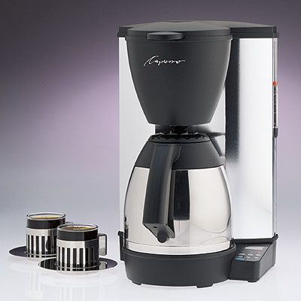
Coffee makers are an excellent example of a product protected by copyright.

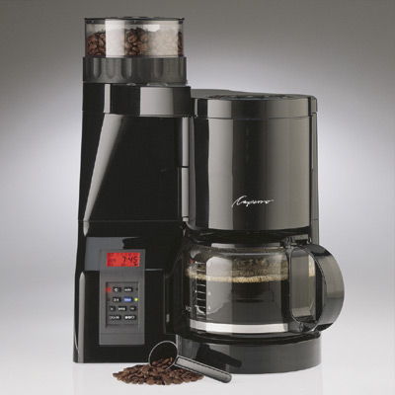

Coffee makers come in various
designs, copyrighted by the
manufacturer to protect their
investment.

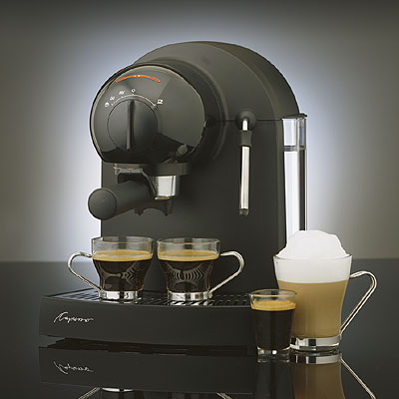
Espresso machines and other products are additional manifestations of the same idea. Although similar, we are still able to develop similar products as a result of Fair Use.

One can easily make coffee makers, espresso machines, and other related products, that are similar to the products of a rival, given they respect the mandate that they will not copy the actual design of a rival.

By studying the design of a coffee machine already in use and borrowing certain elements of its design, a company would be engaging in copyright infringement. The company might hear of the infringing party’s actions by an e-mail from a third-party or they might simply discover it themselves.

“A local photographer has told you that the slide shows you create of family events look so professional, you should consider going into business. You add perfectly timed music accompaniments, using songs from your vast music library, all of which you’ve purchased. You’ve created a Web site and want to use a couple of your slide creations for your portfolio. Is this OK? Why or why not?”

It is not alright. The laws governing music are very strict: you do not own the music, you own only a copy of it; you may only have two or three copies of the music for your own access; it is absolutely not permissible to use the music in a derivative work without permission.

Card Reader
Driver
Interlacing
Fields
Camera Raw
PNG
Vision Set
Hand Tool
Crop Tool: Lets you remove the unwanted portions of an image that surround the subject.

Bounding Box: A selection area that defined the part of the image that will remain after you complete the crop

