Camera Comparison
 |  | Panasonic GS-35 | Sony DCR HC 32E
 |  | 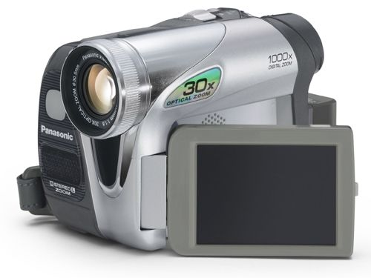 | 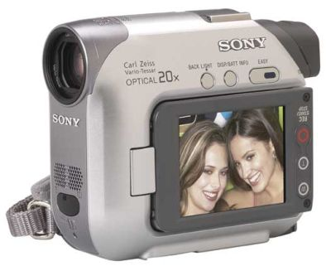
 | Price | Rs. 18000 (this is cheaper) | Rs. 21000
 | Lens type | Panasonic | Carl Zeiss Vario Tessar (this is a much better lens)
 | Zoom | 30x Optical, 1000x Digital (the zooming power is much more) | 20x Optical Zoom, 800x Digital Zoom
 | Effective movie pixel | 400000 (they are same) | 400000
 | Effective still pixel | 307200 | 400000 (this has better resolution for still photos but general digital cameras has more resolution – starting from 20,00000)
 | Memory stick | Has slot (Rs. 800 for 128 KB) | Has slot (Rs. 1000 for 128 KB)
 | Battery charger | If a second one is needed later, is available at market | Not available at market
 | Operation | All function are manual to be used through switch and buttons | Apart from recording which is through switch, all the complex operations are through touching the LCD screen.
 | Minimum Illumination | 2 lux | 0 Lux (during the NightShot Plus Function and you can capture picture even at the dark with the infrared)
 | LED Video Light | Yes (will help you in shooting at low light condition for close objects) | No
 | Other opinion | Though Sony sells more that Panasonic (10:6) the shops are saying that there is not as such problem with the Panasonic but some of the professionals are insisting on buying a Sony (may be for obvious reason or just because they always use Sony)

