Edward De Bono’s Six Thinking Hats (3a)

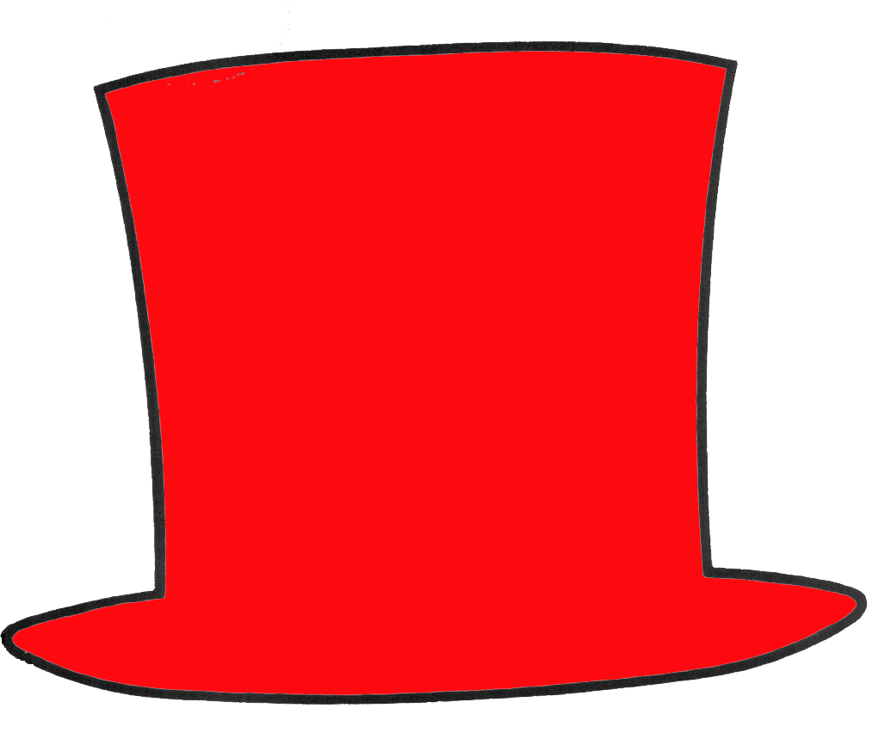  Red Hat - Feelings | What are my feelings about this? (Emotions, hunches and intuition)
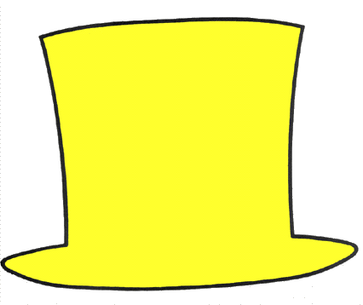  Yellow Hat - Strengths | What are the good points? (Positive thinking)
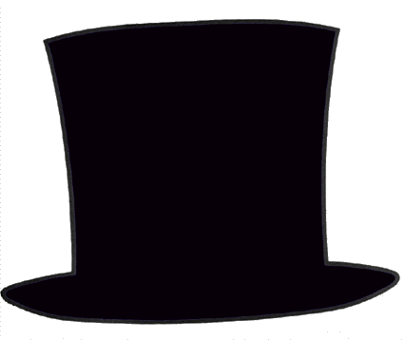  Black Hat - Weaknesses | What is wrong with this? (Negative aspects)
  Green Hat – New Ideas | What is possible? (Creativity, new ideas)
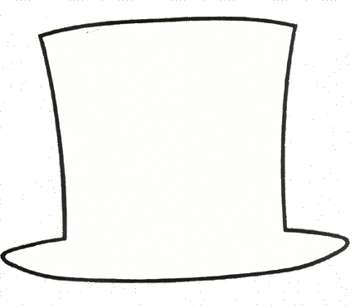  White Hat - Information | What are the facts? (Objective, neutral, facts)
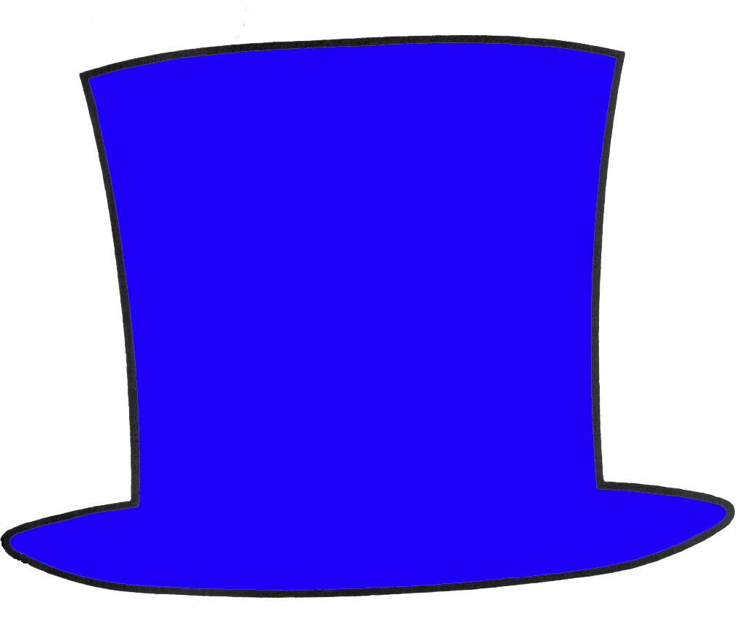  Blue Hat – Thinking | What thinking is needed? (Organising the thinking, summarising your thoughts)

