Prepared for the Conference: Water Resources & Environmental Problems in Karst, Beograd & Kotor,
Serbia & Montenegro, 14-19 September 2005.

Vulnerability of Ground Water in the Karst of Jamaica

Author: Dr. Jasminko Karanjac, Consultant Hydrogeologist and Professor (ret.)
e-mail: karanjac@eunet.yu

ABSTRACT

The White Limestone Formation underlies about 60% of Jamaica. Jamaica is also well known for its “Cockpit Country” – an easily recognized pattern of round-top hills and depressions with internal drainage. White Limestone is in many places karstified; its aquifers are covered with thin soil layers that do not offer much protection against surface pollution. Pollution comes from agricultural practices bringing nitrates into the subsurface, seawater intrusion into coastal aquifers due to the heavy demand by population and over pumping (urban, industrial and agricultural), and by the processes of refining bauxite into alumina. A rather obscure by-product, dunder, of sugarcane distillation into the famous Jamaican rum contributes also locally to contamination. Tourism, the prime-earning sector, also places a burden on fragile coastal environment.

The paper presents ground water resources development issues with an emphasis on contamination and vulnerability of the resource in karstic environments.

- Introduction

Water, water everywhere! These were presumably the words Christopher Columbus shouted when his ship landed in Jamaica in 1494. Today, it appears that Jamaica, which has an area of 10,991 sq.km, may have problems developing enough good-quality water for its population of just over 2.7 million. It is the same problem experienced by many Caribbean islands. The “key phrases” in water resources management in Jamaica are vulnerable karstic aquifers, ground water contamination, seawater intrusion, irregular and unpredictable rainfall pattern, population mostly concentrated along the coast, some of these interrelated or resulting one from the other.

Jamaica is well known for the type locality of the so-called “cockpit” geomorphology (Cockpit Country), which occupies less than 4% of the island (430 sq.km). However, the White Limestone Formation of the Tertiary Age covers about 60% of the island (over 6,000 sq.km). In great many parts this limestone is karstic. Most important aquifers are contained in the White Limestone.

Ground water accounts for about 84% of all available water. Ground water also accounts to some 92% of all used water. The current production of water falls short of demand. Jamaica is looking into other non-traditional ways to offset the shortage of water.

Seawater intrusion in both alluvial and limestone (karstic) aquifers is a serious problem. The Metropolitan Kingston and many developments along the coast depend on good-quality and sufficient supply of ground water. The refining of bauxite into alumina and the discharge of caustic waste into mined out unsealed limestone pits has locally contaminated karstic aquifers. Irrigation of sugarcane fields overlying limestone aquifers and uncontrollable use of fertilizers rich in nitrogen pollutes ground water as well. Yet, it is difficult to distinguish between agriculture-supplied nitrogen and soakaway sewage disposal systems; the latter are believed to contribute most of the nitrates into the karstic aquifers.

Good points in water resources management are (a) well established legal framework and well managed institutions dealing with water resources, (b) monitoring ground water quality and water levels, and creating ground water databases and information systems, (c) well established and enforced system of permits, licenses and quotas, (d) post-graduate education at the University of the West Indies (UWI), and (e) overall understanding of the fact that water is a commodity that should be paid for.

- Ground Water In Jamaica

Figure 1 is a map showing the hydrostratigraphic units of Jamaica. Limestone (light blue) is the White Limestone Formation, which in places is reported to be as much as 700 m thick. Figure 2, prepared by The Nature Conservancy (TNC), shows numerous springs, caves, sinkholes, and other features typical of a karstic environment.
Exploitable ground water is estimated at 3,420 MCM (million cubic meters) annually, surface water about 670 MCM, and the total is close to 4,100 MCM per year. It appears that Jamaica has about 1,500 m³/yr for each inhabitant. Although it may be sufficient, this rate ranks Jamaica as a water-stressed country according to the UN criteria for water availability (“water-scarce” country is one with less than 1,000 m³/yr per capita, and “water stressed” country has less than 2,000 but more than 1,000 m³/yr per capita). Actually, currently Jamaica is using about 1,000 MCM each year.
The use of the water in the past, and the projected use for the year 2015, shows that agriculture is the major water consumer. Near the end of the last century the share of agricultural use (sugarcane, bananas, and vegetables) was 75% expecting to increase to 79% by 2015.
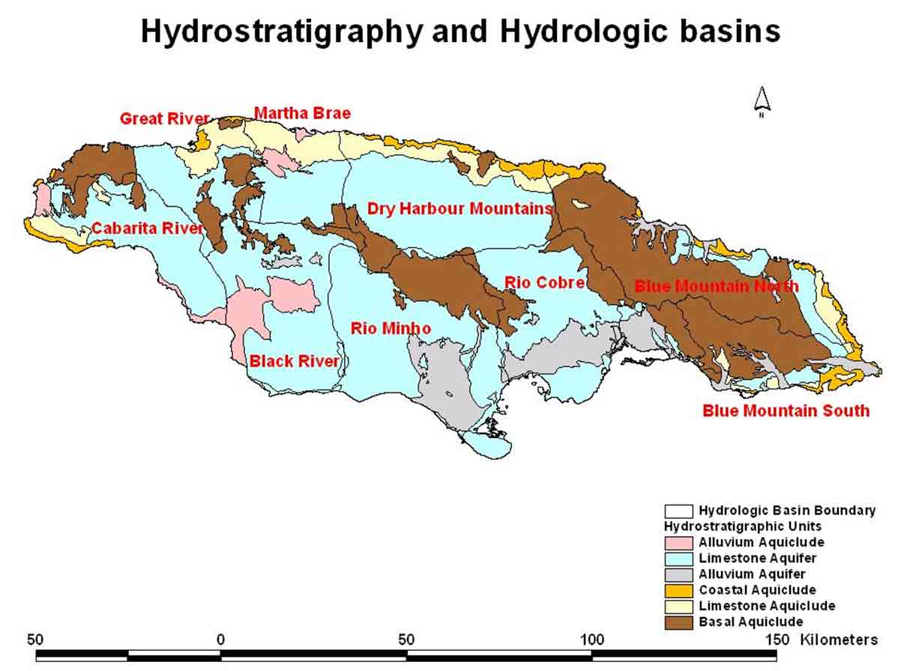

Figure 1. Hydrostratigraphic Units (after WRA).

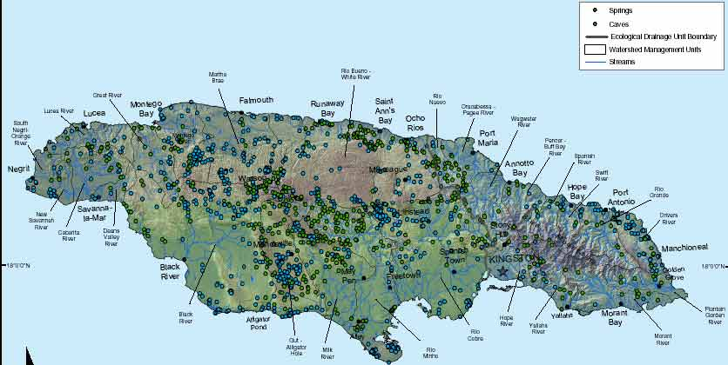

Figure 2. Springs and Caves in Jamaica (after TNC).

Both alluvial and limestone aquifers along the south coast are overexploited. As a result the piezometric surfaces along the coast are very low, almost flat, and in places the dynamic levels are below the sea level.

Ground water is exploited by wells. The Water Resources Authority (WRA) records point at some 1,500 wells drilled to tap the limestone and alluvial aquifers. WRA maintains computerized databases from which data and information are easily retrievable. Working in Jamaica between 2000 and 2004, the author of this paper has established a Ground Water Information System (GWIS) using data from WRA’s databases. The satellite map in Figure 3 locates some 1000 wells and springs.

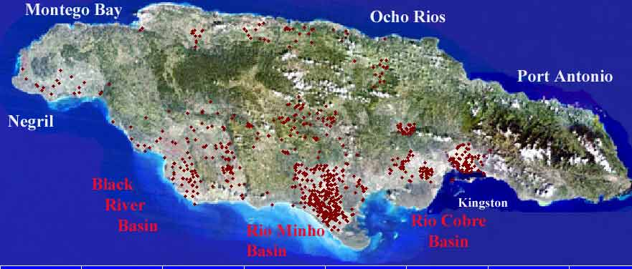

Figure 3. Satellite Image of Jamaica with about 1000 Wells.

The wells are mostly along the south coast, and the springs are in the interior at the higher elevations. The concentration of wells in rather small areas and the nature of water-bearing formations (limestone, karstic, fractured, closeness to the sea, thin top soil cover, etc.) have raised the questions of vulnerability of aquifers, primarily the ones developed in limestone rocks.

- Vulnerability Of Aquifers And Ground Water Contamination

General Considerations. Increasing population, agriculture and industry competing with domestic demands for ground water, closeness to the sea, karstic nature of the limestone aquifer, all these pose a threat to ground water in limestone and alluvial aquifers of Jamaica.

General Vulnerability Criteria in Jamaica. Below are listed some of criteria that define ground water vulnerability in Jamaica:

- Seawater intrusion: closeness to the coast, intrusion already advanced, over development of ground water.
- Soil cover: thickness, permeability, filtration and sorption capacity.
- Land use: agriculture with fertilizers (nitrates, phosphates, etc.).
- Disposal of sewage via soakaway pits into the limestone.
- Depth to ground water.
- Ground water gradient, velocity of flow, residence time.
- Alluvial deposits near rivers, rivers recharging aquifers, local cones of depression created near rivers.
- Industrial developments, waste water ponds, industrial canals.

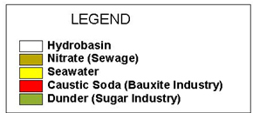
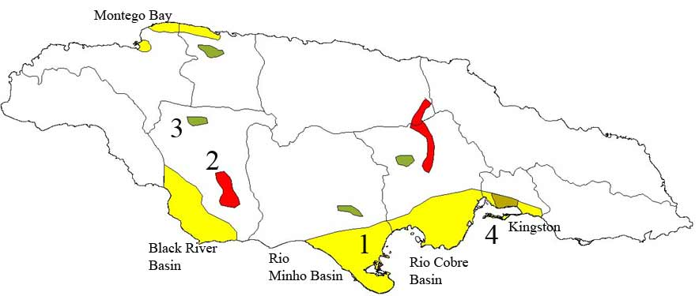
Some wells have been abandoned due to increased salinity (1 and 4 in Fig. 4); others produce water of such a quality that it is unsuitable for agricultural use. Industrial waste ponds with water enriched with sodium and metal impurities from the bauxite-to-alumina refining process (2 in Fig. 4) are located in highlands over limestone layers capped with thin soil layer. Dumping of industrial waste from rum distilleries into the surface and subsurface is a known practice that contaminates karstic aquifers and fouls surface water. Figure 4 points at the localities in which ground water quality has been already impaired. These are the most vulnerable areas in Jamaica. The map in Figure 4 was created by WRA.
Figure 4. Contaminated areas. Source WRA.

Seawater intrusion. The Water Resource Authority of Jamaica has calculated that the degradation of water quality has resulted in the loss of some 100 million cubic meters annually, which is about 10% of all currently used ground water, primarily as a result of overabstraction that led to seawater intrusion. An additional 15% of fresh ground water is being affected by the same process but continues to be used for restricted purposes. Many production water wells in the south are no longer pumped and many sugarcane fields have been abandoned. In the Rio Minho and Rio Cobre areas (central-southern part; 1 in Fig. 4) the increase in salinity is being observed at distance more than 10 km from the coast. However, one should point out that the saline intrusion along the south coast occurred prior to the 1961 period when the control of licensing was introduced onto the island. Since then the moratorium on new abstraction has reduced the salinity levels and the saline front has been pushed back several kilometers.

Bauxite processing. An increased content of sodium (Na) in water wells in the Essex Valley, which is located within the eastern area of the Black River Basin, (2 in Fig. 4), is a cause of concern for the usability of good quality ground water for domestic uses. The contamination results from leaky industrial waste ponds, known as mud lakes, which were created as recipients of red mud waste from the bauxite-to-alumina processing. The lakes are “sitting” at an elevation of about 160 m AMSL over very permeable, fractured and karstified limestone rocks. One “active” mud lake is shown in Figure 5. Its “dried-up” part is shown in Figure 6.
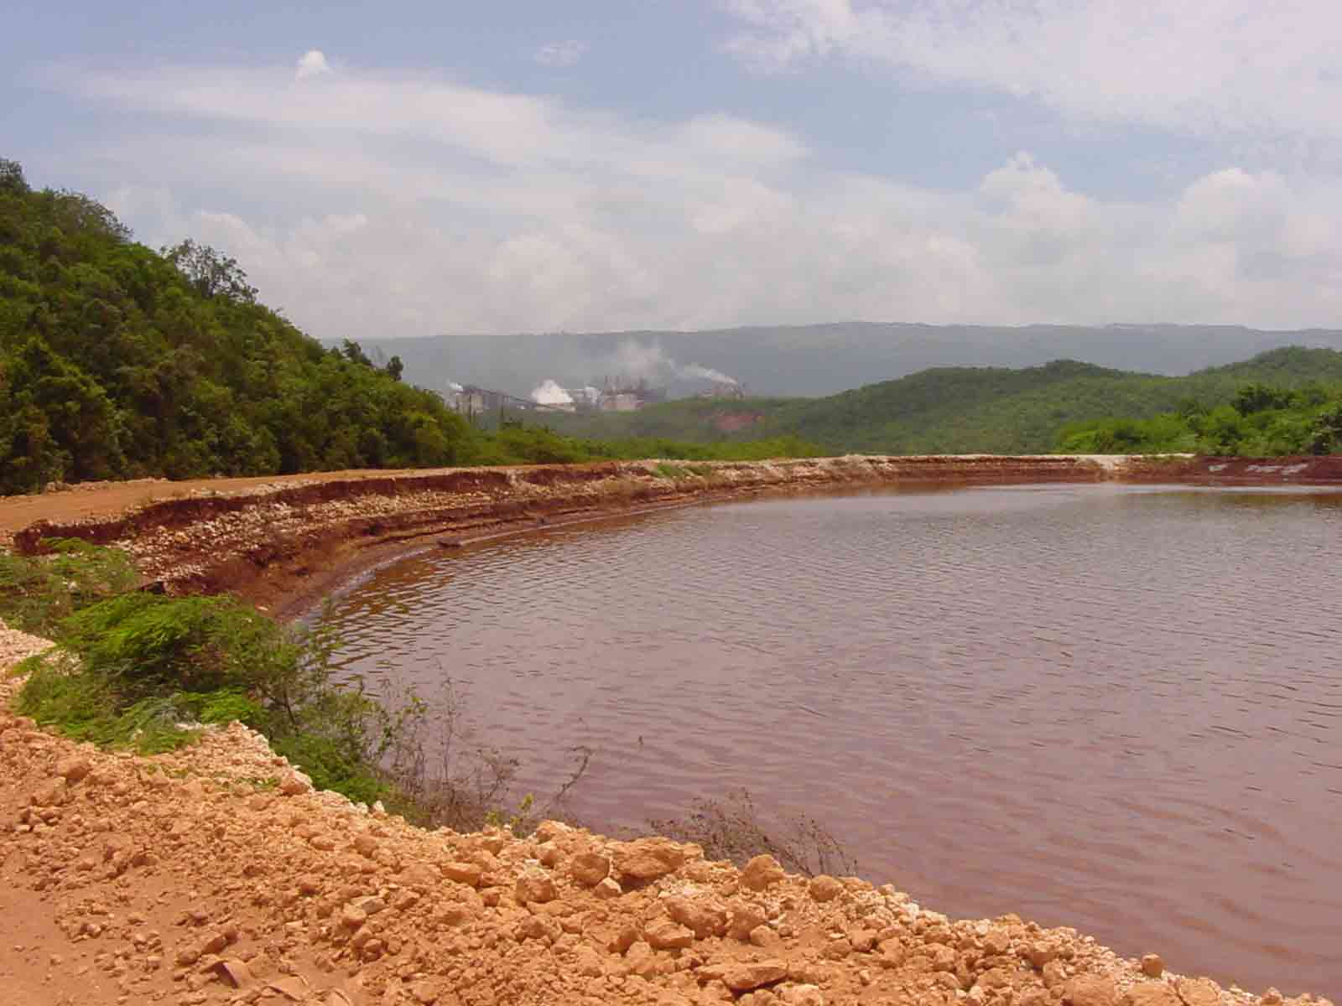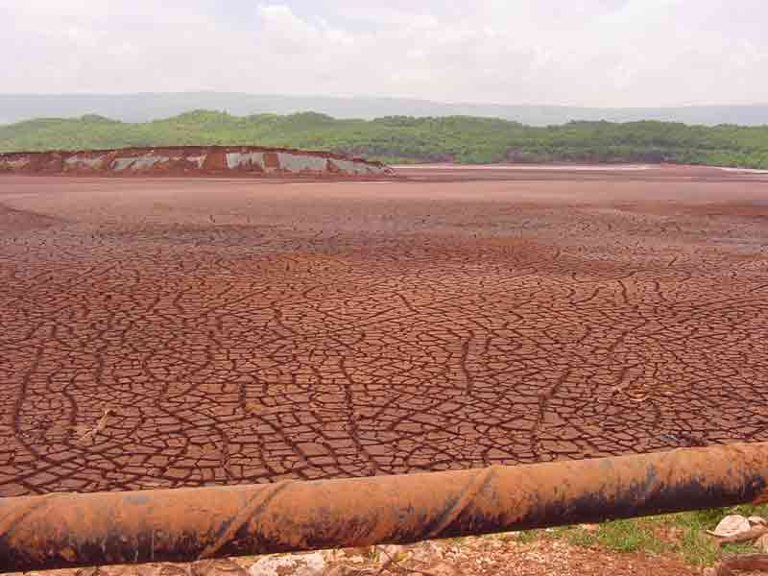
Figure 5. Mud lake in Essex Valley, Jamaica. Figure 6. Mud lake in "dried-up" conditions.

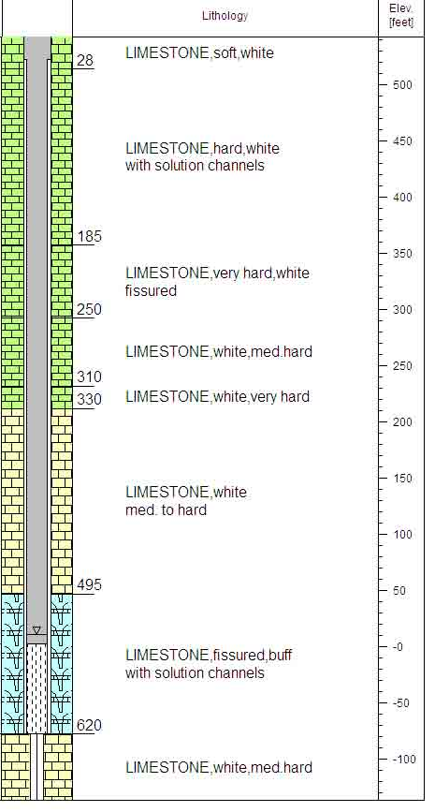
Lithological logs of wells within the area affected by Na contamination show karstic features down to several hundred meters. Notice cavities in Figure 7 at depths down to 620 ft (189 m).
The GWIS of Jamaica comprises hundreds of wells monitoring water quality with time. Within the Essex Valley alone, there are more than 20 monitoring wells. The time series of sodium for water in the well BR-075 from Figure 7 is shown in Figure 8.
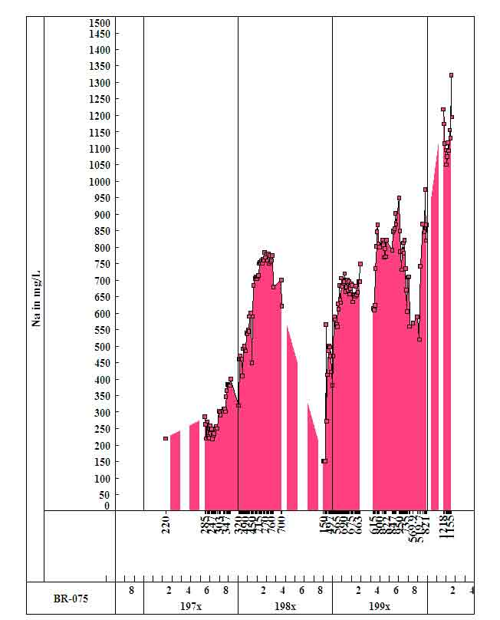
Figure 7. Lithology at Alpart 5 (BR-075) Figure 8. Sodium in ground water at BR-075

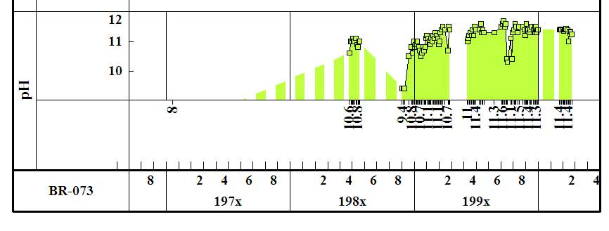
The drop of Na in mid 1980’s coincides with the period of closure of the refinery. The rise of sodium from a background value of several tens mg/L (1960s) to over 1,400 mg/L in 2003 is the result of use of NaOH and Na₂CO₃ in the processing of bauxite. The time series of pH value, which is another indicator of contamination, is shown in Figure 9 for another well. Notice the values as high as 11.6.

Figure 9. pH value in limestone aquifer at BR-073.

This is a well-known case of contamination by sodium. While sodium is not a “dangerous” contaminant (at least if its content is within the WHO’s recommendation of 250 mg/L), the presence of other metals in wastewater after bauxite is processed, such as As, Cd, Al, Fe, Zn, etc. may be of concern if detected above maximum permissible concentrations (MPC). Several mathematical models were made, some of them by this author. The importance of understanding the vulnerability of this karstic environment lies in the fact that not far from the waste ponds is the source of supply for the town of Mandeville (nicknamed “the bauxite capital of the world”). Models did show that the plume with sodium and eventually associated impurities would not reach the wells supplying Mandeville. Sodium, used as a tracer, points at “karstic” velocities of ground water flow, of several hundred meters per day. The Na plume would have propagated far away from the waste ponds had it not been for “scavenger” wells at the plant that have reclaimed and recirculated the major part of the contaminant.

Contamination by dunder – waste product of rum distillation. Jamaica is famous for its rum. Many people are fond of the prime Jamaican brand, the Appleton rum. Yet, distillation of sugarcane to produce rum leaves behind dunder – a juicy, foul smelling waste that is freely discharged through sinkholes into karstic systems reaching surface creeks and rivers (3 in Fig. 4). The effect of discharge of dunder is being monitored by WRA. Color, odor, phosphates, pH values, etc. are some of issues of ground water contamination.

Nitrates in ground water. Nitrates pose a problem in agricultural lands along the southern coast of Jamaica. Ground water in both alluvial and limestone aquifers is affected (1 and 4 in Fig. 4). The elevated concentration of nitrates come from the use of fertilizers and manure as an agricultural practice primarily in sugarcane fields. In urban areas, the “culprit” is the sewage disposal that is accomplished via septic tanks, soak-away pits, and pit latrines. Permissible level of nitrates (as nitrogen) is 10 mg/L, but in some wells concentrations many times that much are encountered.

Heavy metals in Jamaican soils. This is a controversial issue. Although high concentrations of arsenic (As) and cadmium (Cd) in soils overlying limestone have been detected, as shown in Figure 10, there is no proof that either of these metals has reached ground water in limestone aquifers. The elevated distribution of arsenic in soils coincides with the distribution of the White Limestone Formation.
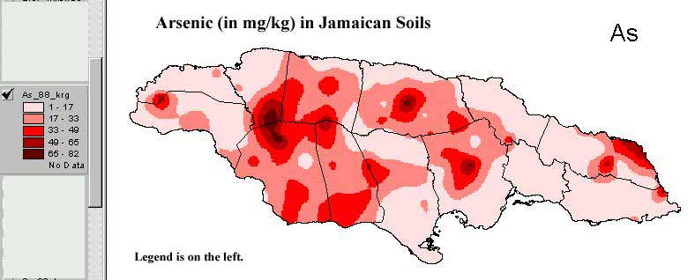
Figure 10. Arsenic in Jamaican soils.

The levels of cadmium is some Jamaican soils have been found by ICENS (International Centre for Environmental & Nuclear Studies, UWI, Jamaica) to be extremely high compared to other countries (Jamaican mean 20 mg/kg vs. world mean of 0.5 mg/kg). The soils with the highest levels (max about 900 mg/kg) are located in central Jamaica. The White Limestone group underlies soils with high Cd, As, etc. About 40% of Cd is bioavailable and could enter the food cycle. White Limestone is very transmissive, in places karstic, and allows for rapid circulation of infiltrated rainwater. What if the rainwater percolating through bauxitic soils picks up some heavy metals, dissolves them and carries down to aquifer?

This author initiated the study of vulnerability of ground water to heavy metal contamination in the summer of 2004 under the grant by the UWI. This is an on-going study by his former students and results are not yet made available.

- Ground Water Information Systems (GWIS)

A Ground Water Information System is both a database that contains and provides access to inventory information about drilled sites, wells, test holes, springs, lakes, reservoirs, ponds, excavations, and water-use facilities, and an information system with field and laboratory data turned into information. To be a real decision-making tool, a GWIS needs to be well integrated, and comprehensive, with field data and information checked, validated, processed and brought up-to-date.

The database, along with various thematic maps, cross sections, time- and depth-diagrams, makes an object-oriented information system which lends itself to analysis, assessment, interpretation, presentation and reporting. In Jamaica, the GWIS with over 1000 wells has been established with data such as lithology, water quality, repeated sampling (time series), water levels, abstractions, etc. Portions of the overall GWIS have been uploaded to the Internet:

www.geocities.com/kkaranjac - The Rio Minho Basin
www.geocities.com/briver2000 - The Black River Basin

The GWIS of Jamaica points at some parts of the country in which aquifers are vulnerable to either seawater intrusion, domestic and/or industrial pollution.

A recently produced CD titled “Water Resources of the Caribbean Countries and Territories” features 33 countries of the Caribbean basin. Jamaica case is uploaded to the Internet at the site www.geocities.com/watercaribbean.

- CONCLUSIONS

The WRA of Jamaica is very much aware of the predominantly karstic nature of its island and fragility of the limestone environment. The WRA monitors the ground water resource, protects it from “damage” through a system of permits and quotas, and maintains ground water data bases.

Just like other Caribbean islands with predominantly limestone aquifers (examples: Barbados, Antigua, the Dominican Republic), ground water in Jamaica is very vulnerable to contamination. There are no feasible sites for surface water storage and ground water remains the major source of water supply. Along the south coast the aquifers are overabstracted and in the interior explorations and drilling are prohibitively expensive. Jamaican NEPA (National Environment & Planning Agency) has a clear mandate, to keep polluters accountable.

In spite of sufficient ground water resources and relatively low level of its utilization (less than 30%), due to distribution of population, seawater intrusion which greatly reduces options for augmenting water supply from coastal aquifers, industrial, urban and agricultural pollution, and irregular rainfall Jamaica will have to introduce reverse osmosis on a reasonable scale. Rainwater harvesting will be another alternative, same as waste water treatment and reuse.

The final graphical presentation, Figure 11, shows the character of limestone rocks along the coast. This is one of outlets of the White Limestone that discharges water to the sea. The tidal effects have made this water saline.

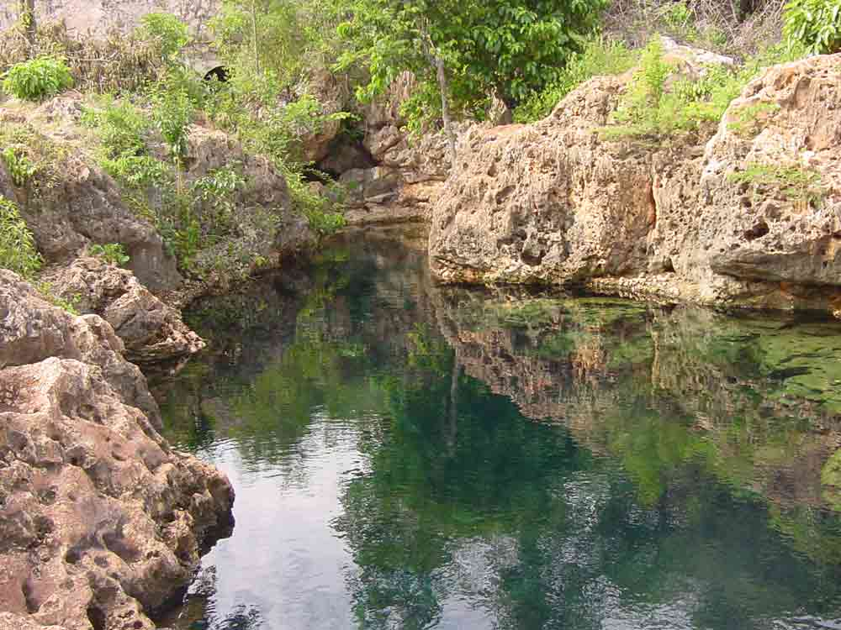
Figure 11. One of larger karstic springs on the central-southern coast.

Acknowledgment

This paper has been read, edited and approved by Basil Fernandez, Managing Director of the Water Resources Authority, Jamaica. The author is grateful for his effort.

