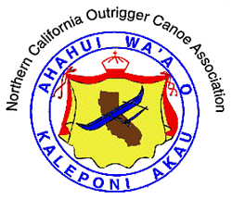
NORTHERN CALIFORNIA OUTRIGGER CANOE ASSOCIATION

OFFICAL RACE ROSTER
LONG DISTANCE EVENT REGISTRATION

HOSTING CLUB: Kaimanu Outrigger Canoe Club
RACE DATE: August 11, 2001

CLUB NAME: ______________

 |  | Long Boat |  |  |  |  |  | Malia
 |  | Open |  |  |  |  |  | Open
 |  |  | Men |  |  |  |  |  | Men
 |  |  | Women |  |  |  |  |  | Women
 |  |  | Coed |  |  |  |  |  | Coed
 |  | Masters
 |  |  | Men
 |  |  | Women

CANOE NUMBER: _____ NAME:_____________________________

(If your canoe does not have a number, one will be assigned for it.)

MANU COLOR: __________ HULL COLOR:_________ SPRAY SKIRT:_______________

PADDLERS (PRINT) | ID NO. | RACE SIGN-IN
1.
2.
3.
4.
5.
6.

Entry fee is $12 per paddler and includes a Hawaiian plate lunch.

ESCORT BOAT INFORMATION:  OWNER: ___________  BOAT NAME: ________  MARINE RADIO ON BOARD?___ | Mail or email crews to: debbie.green@crownwms.com  Debbie Green  13424 Doolittle Dr.  San Leandro, CA 94577  Registration deadline: August 8, 2001

