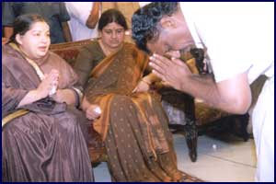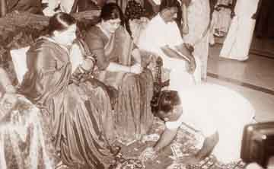
Above: Panneerselvam Above: Semmalai
Dummy CM
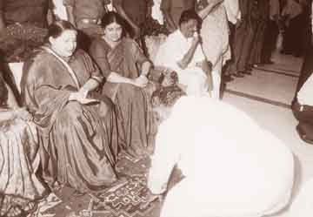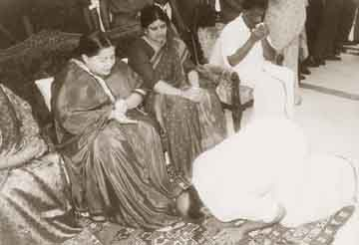
Above: Pandurangan Above: Jeyakumar

After the SC debarred her in 2001 from being the CM, as she was found guilty of corruption, Ms Jayalalithaa installed Sri Panneerselvam as CM . He and other ministers are paying their obeisance to the Defacto CM and her partner Sashikala. There are more number of ministers paying obeisance. Due to want of cyberspace all the photos are not reproduced here.

No Wonder ! Now hoardings are erected all over Chennai depicting her as one or the other Hindu God/Goddess!

Click on this link to go back to the Home page: http://www.geocities.com/kanchimutt2004

