Welcome to Climbing in the Greater Sackville Area

As an everyday person no one thinks there is any sort of climbing in the Greater Sackville Area, but with a little help from other climbers and some personal motivation I have put together a little guide to help with getting on some good quality rock and ice without driving for hours.

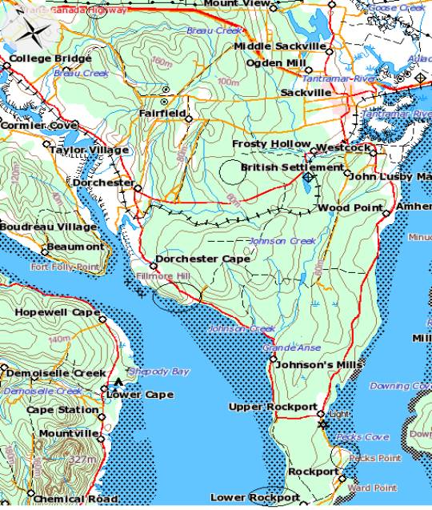

This topo shows us Sackville, Rockport, and Dorchester with the climbing areas circled. There are 4 ice-climbing areas Dorchester Cape, Lower Rockport/Cape Maringouin, Pecks Point and Breau Creek on the Trans Canada.
As of right now there is only one rock area and it is full of large sandstone boulders. I have put a star rating out of 3 on the routes remember everyone is different.

Dorchester Cape

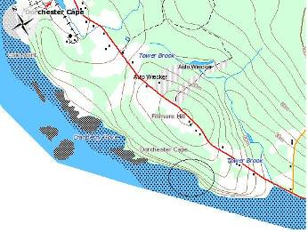

Drive from Sackville towards Dorchester on the old Highway, when you arrive in Dorchester there is only one four way stop and you turn left. Stay on this road until you come to the Tower Brook (which is on the map), park by the guardrail and hike along the beach for 30 minutes. You’ll walk by some crappy ice and then you’ll come to a nice corner where the ice looks good turn that corner for the big flows. The routes here range from WI 3-4+, 15m to 35m, and there is a pillar that has yet to be done. 70m rope recommended.

Routes from right to left.

1. WI 4+ Hollow Curtain***. At the corner before you turn to the big flows there is a flow that starts halfway up the wall. It starts with an 8m curtain and then mellows out. Rappel off abalakov. FA Max Fisher

2. Pillar Project WI 5 or 6 15m. Starts ¾ of the way up the wall, right around the corner from Hollow Curtain.

3. WI 4 name unknown***. This is the largest flow and it is sustained throughout. 35m Belay off trees. FA Unknown. 40m left of pillar

4. WI 4 name unknown**. This flow is directly left of largest flow and belay from same trees. 35m FA Unknown

5. WI 3 name unknown. This is the easiest route to the top. Belay off trees 35m. FA Unknown

6. WI 3+ name unknown**. Starts 10m left of WI 3. This is a great climb starts with a steep section that mellows out and finishes with a steeper section. 30m Belay off trees. FA Unknown

7.WI 4 name unknown***. Start on the vertical curtain just left of the WI 3+ and climb to mellow ground then go slightly left and finish on another steep section. 35m Belay on trees. FA Unknown

8. WI 3 name unknown. Start on the left of the curtain and climb up to easier ground and then finish up another steep section. Belay off trees 35m. FA Unknown

9. WI 3+ name Unknown. This is the farthest left of the large flows. Has a steep start then and mellow finish right to the trees. Belay from trees 35m. FA Unknown

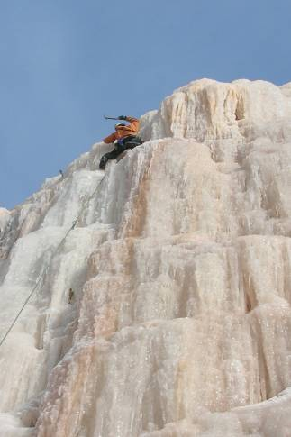
Max on first WI 4 in Dorchester Cape. Photo Heidi Gerrard

Lower Rockport/Cape Maringouin

Heidi Gerrard and I hiked out here in February 2007 and found 12 fat routes and 5 sketchy but climbable routes. This is a great place to escape from everything. From Sackville take Queens Rd to the Y in the road go left to Wood Point and stay on this road until you come to Upper Rockport turn right and the next road you come to is Pink Rock Rd. Turn left into here and park past the house. There are a lot of No Trespassing signs so please stay on trail. Hike the trail to the beach and then hike down the beach to the ice.
It is about an hour hike from Johnsons Mills (Pink Rock Rd).

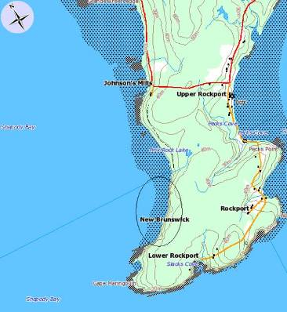

The routes range from WI2-WI5 and are from 10m to 25m.

Routes looking from left to right:
1. WI 3+ Fat So*. On the first major ice flow there are numerous lines from 3-5. Fat So is on the left corner. Small trees on top for anchor. 10m FA Max Fisher & Heidi Gerrard

2. WI 4 A Frozen Morning**. Is the next major fat flow. This vertical flow has multiple lines this being the easiest. Climb the left side to top, rappel off trees. 25m FA Max Fisher & Heidi Gerrard

3. WI 3 Plates*. About 40m right of A Frozen Morning is a smaller flow that starts steep and mellows out at the top. Rappel off trees. 20m FA Max Fisher & Heidi Gerrard

4. WI 4 Brittle Sweet***. 30m right of Plates. It was –28 degrees when we did this one. This has multiple lines this being the easiest. Climb straight up the middle and trend slightly left to top. Rappel off trees. 25m FA Max Fisher & Heidi Gerrard

5. WI 3 Sore Feet**. 20m right of Brittle Sweet. Starts vertical then mellows out, followed by another short vertical section to top. Rappel off trees. 25m FA Max Fisher and Heidi Gerrard

Like I said 12 fat lines, so far this is what has been done but the winter isn’t over.

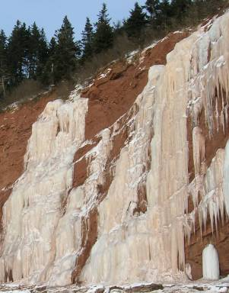
The 6 major flows in Dorchester Cape. Photo Max Fisher

Trans Canada Ice (Breau Creek)

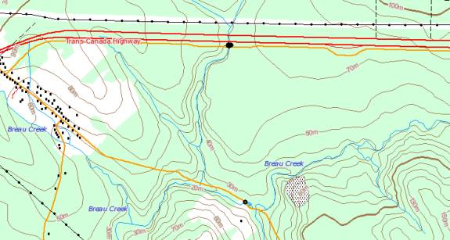

This route is found in the low point of the 4 mile stretch from East Memramcock to Sackville just after the U-turn where the cops always sit. You can easily see it from the TCH. It is about 25-30m high and WI 2-3. It often gets cover with snow.
The largest black dot is where the ice is. Not much there but it is in the area.
Name and FA unknown.
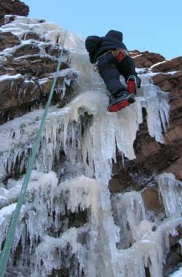
Heidi Gerrard in Rockport in early early conditions. It forms really fat trust me.
Photo Max Fisher

Pecks Point/Rockport
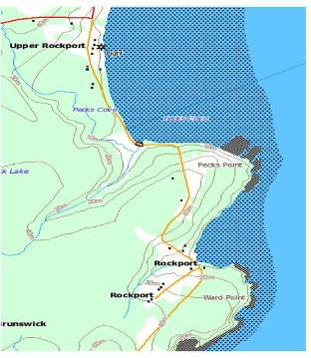

Driving from Sackville head towards Wood Point and stay on this road past the turn off to Pink Rock Rd and over a bridge. Just after the bridge is a turnoff on the left take that and park basically on the beach. Walk toward the rising cliffs. The flows range from WI 1-4 3m to 20m. Great place for ice bouldering.

Routes starting from right to left:
1. WI 1 a small fat flow good for descents of other short problems.
2. WI 2-4 as you walk along the beach there are probably 8 routes from 4m-5m which can be a fun warm up or great place to get comfortable soloing. FA’s Max Fisher
3. WI 3+ 5mins from small flows. A nice flow that finishes 10ft below the top rappel on abalakov.
4. WI 3 Walk around corner to the nicest flow in Rockport a fat flow that is 15m high.

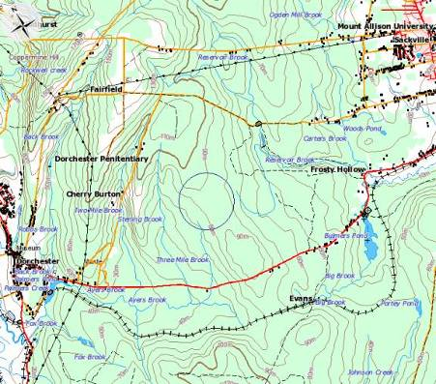

Cherry Burton Rd. Dorchester

I found these boulders 2 years ago and put up 5 routes. Since then I have put up about 12 and have more projects on the go. These boulders are found by driving from Sackville to Dorchester on the old Highway (which starts at Queens Rd). Before you drive into Dorchester you will see a sign for Cherry Burton Rd., turn right here and drive until you hit the gravel road. As you hit the gravel there will be a blueberry field on your right with a gated road. Park here and walk for 30-40 minutes up the road. (DO NOT WALK IN THE BLUEBERRY FIELD OR THE PRIVILEGE OF CLIMBING HERE WILL BE LOST) At the top of the hill you will see the boulders in the distance. Walk straight to them through the trees. There are 2 small streams and a marsh section to cross, so be prepared. Finally made it! Here are a few of the routes:

The 25ft-overhanging boulder (The Roof) is where everything starts:
1.V1 Sharp*. Dyno from lower right corner crimps with feet below to huge jug in roof. FA Max Fisher
2.V0 Hole in My Pocket. Start in back of overhang in the corner and traverse right and up to large jug (same as dyno) in roof. FA Heidi Gerrard
3. V0 Getter Done. On the far left face on the roof boulder climb the horizontal cracks starting with hands in the bottom one. FA Max Fisher
Traverse Boulder
Is the first boulder before The Roof Boulder. On your left as you walk in.
4. V2 Flirting with a Tree*. Is the very first problem on your left. SDS. Left hand on low jug and right hand on first low positive crimp. Work up small holds to top. FA Max Fisher
5. V0 Cherry Burton Traverse*. Start immediately after the small fur tree and traverse right to top edge of boulder. Mantle variation possible but not completed. FA Max Fisher

Ride My Lama Boulders.
Boulders up and left of The Roof.
6. V0 Ride My Lama*. Climb the sharp arête directly left of Getter Done. FA Zac Fisher
7. V1 Cherry Burton Arête**. The boulder directly above Ride my Lama. SDS the arête with hands low on corner and sneak up arête. FA Max Fisher
8. V0 Sloppy Jugs***. Same boulder as CBA. Climb the front starting with hands on large slopper and top out. FA Max Fisher
9. V0 Not All There. Is found up and left of Ride my Lama on a blank face start on small crimp and move to top. FA Max Fisher

Camp Boulder
Up by where the flattest area is to camp.
10. V1 Mantle Me*. Start in a small overhang with hands under overhang and move to the top and mantle. FA Max Fisher

The Hidden Boulder **
11.V1 10ft Fall. From not all there turn around and climb down to large tree and look left and you’ll see why it’s has this name. SDS on the right corner of boulder on a couple good hands then move up and left, don’t fall on the first 2 moves.

These are all the problems I have done so far. I have 5 or 6 projects on the go. This area has a lot of potential for moderate to hard routes. I’ll say probably 30-50 problems not adding variations.
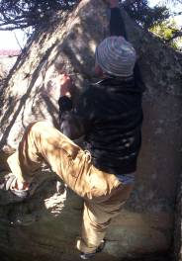
Max Fisher on Sloppy Jugs. Photo Zac Fisher

