
Figure 1.a: Encryption model;
Distorter: Decomposition using infinite even-length simplet
Encryptor: Decomposition using ISITRA

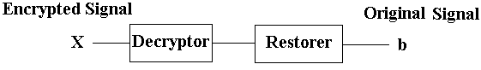
Figure 1.b: Decryption model
Decryptor: Reconstruction using ISITRA
Restorer: Reconstruction using infinite even-length Simplet.

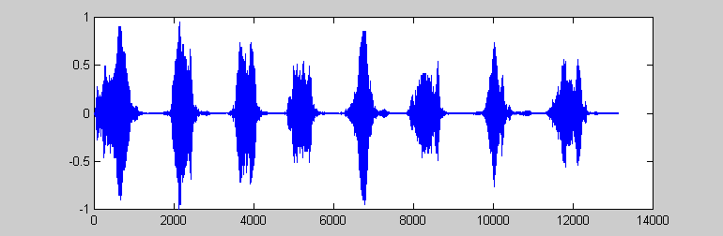
Figure 2.a: Original chirp Signal

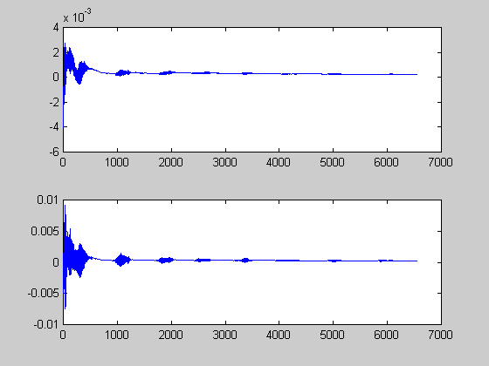
Figure 2.b: Decomposed components of the chirp signal at the first-level

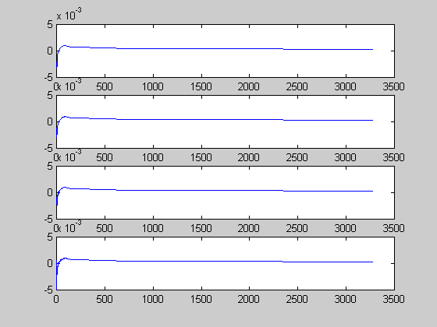
Figure 2.c: Decomposed components of the chirp signal at the 2nd Level (Full decomposition)
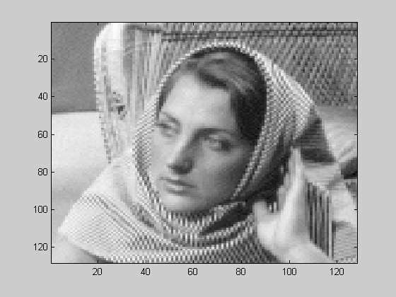

Original image

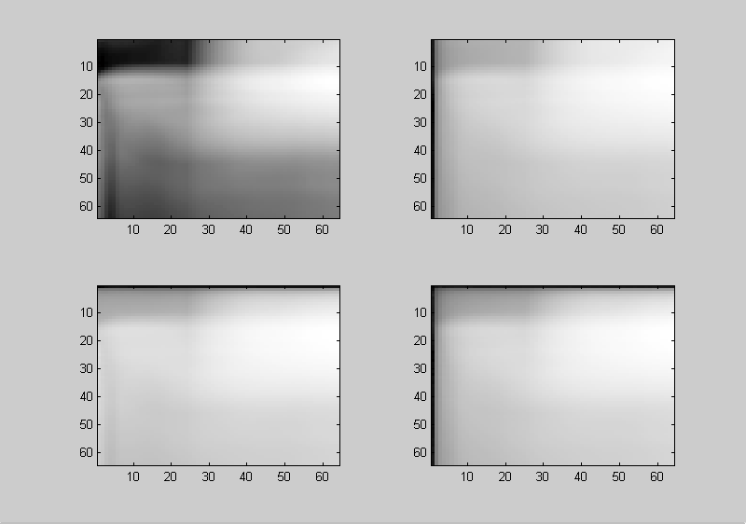
Single-level image decomposition using Simplet.

