Design of a Nonradiative Dielectric Rotman Lens
in the Millimeter Wave Frequency

Jae-Gon Lee*, Jeong-Hae Lee*, and Heung-Sik Tae**
*Dept. of Radio Science & Communication Engineering, Hongik University, Seoul 121-791, Korea
**School of Electronics and Electrical Engineering, Kyungpook National University, Taegu 702-701, Korea

Abstract – In this paper, a Rotman lens of multi-beam feed that can be applied to a car collision avoidance radar in the millimeter wave frequency was designed using nonradiative dielectric (NRD). NRD guide at the output ports was designed to obtain low loss, small coupling between the output ports, and dominant mode operation. The Rotman lens is optimized so as to minimize sidelobe of array factor. To prevent beam pattern from being distorted, multiple-reflection from sidewall has been eliminated by a corrugated sidewall.

Ⅰ. INTRODUCTION

Multi-beam feed which can be applied to a car collision avoidance radar in the millimeter wave frequency has been studied in this paper. A car collision avoidance radar requires minimum beams of three because of detecting distance, ascertaining velocity, and distinguishing obstacle in the main, left, and right lane, respectively. Electric beam steering network of good confidence and lasting quality is generally utilized. A rotman lens [1] has been adopted in electric beam steering network. A rotman lens has three input ports and plenty of output ports and then forms to obtain beam of intending angle in each input port. A rotman lens can be realized with parallel plate or microstrip. However, its large size is weak point of parallel plate rotman lens. Moreover, if we had used microstrip in a rotman lens, we would encounter a difficulty situation of high conduction loss in the millimeter wave frequency of 77GHz.
In this paper, a rotman lens has been designed with nonradiative dielectric (NRD) guide [2] to realize a compact size and low loss beam feed. While NRD guide has low loss characteristic in the millimeter wave band, it has a relatively strong coupling characteristic compared to other transmission lines [3]. Thus, coupling between the NRD output ports of the rotman lens may give rise to distortion of beam pattern. These coupling effects should be taken into account in the design of a NRD rotman lens. Besides coupling between the output ports, multiple-reflection from sidewall, which occurs due to structural characteristic, causes distortion of output beam. To eliminate multiple-reflection, the sidewall of a rotman lens has been corrugated.

Ⅱ. LOSS, COUPLING & OPERATION of DOMINANT MODE of NRD GUIDE

The cross-section of NRD guide is shown in Fig.1. It consists of a parallel-plate guide with a dielectric strip (a<λ₀/2) inserted between the plates. Loss of NRD guide decreases with frequency while that of microstrip increases with frequency. Thus, NRD guide becomes more useful structure in the millimeter wave range. In this paper, we analyzed dominant mode of LSM₁₁ [2].
Fig. 1 Cross-section of NRD guide

The propagation constant is simply defined as

$β=\sqrt{ε_{r}k_{0^{2}}−k_{x^{2}}−k_{{y1}^{2}}}=\sqrt{k_{0^{2}}−k_{x^{2}}+k_{{y2}^{2}}}$ (1)

where k_{y1} and k_{y2} are, respectively, the propagation and attenuation constants in the core and outer dielectric regions, k_{x} = m$π$/a and k₀ = $ω$/c. Also, k_{y1} and k_{y2} are related by

$k_{y1}\text{tan}(\frac{k_{y1}b}{2})=ε_{r}k_{y2}$ . (2)

Transmission loss is calculated with respect to height of a and width of b [4]. As indicated in Fig. 2, both dielectric and conduction loss decreases as a. However, Fig.3 shows that transmission loss increases as b except the small value of b. It is easy to conclude that larger value of a and smaller value of b results in low transmission loss.
It is confirmed that loss of NRD is much smaller than that of microstrip at 77GHz. To compare, it is assumed that a dielectric of NRD guide and microstrip is made up of teflon ($ε_{r}=2\text{.}\text{08}\text{,tan}δ=0\text{.}\text{0004}$). When a focal length of rotman lens, which will be decided later, is 16$λ_{g}$ at 77GHz, total loss of NRD lens is decreased by ~80% compared with that of microstrip lens.
Fig. 2 Transmission loss versus a/$λ_{0}$
(f=77GHz , b=1.847mm ,$ε_{r}$=2.04,$\text{tan}δ=0\text{.}\text{0004}$(Teflon))

Fig. 3 Transmission loss versus b${\sqrt{ε_{r}−1}}/{λ_{0}}$
(f=77GHz , a=1.753mm ,$ε_{r}$=2.04, $\text{tan}δ=0\text{.}\text{0004}$(Teflon))

Fig. 4 Top view of two NRD guides

Fig.4 shows a top view of two NRD guides to investigate coupling between NRD output ports which results in serious distortion of beam pattern. Coupling coefficient [3] is calculated using equation (3). Note that equation (3) is approximate numerical formula which is valid when the value of d is larger than 1mm in this calculation.
Fig. 5 S₃₁ versus the distance of d
(f=77GHz,$a=0\text{.}\text{45}λ_{0}$
$b=(0\text{.}5\text{\sim }0\text{.}7){λ_{0}}/{\sqrt{ε_{r}−1}}$,$ε_{r}=2\text{.}\text{08}$)

Fig. 6 S₃₁ versus dielectric constant
(f=77GHz,$a=0\text{.}\text{45}λ_{0}$, $b=0\text{.}6{λ_{0}}/{\sqrt{ε_{r}−1}}$)

$C=K\text{exp}(−k_{y2}d)$ (3a)
$K=\frac{ε_{r}k_{{y1}^{2}}k_{{y2}^{2}}}{β\left[\left\{k_{{y1}^{2}}+(ε_{r}k_{y2})^{2}\right\}(\frac{k_{y2}b}{2})+ε_{r}(k_{{y1}^{2}}+k_{{y2}^{2}})\right]}$ (3b)

Both Fig.5 and Fig.6 show that coupling decreases with the distance between NRD guides as expected. The larger values of width (b) and dielectric constant (ε_{r}) produce a smaller coupling since the fields are well confined in a dielectric. However, these larger values are limited by dominant mode (LSM₁₁) operation condition. It is also noted that coupling is relatively insensitive to height of dielectric.
The calculation results of Fig.2,3,5, and 6 are plotted in Fig.7 for deciding the value of a and b of NRD guide to obtain low loss and small coupling. Dominant mode operation region is also shown inside a dotted lines. Normalized value of a and b are located in dotted line for the sake of operating to dominant mode. As indicated in Fig.7, the values of a and b are chosen as $0\text{.}\text{45}λ_{0}$, $0\text{.}7{λ_{0}}/{\sqrt{ε_{r}−1}}$, respectively, for low loss and small coupling under the condition of dominant mode operation.

Fig. 7 Characteristics of NRD with its dimension ($ε_{r}=3\text{.}\text{78}$)

Ⅲ. DESIGN of ROTMAN LENS

A schematic diagram of rotman lens is illustrated in Fig.8.. A rotman lens is composed of three input ports, as indicated in Fig. 8. The beam is focused to array output ports provided that incident wave propagates to focal point. In order to steer an output beam with an angle of ψ, the path difference between two output rays from the point F₁ should satisfy equation (7a) [1]. Similarly, the equation (7b) and (7c) should be satisfied to steer an output beam with an angle of –ψ and 0°, respectively.

$\vec{F_{1}P}\sqrt{ε_{\text{eff}}}+W+N\text{sin}ψ=F\sqrt{ε_{\text{eff}}}+W_{0}$ (7a)
$\vec{F_{2}P}\sqrt{ε_{\text{eff}}}+W−N\text{sin}ψ=F\sqrt{ε_{\text{eff}}}+W_{0}$ (7b)
$\vec{\text{GP}}\sqrt{ε_{\text{eff}}}+W=G\sqrt{ε_{\text{eff}}}+W_{0}$ (7c)

The value of ε_{eff} in the above equation should be modified since it is different from that of rotman lens with parallel plate. Since an incident wave in NRD guide propagates in dominant mode of LSM₁₁, TE mode is generated inside a lens, we must to adjust, as much as $\sqrt{ε_{\text{eff}}}$($={λ_{0}}/{λ_{g}}$ ), port position computed in parallel plate lens. After focal angle, array spacing, focal length, and focal ratio of parameters are decided, positions of input and output ports are computed using (7). In this paper, $ψ$and array number are selected as 6°and 29, respectively.
The flat dielectric structure with a thickness of a (<λ₀/2) in Fig.9 is inserted between the parallel conductor plates. The structure of a rotman lens with three input ports and 29 output ports is indicated in Fig. 9. The corrugated sidewall for matching is also shown.

Fig. 8 Schematic diagram of rotman lens

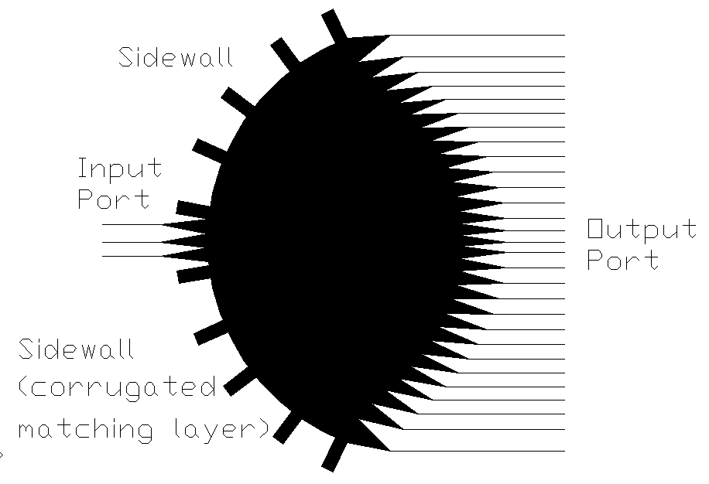

Fig. 9 Structure of rotman lens

Table 1 Flowchart for optimization of array factor

Array factor is computed using 2-D green function [5] based on far-field approximation after port positions and length of output transmission line are calculated using the equation (7). Array factor is optimized through flow chart shown in Table 1. Beam width increases in proportion as focal ratio but in inverse proportion as array spacing. Sidelobe increases in proportion as array spacing and focal length relates with only dimension of rotman lens. Finally, optimum of array factor is calculated in Fig.10 and the amplitude difference between main beam and sidelobe is 30dB or more. The dimensions of a NRD rotman lens for optimized array factor is shown in Table.2.

Fig. 10 Optimized array factor

Table 2 Dimensions of an optimized NRD rotman lens

Ⅳ. CORRUGATED SIDEWALL

To consider multiple-reflection from sidewall which causes distortion of beam pattern, a NRD rotman lens with five output ports is simulated using High Frequency Structure Simulator (HFSS). Transmission coefficients from center input port to five output ports are computed with and without corrugated sidewall, respectively. Transmission coefficients are also calculated using 2-D green function which does not include multiple-reflection. The results are compared in Fig. 11. The result with corrugated sidewall is similar to those from 2-D green function, which indicates that corrugated sidewall eliminates multiple-reflection.

Fig. 11. Comparison of transmission coefficients
(number of output=5 , N=3mm)

Ⅴ. CONCLUSION

In this paper, a Rotman lens of multi-beam feed that can be applied to a car collision avoidance radar in the frequency of 77 GHz was designed using low loss NRD guide. Since coupling between the NRD output ports gives rise to distortion of beam pattern, these coupling effects has been taken into account in the design of a NRD rotman lens. Besides coupling between the output ports, multiple-reflection from sidewall, which occurs due to structural characteristic, causes distortion of output beam. To eliminate multiple-reflection, the sidewall of a rotman lens has been corrugated. Furthermore, the NRD rotman lens are optimized so as to minimize sidelobe of array factor.

Acknowledgments: This work was supported by LG Innotek and ITRC-CHOAN.

Ⅳ. REFERENCES

- Y.T.Lo, S.W.Lee, “Antenna Handbook,” Ch.17, Ch19, ITP.
- T.Yoneyama, S.Nishida, “Nonradiative Dielectric Waveguide for Millimeter-Wave Integrated Circuits,” IEEE Trans. Vol.29, No.11, pp.1188-1192, 1981.
- T.Yoneyama, N.Tozawz, S.Nishida, “Coupling Characteristics of Nonradiative Dielectric Waveguides,” IEEE Trans. MTT, Vol.31, No.8, pp.648-654, 1983.
- J.Dallaire, K.Wu, “Complete Characterization of Transmission Losses in Generalized NRD Waveguide,” IEEE Trans. MTT. Vol.48, No.1, pp.121-125, 2000.
- C.A.Balanis, “Advanced Engineering Electromagnetics, ” Ch.14, Wiley.

