Integrated Design and Process Technology, IDPT-2006
Printed in the United States of America, June, 2006
©2006 Society for Design and Process Science

A PLATFORM-INDEPENDENT WEB-BASED TUTORIAL SUITE WITH ADAPTABLE STRUCTURE

Liciniu-Alexandru Kovács, PhD
Faculty of Business, "Babeş-Bolyai" University
7 Horea Street, 400174 Cluj-Napoca, Romania
tel.+40-264-599170, fax+40-264-590110, e-mail: liciniu@yahoo.com

Silvia-Emilia PLĂCINTAR, PhD
Faculty of Economics and Business Administration, "Babeş-Bolyai" University
58-60 Th. Mihali Street, 400591 Cluj-Napoca, Romania
tel.+40-264-418654, fax+40-264-418656, e-mail: emilia.placintar@yahoo.com

Gabriel Marius POP
Faculty of Business, "Babeş-Bolyai" University
7 Horea Street, 400174 Cluj-Napoca, Romania
tel.+40-264-9-599170, fax+40-264-590110, e-mail: gabriel.pop@gmail.com

ABSTRACT
Some years ago we could speak about "the art of computer programming". In the meantime, this concept has been achieved by specialized companies that have developed sophisticated software tools to be used in many areas. As we are heading towards the information society, we now speak about "the art of computer usage". But the option of only one dominant computer operating system is not feasible simply because IT cannot be a monopoly. Since Windows, Linux, Solaris, and associated packages dominate the market, competition among software applications is highly desirable. In order to understand how to use a computer and computer software, we need user’s manuals and tutorials. In this sense, there are many possibilities to develop tutorials which can be "seen" under any HTML interpreter (Web browser). In our paper, we describe a Web-based platform-independent tutorial suite whose key-features are structure, simplicity, multimedia, accessibility, and comparative approach. We conclude by launching the idea of an encyclopedia of software resources.

THEORETICAL ASPECTS
We are witnessing the development of information society with computers and IT being virtually applied in all human activities. We cannot run businesses, production, research, education, hotel reservations, and many other services/operations without engaging digital information. Texts, still and animated graphics, sounds and videos "travel" from producers to consumers on storage media and, due to the Internet, can be downloaded at any time from servers and safely saved to your computer at home or at work. Initially developed in specialized companies as programming languages, today’s sophisticated software tools make things happen at great speed. To penetrate the digital era and take advantage of it, we need to understand quickly as many specific concepts as possible and focus the education process on the practical training of students.

Education has made considerable progress as a direct result of the advances in IT. This is reflected in the creation of up-to-date didactic technology, including Computer Based Training (CBT). To meet the new educational need for life-long learning, the global market offers training courses that integrate the computer in the teaching/learning process. This tendency is due to the following circumstances:
- The computer industry with its two major components – hardware and software – has developed explosively;
- Specialized institutions in advanced countries have developed a strong computer infrastructure and associated courses;
- Companies (e.g. radio and TV broadcasting networks, telephony, transportation, etc.) are developing and implementing informational, communication, and decision-making processes based on computer applications;
- The Internet has become a global communication environment able to share knowledge online;
- Content management systems (CMS) have become widely applied;
- Educational institutions apply high standards in order to be accepted in the system and provide activity sectors with well-rounded specialists.
The computer is the most versatile equipment in education because (Kovács, 2001):
- It works with special written programs;
- It can process texts and/or numbers;
- It can concentrate data and generate reports from spreadsheets and databases, with textual, numeric, and graphic information, to be used in performing managerial tasks;
- It can process images from different sources – compact disks, scanners, traditional and digital cameras, camcorders, video cassette recorders, cassette players, and TV;
- It can play and/or process sound from audio compact disks, microphones, radios, cassette players, and other audio-visual equipment;
- It can play and/or process digital video;
- It can replace traditional visual equipment;
- Integrated in Internet networks, it allows us to obtain/send information from/to any user.

In some cases though, the computer alone is not sufficient in the educational process: it has to be helped/assisted by other technical instruments, such as multimedia projectors, LCD and overhead projectors, photo and audio-visual equipment.

In order to elaborate a computer program for educational purposes in general, and a tutorial in particular, it is necessary to take into consideration the following steps (Besnaiou et al., 1988): Pedagogic Analysis, Validation of Pedagogic Analysis, Elaboration of Didactic Scenario, Validation of Didactic Scenario, Media Advertising, Validation of Enclosed Information, Testing, Correction, Distribution, and Evaluation.

In addition, one has to follow a certain model of internal structure. Without going into detail, internal structures can be linear, hierarchical, non-linear, and composite (Vaughan, 1994). Forester (1979) underlines the following reasons to learn the fundamental structure of a subject:
- Understanding the basic principle of a subject makes it intelligible;
- If no detail is shown in a standard model, this is rapidly forgotten;
- Understanding something as a particular example of a general case is based on understanding its essential structure and therefore helps in understanding other similar phenomena;
- The material has to be continuously examined in order to shorten the distance between advanced and elementary knowledge.

Because "content is more important than nice formatting" (Thoeny, 2004), we now have to deal with tree + hyperlink structures.

The author of a computer-based tutorial should have a thorough strategy in order to put each piece in place. The design of a tutorial’s content will be informed by the answers to the following questions (McCormack and Jones, 1998):
- How much do the students know about the subject?
- What is the students' level of education?
- What is the students' professional orientation?
- What do you want the students to learn or be able to do?
- Are the objectives realistic and attainable?
- Do the electronic page contents relate to the objective?
- Does the electronic page present a clear and direct concept?
- Are the subjects and/or electronic pages in a logical order?
- Is the information accessible?
- Does the program contain a printable version?
- What can be improved?

These theoretical aspects should be taken into consideration when developing Web-based applications.

WEB-BASED TUTORIALS IMPLEMENTED IN INTRANETS/THE INTERNET
First of all, what is a Web-based tutorial implemented in intranets/the Internet? Here are some possible answers (McCormack and Jones, 1998; Kovács, 2001):
- Information on a specific subject can be found in computers (servers and workstations) and storage media and available in printable version;
- Such information can be retrieved in more than one language, according to the user’s choice;
- All documents from computers and/or storage media are developed to be accessed with browsers running on different platforms;
- Diagrams, graphics and animation can be retrieved with browsers and/or other specific (integrated) software packages;
- Static information is accompanied by sound and digital video, i.e. multimedia or, in particular cases, hypermedia;
- Any file type can be sent/received via e-mail or uploaded/downloaded;
- The lessons and their related parts can be accessed/studied both inside and outside an organization/institution.

Today, the evolution of Information Technology makes it possible to edit web pages by using just a browser via the so-called Wiki engines. These original and productive software tools are mainly used by Internet communities and universities. One can find hundreds of Wiki engines, mostly as an open source.

The parties involved in a Web-based tutorial implemented in intranets/the Internet are the professors, students, educational materials, hardware resources, and software resources. One can find relevant materials in the specialist literature and on the Internet. Due to the specificity of the intranet/Internet, any Web-based tutorial should contain the following types of page: Home page, Index pages, Content pages, Study pages, and Evaluation pages.
The largest part of the traditional educational material consists of books with a combination between text and graphics; CD's are rarely attached. Conversely, CBT materials are a combination of multimedia, i.e. text, graphics, sound, and digital video. In order to produce and maintain such multimedia programs, the designer needs to have solid specialist knowledge and access to a multitude of software resources.

The market offers a wide selection of more and more integrated software packages. Some of them are used to build tutorials, while others only as auxiliary resources. A possible classification of software resources with some of their corresponding products is (Kovács, 2001):
- Operating systems: DOS, Windows, Unix, Solaris, Linux;
- Word processors: Word Star, WordPerfect, Word, QuarkXpress;
- Spreadsheets: Lotus 1,2,3, QuattrePro, Excel.
- Database Management Systems: dBASE, FoxPro, Access, Paradox, Oracle;
- Graphic and Presentation packages: Astound, Bravo, Asymedia, Charisma, Power Point, WordPerfect Presentations, Freelance Graphics, SmartDraw Pro, Corel Draw, Macromedia Action, Persuasion, Stanford Graphics, Adobe Illustrator, Macromedia Freehand, ABC Graphics, GSP Design Works, Windows Draw;
- DeskTop Publishing software: Xpress, PageMaker, Ventura, Page Plus, Publisher, Frame Maker, Canvas, ipublish, PressWorks;
- Voice Recognition software: Voice Type Simply Speaking, Via Voice, Voice Command, Dragon Dictate, Naturaly Speaking, Voice Pad;
- Digital Video software: Adobe Illustrator, Adobe After Effects, Ulead Media Studio;
- Optical Character Recognition software: Inovatic Easy Reader, OmniPage, Recognita, TextBridge, Ocron Perceive Personal;
- Computer Aided Design software: AutoCAD, CorelCAD, Corel Visual CADD, Design CAD, Drafix CAD Pro, MicroGDS Pro;
- Browsers: Internet Explorer, Navigator, Opera, HotJava Browser;
- Remote connection software: LapLink, Carbon Copy, pcANYWHERE, CoSession Remote, ReachOut;
- Videoconference software: Captivator, Net Meeting, Intel Proshare Conferencing System, VideoLogic;
- Antivirus software: BitDefender, Dr. Solomon’s Home Guard, F-Secure Anti-Virus, IBM AntiVirus, McAfee VirusScan, Norton Antivirus, PC-cilin, VDS Pro, VET Antivirus, Sophos Antivirus;
- Visual Programming Languages: Visual J++, Java Workshop, Delphi, Optima, Power Objects, Power Builder, Visual Basic, Visual C++, Visual FoxPro, Visual Café, JBuilder, Visual Age;
- Multimedia Authoring software: IconAuthor Net Edition, ToolBook II Instructor, MacroMedia Authorware, Macromedia Director, CBT Express, Click & Create, Illuminatus, Dazzler, MatchWare Media8or, Multimedia MM 200, Immedia.

The above list (completed with tables that contain comparative data) was "valid" for the year 2000. Since then, there have been great advances in computer science, with Microsoft still remaining top of the market. Thus, Sun Microsystems has spent millions of dollars on the development of Solaris operating system, Linux and Linux-related magazines have become easily accessible, OpenOffice.org 2.0, Star Office 8.0 and many more complex software resources are available on the market…

It cannot be ignored that IT has a great future ahead of it. This is the reason why educational institutions have developed curricula where IT-related subjects are given considerable attention. During our teaching activity, we have observed that:
- If the students are IT beginners and the teaching process is mostly theoretical, they can learn with difficulty;
- Students are fond of searching the Web and therefore there is demand for more and more access time to the computer networks;
- Students utilize the e-mail service mostly.

Starting from the above observations, we have elaborated the following hypotheses:
- An interactive and comparative approach can generate enthusiasm and positive performance;
- The use of multimedia renders the learning process easier and more efficient.
- The learning time is shorter if the educational material has a clear structure, is stored in the computer, intranets or the Internet, and contains practical exercises.

CHARACTERISTICS OF THE TUTORIAL SUITE
The tutorial suite can be explained with the help of associated screen captures. As all tutorials have about the same structure, we will limit the explanations to the tutorial for word processing.

Surfing the Internet, one can find: "Virtualization allows multiple virtual machines, with heterogeneous operating systems to run in isolation, side-by-side on the same physical machine. Each virtual machine has its own set of virtual hardware (e.g., RAM, CPU, NIC, etc.) upon which an operating system and applications are loaded. The operating system sees a consistent, normalized set of hardware regardless of the actual physical hardware components" (www.vmware.com). The same idea is strengthened by M. Rosenblum, Chief Scientist, VMware Inc.: "Virtual machines provide a powerful unifying paradigm for restructuring desktop management" (ibid.).
The above remarks are in line with the comparative approach to software packages belonging to the same family which was applied in the tutorial Word Processors – A Comparative Approach, first published in 1999. At that time, for practical reasons, primarily to make it more user friendly to our students, a Web-based tutorial was created that provided explanations in Romanian of the basic concepts relating to well-known word processors, i.e. Word (two versions) and WordPerfect. Since then, the tutorial has been revised, enhanced, and upgraded. In 2004, with the addition of a tutorial for spreadsheets (version 1.0) and the inclusion of company intranet concepts (version 1.0), the tutorial became a suite. Starting with the academic year 2005/2006 we have included elements of Linux and OpenOffice.org under Linux (and Windows) in the syllabus, and we are planning to teach comparatively Windows, Linux and Solaris operating systems, as well as software packages from Microsoft Office, OpenOffice.org, and StarOffice in the coming year. As a large part of the computer network of the Faculty of Business has three operating systems (Windows '98, Windows XP and Suse Linux 9.3), the tutorial has now been optimized to run under any HTML interpreter. Because the tutorial suite has grown too extensive for one person to be in charge of all the aspects, Ms. Plăcintar has taken over the responsibility for the English terminology and Mr. Pop for the installable versions and the video sequences.

Going back to the structure of the tutorial, we will analyze fig.1, fig.2, fig.3 and fig.4. Supposing we want to study the basic elements of word processing, we will follow the hyper-link in the home page (not reproduced in this paper). The associated tutorial begins with the screen (see fig.1), which describes the structure of the tutorial and explains the meaning of each number. Thus,
- is the frame that specifies the tutorial's name and the image of a house which facilitates navigation to home page;
- is the frame that contains a list of the subjects presented in the tutorial (it can be a very long one!); according to the License Agreement, you can add, for personal use only, other subjects connected with word processing;
- shows the author’s institutional affiliation and a hyper-link to a page with details; it is always the same in all distributions;
- indicates the name of the partner institution and a hyper-link to a page with details, which differs from case to case; this page serves as a promotion for the institution's products/services and is used according to its needs; because programs are often copied illegally, the page serves as a hidden promotional method for the partner institution (in our case Intend Computer).
We have noticed that users tend to study a subject randomly. That is why one of our main concerns was to provide the user with clear and logical guidance through the tutorial as a whole and through each separate section. To illustrate, suppose we are interested in the subject "Print document". All we have to do is click on the selected subject on the left side and in the right-side frame we will "obtain" the subject details (see fig.2). The meaning of each number is:
- the "name" of the subject;
- the frame that specifies whether the respective subject is followed by a quiz or a self-test; quizzes are on the same page, while self-tests are on separate pages;
- icons for viewing mode; if you want to take advantages of a larger screen area, click on the "NO frames" icon, which is often necessary in order to visualize large images and associated explanations; if you want to come back, then click on the "Frame view" icon;
- the frame where we "obtain" the subject details (i.e. text, still/animated images, and hyper-links to video sequences);
- hyper-link to pages with details also used in other places of the tutorial; those pages always have a "Back" button;
- quiz or hyper-link to a self-test page.

If we click on the "NO frames" icon, then we can have the subject detailed on a maximum surface allowed by the browser – fig.3 (note that fig.3 is "broken"). The meaning of each number is:
- hyper-links to pages containing details including video sequences related to the subject under study, in our case how to print a document in Microsoft Word XP, OpenOffice.org 2.0 Writer, and Star Office 8.0 Writer; according to the License Agreement, you can add, for personal use, other examples from any word processor.
- navigation: it contains the "Quit" option and two arrows (previous/next subjects); note that one can "jump" to any other subject only from within the frame view.

Finally, if you want to know where you are in the tutorial's structure, click on "Frame view" and you will get the frame with the tutorial’s name on the left, and, below, the frame that specifies the subjects to be detailed (see fig.4). One may say that fig.4 is identical with fig.1, but this is only partially true because number 13 indicates that the name of the subject from within which you clicked on "Frame view" is the first on the list in the frame where the subjects to be detailed are specified. In this way, you cannot get lost in the program, as you can always click on the "Frame view" icon to find out where you are in the tutorial's structure.

The tutorial suite is copyrighted, but it seems that its evolution is towards becoming an open source. The tutorial suite is updated yearly and is available on the intranet of the Faculty of Business (http://192.168.1.2/). It is free in the intranet and cannot be borrowed from the faculty’s library. On demand, any student can buy a personalized copy on CD-ROM for personal/family use.

Ionescu and Radu (1995) have studied the principal components of the educational process seen as a system. Drawing a comparison, a Web-based tutorial can also be seen and analyzed as a system (Kovács, 2001).

Objectives
- When pupils/students use the tutorial, they are able to learn specific terminology rapidly and easily due to the comparative approach.
- Theoretical study followed by practical exercises leads to a rapid and steady development of the abilities to work with software applications.

Action agents
- Professors – the tutorial can be used by any professor who teaches IT in general and word processors and/or spreadsheets in particular;
- Students – the tutorial can be used by any student who wants to learn how to use a computer;
- Other persons – if placed on the Internet, the tutorial would be accessible to any person willing to become proficient in the use of a computer.

Tutorial content
- The tutorial contains basic concepts relating to the majority of today’s operating systems, word processors, spreadsheets, and intranet.

Means
- The tutorial runs on any computer with frames compatible browsers;
- Initially, the word processor tutorial was optimized for Internet Explorer, but the suite can run under any browser;
- The tutorial suite can be copied on a host server.

Techniques
- The tutorial suite takes full advantage of the Internet Web service and has a composite structure for its units of interaction;
- The tutorial suite is evolving towards tree + hyperlink structures.

Organizational forms
- The tutorial suite can be integrated in the school curriculum or it can be used outside the education system;
- The tutorial suite contains the home page, index pages and study pages, content pages, summary pages, and evaluation pages.

Advantages of the tutorial
- The content can be "seen" under any browser;
- The structure is flexible, being adaptable to the study of almost any subject;
- The pages can be larger (in both directions) than the screen;
- It can be accessed either full-screen or with frames with the index on the left and all the other pages on the right;
- Students can evaluate themselves;
- The content is printable;
- It can be installed on PC’s under Windows, using a seven-step installing program, including User information, License agreement, and Information about the tutorial suite;
- It can be copied on computers with other operating systems, like Linux or Solaris;
- It can be run from CD's, local or network HDD's, memory sticks, the Internet or intranets;
- If it becomes too huge, it can be stored using advanced technologies like HD-DVD, Blue Ray or holographic storage media;
- The scanned covers of the reference books cited in the tutorial lend credibility to the authors.

Disadvantages of the tutorial
- Students can access both the HTML and the JavaScript codes and copy the correct answers to the tests and quizzes. This disadvantage can be eliminated if the program is installed on servers;
- The use of audio techniques may disturb the laboratory activities;
- The current version is "constructed" manually.

Relational field
- The relation instructor-student is simple because the study is interactive;
- During the group activities, the program generates discussions on the perception of the content and comments on the solutions.

Results
- Students understand the terminology rapidly;
- Students can work better with the tutorial and the applications because of the multi-task facility of the operating system;
- If concepts are forgotten, it is no longer necessary to consult any manuals, as digital videos can be used instead.

NOTE: The DEMO of the Web-based tutorial suite is published on the IDPT 2006 conference CD-ROM and at http://www.tbs.ubbcluj.ro/~liciniu/demo/index.html.

CONCLUSIONS
The usage of computers in general and a Web-based tutorial in particular determines a better understanding of many subjects. Education through Web-based multimedia tutorials implemented in intranets/the Internet is the most flexible method, as the instruction is student-focused and the rigid traditional methods are eliminated. A large amount of information is accessed by the student in a very short time via computers or is stored on high-capacity storage media.

The advantages of a Web-based tutorial implemented in intranets/the Internet are:
- integration of computers in education;
- simplicity of user interface;
- temporal and geographic independence;
- provision of the core level for distance and life-long learning;
- increase in the level of knowledge and flexibility;
- easy to update;
- platform independent;
- increase in the supply and demand of teaching materials on classic and electronic support.

Because there is no single answer and because no one has all the possible answers to solve all the aspects of a Web-based tutorial, we contend that, in building such an educational program, we should specify that the structure described in this article is limited to the example given. Any other structure similar to this one is to be adapted to the concrete subject by taking into consideration the resources (e.g. financial, hardware, software, etc.) and the specific culture existing in a certain organization. The support, access, performance, security, and information presented in a tutorial closely depend on the policies of the organization that the program designer represents.

Starting from the possible classification of software resources presented in the tutorial, we can extend the comparative approach as shown in the ensuing section.

THE IDEA
- refine the above classification;
- make an inventory of all the types of software existing on the market;
- elaborate material dedicated entirely to software resources, such as Home Edition, Enterprise Edition, Professional Edition, etc.;
- organize the entire material into a classical and electronic dictionary with cross-references among keywords;
- give examples of screen captures, photos, graphics, sounds, and digital video for the software resources found and place them on one or more (HD)-DVD's;
- provide tutorials for related software packages;
- place the whole material and the examples in university intranets and libraries so that all members of the community can access them at any time; part of it may become open source;
- provide the electronic version with a complex local search engine;
- provide ways to complete the material with new topics (a kind of Wikipedia);
- publish the book and the (HD)-DVD('s) as an encyclopedia of software resources.
MOTIVATION
- As far as we know, there is no material on the market in this format.

TARGET "MARKET"
- This reference resource can be used in education units (universities, colleges, high schools) and by the research community, the medical community, the industry, and the public in order to help these potential users understand what information society means.

OBJECTIVES
- to help users understand clearly what specific software packages are good for;
- to provide a reference source that explains what can be done with a certain software package;
- to integrate knowledge of software resources in the society.

MEANS AND TECHNIQUES
- The project is to be designed by a (large) team of professors, engineers, specialists, and software end-users.

RESEARCH
- After collecting and organizing the material, further research will be done to determine the optimum quantity of multimedia for the printed version and DVD content in order to ease the operation of finding a certain software resource and have a maximum transfer of information towards the students and/or other users.

REFERENCES
Besnaiou, R., Muller C. and Thouin, C., 1988, "Concevoir et utiliser un didacticiel, Guide pratique," Les Éditions d'Organisation, Paris.

Forester, J.W., 1979, "Principiile sistemelor," Editura Tehnică, Bucureşti.

Ionescu, M. and Radu, I., 1995, "Didactica Modernă," Editura Dacia, Cluj-Napoca.

Kovács, L.A., 2001, "Utilizarea computerului, tehnicilor foto şi audio-video în învăţământ," Editura Todesco, Cluj-Napoca.

McCormack, C. and Jones, D., 1998, "Building a Web-Based Education System," John Wiley & Sons Inc., USA.

Thoeny, P., 2004, "Wiki, a Shared Blog for the Corporate World," conference talk in the Emerging Technologies Track at LinuxWorld in San Francisco (reproduced at http://twiki.org).

Vaughan, T., 1994, "Multimedia: Making It Work," Osborne McGraw-Hill, Berkley, California, USA.

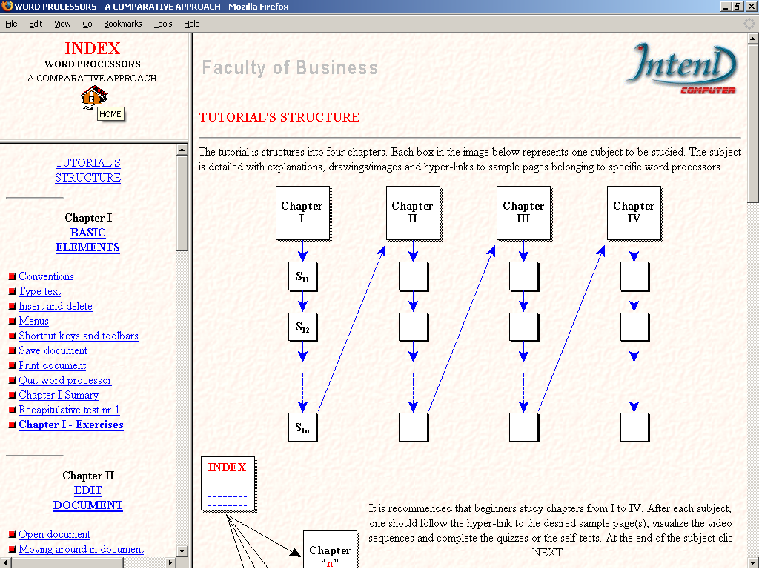
1
2
3
4

Fig.1 The tutorial about word processors starts with this screen

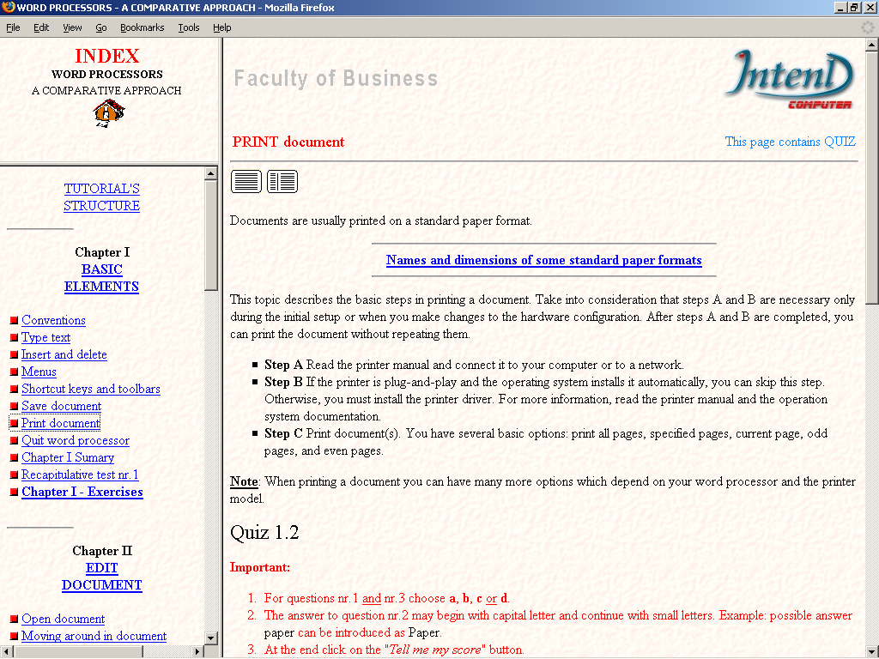
5
6
7
9
8
10
NO frames

Fig.2 Click on Print document on the left side and the subject "Print document" appears on the right side
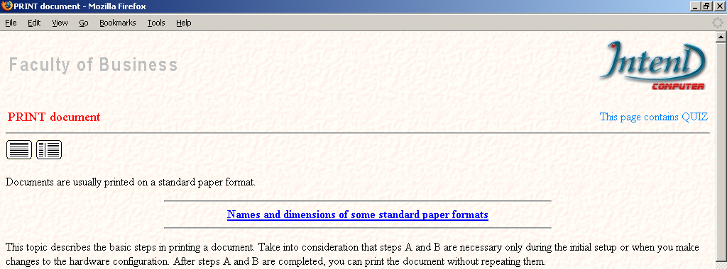
* * * * * * * * *
Frame view
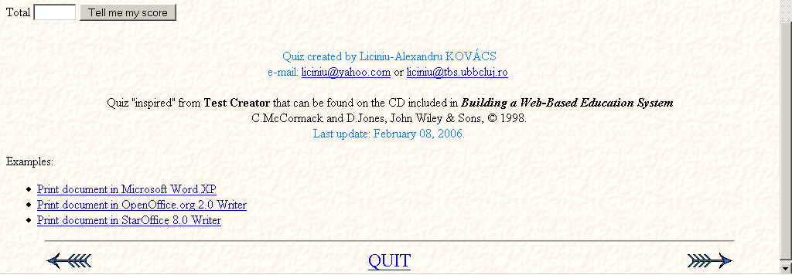
11
12

Fig.3 Click on "NO frames" icon (see fig.2) and the subject appears in the entire window

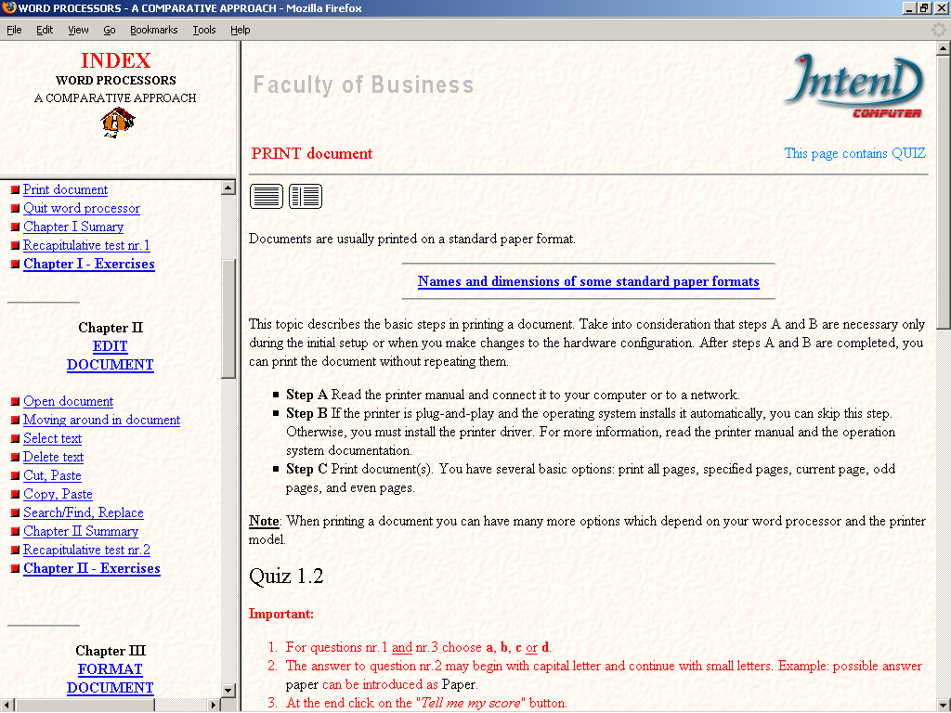
13

Fig.4 Click on "Frame view" icon (see fig.3) and the tutorial pages appear in frames

