East-Central/American Society for Eighteenth-Century Studies Rosemont, Pennsylvania, October 17-19, 2002

"Petrus Camper’s Protean Performances: The Metamorphoses"

— Miriam Claude Meijer, Ph.D. —

Petrus Camper’s "Two Lessons on the Analogy that exists between the quadrupeds, birds, and fish" was delivered on October 13-14, 1778 in the Amsterdam Drawing Academy.
Details, along with some animated graphics, are on Dr. Meijer’s web site: http://www.geocities.com/paris/chateau/6110/camper1.htm

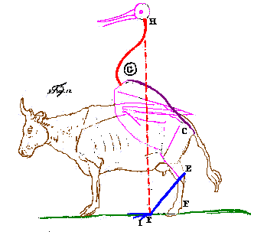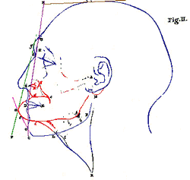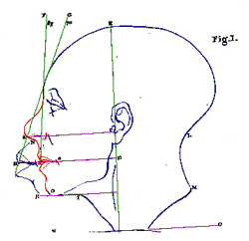
Figure 12 Figure 2 Figure 1

