Macroeconomics

Assignment number two

The Phillips curve

Presented to
Dr Kofi Orleans-Lindsay

By Jean-François Charette



European Business School, London
Tuesday 28th of November 2000

You can fool some people some time,
But you can’t fool all the people all the time

Bob Marley

- How might the original Phillips curve be interpreted?

It’s in 1958 that Alban W. Phillips, then professor at the London School of Economics, drew his now famous curve. This curve states the fact that there is a trade off between unemployment and inflation.

The curve was drawn with the regression of historical data about unemployment and the wages growth for the 1861 – 1957 pediod. The regression showed a negative relationship between unemployment and inflation over the period of time studied.

The interpretation

The interpretation of that original curve was that the government, by using fiscal and monetary policies, could decide of a certain level of unemployment and inflation. That is, if we look at the figure 1 representing the original Phillips curve, the government could choose to reduce the unemployment from level U* to level U₁ but then, should accept to suffer an increase in the level of inflation from 0 to π₁. On the other hand, the government could prefer a higher level of unemployment if it meant a lower level of inflation, or even a decrease in the prices below the no-inflation point 0. That is, by decreasing its investments, the unemployment would raise to U₂, while the inflation would become deflation at level π₂.
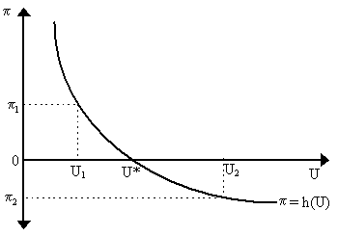
Figure 1 – The original Phillips curve

Within the rest of this paper, we will focus on the exercise of proving the fact that the original Phillips curve doesn’t work in the real world, and show the conditions under which it could work. One major point that we want to express now is, as we will see in the section B of this paper, that the Phillips curve’s theory works as long as the workers stay fooled by the increase of wages and believe they are better off with the new wages than with the old ones.
- What arguments can be put forward to explain why it is that unemployment and money wage growth have risen so far above the levels predicted by the original Phillips curve?

In this section of the paper, we answer the question B and evaluate the issue critically. Many reasons may explain the situation described. We state some of them.

Type of inflation
Figure 2 – Cost-Push inflation

Mr. Martin B. Brilliant explains on his web site one reason why the Phillips curve doesn’t survive in practice: theory implies a demand-pull inflation only, but there is also cost-push inflation, such as what resulted from the oil crisis in 1973. Such inflation gives birth to a higher level of unemployment because prices increases without an increase in the demand, and therefore it shifts the supply curve left, resulting in less output and then more unemployment. That is, for the same price, firms are willing to produce and sell less goods than before, and then they reduce production, fire employees, and so on… We show this behaviour in the following Figure 2.

Theory vs. Practice
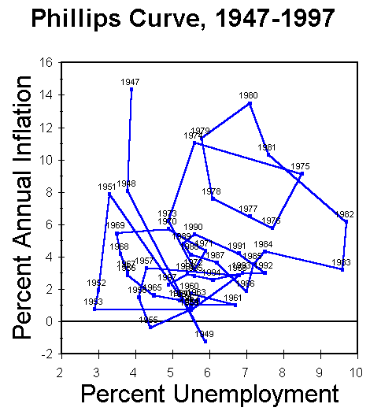
Figure 3 – Phillips curve for 1947 – 1997 period

We can get a good view of the difference between the original Phillips curve and a new one drawn for the 1947 – 1997 period for the United States of America by looking at Figure 3. The original curve may be found in some short-term periods, such as the 1961 – 1969, 1976 – 1979 and 1980 – 1982 periods, shown in pink of the Figure 3. However, on the long run, the theory behind the Phillips curve fails to prove true, and looks more like an 8 months baby’s draw…

Friedman’s critics

One of the critics of the original Phillips curve came from Milton Friedman, who explained in three steps in his paper the logical (or lack of logical) and stage of life of the Phillips curve.
Milton Friedman

We use here the Friedman’s paper published in the Journal of political economy in 1976 to explain how he came to the conclusion that the Phillips curve didn’t keep the road.

In theory, things should happen in the same way as planned in the part A of our paper. That is, there is a stable and complete trade off between the inflation and the unemployment (Figure 1)
However, the empirical data for the USA (Figure 3) tend to show periods where high inflation leads to high unemployment (1951 – 1953, 1979 – 1980), shown in yellow in Figure 3. The paper from Friedman stated that “what mattered for employment was not wages in dollars or pounds or kronor but real wages – what the wages would buy in goods and services”. I would add the Shakespeare’s Romeo and Juliet line “What in a name?” £10 means nothing if not what one pound can buy with it. That is, an other reason why we don’t get the results we could expect is because people are not fooled for a long time. Let us introduce here the concept of natural rate of unemployment.

The natural rate of unemployment

The natural rate of unemployment involves the fact that whatever the benefits of working, there will always be some people not working, for a reason or another. It could be a temporary unemployment in the process of finding a new job after having left (or having been fired from) an old one. It could also simply be because a lady prefers to take care of her children instead of going to work and pay high wage to the lady who will take care of the children when she is not home. It can also be because the government offers so generous unemployment benefits that a low skilled man would lose if he was to work at minimum wage. A general term would be to say that all these persons feel they are better while not working than when working. They constitute the naturally unemployed people, and therefore their weight over the total citizens constitutes the natural rate of unemployment. On figure 4, we see this natural rate at point U*.
Figure 4 – Government strategy

Now let see what happens if the government believe in its capacity to decrease the unemployment rate by increasing money supply. As the government thinks, the increase in money supply will tell the producers to increase their production because the demand should rise. So they will be more willing to provide better wages to their employees, raising wages on Figure 5 from P* to P₁. They believe that the benefits they will receive from the government’s measures will be higher that the increase in labour wages. Then, on the short-run, the non-working people, believing that they are going to receive more if they go to work, will accept to volunteer their labour instead of staying home.

They do so because they perceive an improvement in their situation by going to work. They don’t see that the prices will have to increase on the market in order to compensate the reduction of profit at ancient prices. We are then at point P₁U₁ in Figure 5. However, as we just said, prices are going to increase to support the increase of wages. Workers won’t see it as long as they suffer from money illusion (more nominal money in their pockets, but not more real purchasing power).

Let’s see how. The belief from the government that unemployment will remain as low as planned on the Figure 5 is based on the idea that unemployed and workers have a fixed expectation of the inflation rate that is taken into account in their sight of the prices levels. The government also counts on the belief that workers won’t be able to find out that prices increased more than what was expected and that they have been fooled by the nice voices of the government. They won’t find out that the money they receive now is not able to buy more goods and services than what they were able to buy while being unemployed.
Figure 5 – Companies reaction
Figure 6 – Lady reaction
In numbers, if a lady receives £100 a week from unemployment benefits, and she now gets the opportunity to receive £110 to work for a factory. This increase in the numerical amount of money will fool the lady on the short run, while she believes that she can by for £10 more a week. However, with the time flying, the lady sees the price of her tea rising by 10% in response in the increase of 10% of the wages. When our lady, smart as she can be, realises that she has been fooled, and that she is not better of from working, she will adjust her expectations, and will stop to volunteer her labour. That’s what we see in Figure 6, when the lady refuses to volunteer her labour, the Labour supply curve shifts to the left, somewhere between U* and U₁. This is not all, however. That is, our lady now thinks that the inflation rate will be 10%, so now, to trade her unemployment to a job, she will want a wage in accordance with this rise, higher that her new expected inflation rate. This leads us to Figure 7, where the new expectations of our lady and her fellow citizens have risen to form a new Phillips curve. This demand for higher wages will then lead to higher prices, then higher demand for wages, creating a circle increasing always and always prices but keeping the same unemployment result.
Figure 7 – New Phillips curve

Then what now? We see higher wages, with higher prices that make the higher wages just able to buy the same as the old wages were earlier… Is our lady better of? She sure isn’t. Is she worst of? Well, that depends of the government. If the government indexes the unemployment benefits, she should be in the same exact position than before.

The Figure 8 shows how the general process works. With the presence of a natural rate of unemployment, and in presence of clever citizens, the only result of a government move under the Phillips curve theory is to increase the citizens’ expectations over the rate of inflation, letting the rate of unemployment unchanged between each short-run try from the government to increase employment. The Figure 9 shows the final long-run Phillips curve, which we can already see in Figure 8.
Figure 8 – The lady expectation changes
Figure 9 – Long run Phillips curve

Change in employment structure

Another reason of the increase in employment stated by Friedman is the change in the employment structure. As Friedman says in the same article, the fact that a large amount of women, teenagers and part-time workers entering the work market helped to increase the natural rate of unemployment. Since they are not as frightened to change their job and therefore can change more often, they produce more unemployment during the change process.

Conditions for a working Phillips curve

One way the original Phillips curve could works properly in the long-run would be if the government was able to make its own citizens believe whatever it wants them to believe, like for example that the increase in wages will not lead to an increase in the general prices level.

There is however low chance that the housewife won’t find out that the Pepsi bottle costs more, just like the bread, the soap, etc… this indeed reduces a lot the chances that people stay fooled long enough to re-elect the government.

Another way, in my opinion, the Phillips curve could work is if it’s shaped with an almost horizontal curve. That is, we would come back to the pre-inflation era, where a very small inflation was seen and then, looked inoffensive to population. Then a light increase in inflation would lead to a high decrease in unemployment. We can see it in Figure 10. But is it possible? I fear not. I remember having been told by my economics teacher, in high school, that before the 80’, the government just had to declare the end of recession to see unemployment decrease, as a result of the confidence people had in government. However, the end of 90’s recession announced by government in Canada as a result of the end of the American recession didn’t occur, even with all the nice speeches about the government’s confidence in an increase of output. Then, the fact is that people are not naïve anymore, and they prefer to judge by themselves to appreciate a situation. So, a pronounced decrease in unemployment would lead them to believe that inflation is going to occur, which will in turn provoke the expected increase in prices.
Figure 10 – A working Phillips curve

Conclusion

At the light of what we have seen, it sounds easy now to state that the only good way to interpret the Phillips curve is, at best, a short-term mean to government to decide whether it prefers inflation or unemployment. At worst, we can interpret it as a simple regression of historical data with no worth to predict future government behaviour.

So then, why does government use it to justify its behaviour? Maybe because government’s economists finally convinced their employers that controlling inflation was the best way to create jobs, as suggests Friedman when he commits a positively sloped Phillips curve that sees unemployment decreasing when inflation decreases…

The Fallacy of the Phillips Curve http://www.netlabs.net/hp/marty/econ01.html

