Crash Course: Photography 101

Producing Black-and-White Photos for Dummies
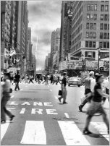
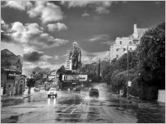
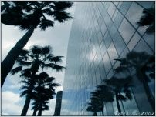

The mystery of making Black-and-White photos manually is as easy as 1-2-3. In fact, you can start having your personal darkroom now, and later on, plan on putting up a small business after orienting yourself with the basics of B&W processing. That will spare you from having to pay manual developing centers with overpriced service fees! Just make sure to follow the basic instructions below and you’ll have your own B&W photos in no time!

Why Black-and-White?
Every thing is digital nowadays. In fact, you might ask what is the need for manual processing when most people are into digital photography, which of course entails less effort and time. But Black-and-White photography has a different story. The beauty in it is that you can control the effects and play with the photo even while processing it! Because of this, you can make dramatic yet creative prints that are better than any machine-printed photo. It only requires a bit of patience and practice to actually understand its nature.

Things to know before starting:
The art of B&W photography starts by taking photos with a camera containing a B&W film. This is used by manual and Instamatic cameras. After taking shots of whatever subject you are interested in, you move on to the processing part. Processing means “developing, fixing and washing exposed photographic film or paper” (www.kodak.com). This method takes up two parts: developing your film, and second, printing your photos manually.

Materials and equipment needed:
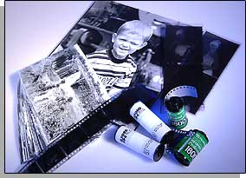

For the Dry Part:
- Dark room = “any lighttight area used for processing films and for printing and processing papers, also for loading and unloading filmholders and cameras”. (www.kodak.com). Dark room should have a sink, faucet for running water and sturdy work surfaces and a cool temperature to keep your sweat off your film and allow your materials (especially your photopaper and chemicals) to stay fresh.
- Stainless steel film tanks and reels = usually go together. It is where you can load and unload your film for developing. It costs around Php800 for single-reeled HANSA tank and Php1200 for double-reeled HANSA tank.
- Photopaper = used for printing your image. It is contained in a light-tight plastic bag. Prices are available for different sizes.
- Timer or clock = to time your exposures
- Red light = not required but advised for beginners. It is referred to as the “safe light” because it does not do much damage to your exposure. It helps you see things in total darkness. You can buy this in your local hardware store at an affordable price.
- Enlarger = a device that exposes the image from the film to the photopaper. Price ranges from Php8000 – 15000, depending on the brand and model of the enlarger.
- Contact print holder = an instrument for holding and printing contact prints. Price differs for different sizes. Estimated price range is from 1000 – 3000.
- Negative carrier = holds the negative to be printed. Usually included when you purchase an enlarger.
- Enough storage space for the needed things mentioned above

For the Wet Part:
- A sink with running water. Sink should be at least 5 feet long, enough for putting trays and bottles of chemicals.
- A 1-ft. hose from the faucet
- Four small trays, preferably 11x14
- Hangers and clips; for hanging processed films and prints to dry
- Surgical gloves and face masks, for protection while mixing and handling chemical. All chemicals to be used are inflammable and poisonous.
- A stirrer for mixing, pouring chemicals.
- Chemicals needed are:
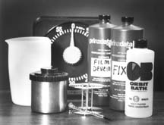

Chemicals | Price for Powder | Price for Liquid

Developer for Developing

Developer fir Printing

Stopbath
*this is running water only*

Fixer
Hypoclear
Photogloss

The materials needed for B&W processing are relatively cheap. However, the enlarger is the most expensive among all the equipment cited above, but you can consider it an investment in the long run if you’re planning to venture into B&W processing business someday. You can ask your local camera shop for other possible equipment or tools needed. As far as I know, there are packaged kits available if you want something more affordable.

Part 1: Developing your B&W film

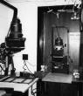
- Construct your own darkroom. Be sure to block the entire light source in building your darkroom. Mask the areas where light is coming from by a packaging tape (even the light bulb switch). For the spaces near the hinges of the door, troubleshoot this by putting a think black curtain larger than the size of the door. Ventilation is also necessary. A room with an air-conditioner is advisable because the chemicals give off fumes that are quite awful and unhealthy if subjected to prolonged exposure. The dark room will be your workplace for developing films and printing B&W images, so it is better to pick a room that is spacious enough to store all the equipment and materials mentioned above.

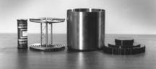
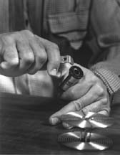
- Now you can start developing your film. First, crack open the container of your film (you can also use a film filter to do this). Roll the film slowly to the reel. Make sure that the reel tightly holds the film and no surface of the film is crumpled. A lot of people have difficulty winding the film onto steel reels. I admit when I first started, I gave up at once and turned on the lights, just to realize that such was a wrong idea. It takes good coordination and a lot of patience, though. You are advised to practice rolling a test film before putting your actual film to the reel. Practice makes it better. Once it is perfectly rolled onto the reel, load the reel (holding the film) into the tank. Cover it with the lid of the tank and switch on the room light. The tank is light-tight, so there’s nothing to worry about. Pull open the cap of the lid (which has a tiny opening to allow chemicals to get through it), then apply the necessary chemicals, in order.
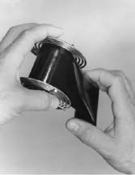
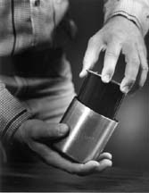
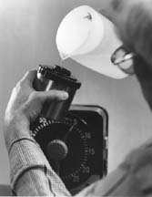
- Pouring the chemicals. Chemicals come in powder and liquid form. The former is much cheaper and they also dissolve more slowly in the water, for the latter, you don’t have to mix them with water anymore; it can be used instantly in whatever quantity needed. Chemicals are light-sensitive so you should put them in a plastic, opaque container with a tight lid. Also, store them in low temperatures (room temperature
should at least be 20ºC). All chemicals have shelf-
lives.
The Developer has the shortest shelf-life of all.

The chemicals to be applied are listed in order:
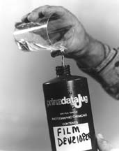
  - Developer – This chemical makes the images in your films appear. Pour the chemical inside the tank until it is filled. Shake it for a few minutes depending on the ASA of your film. You do the math. A table is provided below as a guide:

ASA | Minutes
100 | 3 mins
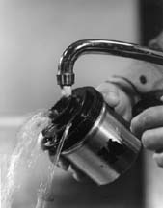  400 | 5 mins

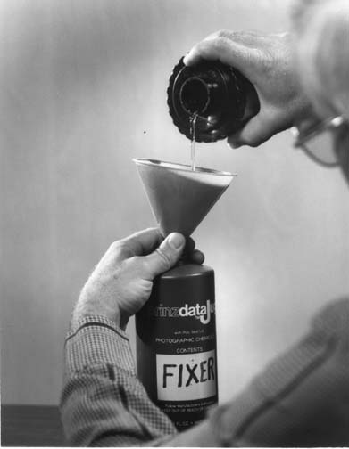
You can shake your tank in different ways: left-to-right, upwards-then-downwards, etc. If bored, you can even do the cha-cha and shake your tank to the beat, just as long as you do it consistently for the rest of the chemicals to be poured in your tank. The principle behind this consistency of shaking is for the chemicals to have a uniform direction or effect on the film (well, at least according to my Film110 professor). This process of pouring chemicals and shaking it for a calculated time is called agitation process.

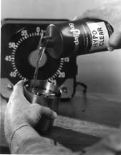
  - Stopbath – According to Mason Resnick, “the stop bath is really a step, not a chemical. It halts the action of the developer by lowering the PH of the residual developer on the film below the working threshold. Once the PH drops below a certain level, the developer stops working” (www.photogs.com). You do this by pouring running water into your tank for 30 seconds. Again, don’t stop shaking, or dancing.
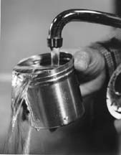
  - Fixer – After that, pour the fixer. From the name itself, it permanently fixes the images in your film. For fixers, I commonly use KODAK, but there are other brands available in the market, if you want to try others. Shake it for about 10 minutes. You can have a quick glance of your shots after applying this chemical because like what was mentioned earlier, it has already fixed your image permanently, so even a ray of light won’t bring much damage to your film. Put the film reel (still with the film) back to the tank after taking a look at your negative.
  - Hypoclear – This solution clears the impurities brought about by other chemicals, it also efficiently gets rid of the fixer. Shake you tank containing this chemical for 4 minutes.
  - Running water – For best results, apply running water to cleanse your film thoroughly. 3 –5 minutes will do.
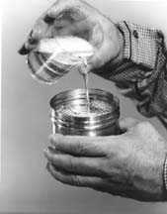
  - Wetting Agent – This is another useful agent, but some developing centers do away with this. I use Kodak Photo-Flo to add a little gloss on my film. Wetting agents make it much easier to squeeze out the film from the reel and dry it off quickly. Pour it into the tank and shake it for 30 seconds.

As a summary of the length of time needed for each solution, a guide is provided below:

Chemicals | Duration
Developer  100 ASA  400 ASA | 3 mins  5 mins
Stopbath | 30 secs
Fixer | 10 mins
Hypoclear | 4 mins
Running water | 4 mins
Photogloss | 30 secs

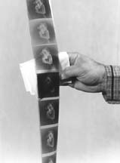
- Drying your film. After applying all the necessary chemicals, you can now open your tank and pull off the film from the reel carefully. Do not touch the emulsion side of the film to prevent fingerprints. Hang your film till it dries.

Part II. Producing B&W prints.
For this part, you should have at least a background on how the enlarger operates and knowledge of the exposure time needed for each setting in the aperture in the enlarger.

- Check your film if it is dry enough for printing the images. There should be no water dripping from it.
- Make sure that the necessary chemicals are already prepared in the dark room before printing your images. Same chemicals are applied in printing an image on a photopaper, except for the developer. I normally use KODAK’s Dektol for printing. The chemicals should also be positioned near your enlarger. Length of time corresponding to each chemical is as follows:

Chemicals | Duration
Developer | Till image comes out
Stopbath | 3 – 5 secs
Fixer | 10 mins
Hypoclear | 5 mins
Water | 3 – 5 mins

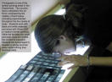
- Make a contact print. Cut your negatives into strips. Each strip should have 6 images or frames. Load them in a contact print holder. Make sure that each strip is tightly secured in it. The contact print should go in emulsion side down, the matt side, with the edge numbers to the back. Ensure the negative is clean.
- Proceed to the dark room. Bring with you your photopaper and of course, the contact print holder containing the strips of negatives.
- Plug the photo enlarger. Make use of the red filter of the enlarger all the time when arranging which images to be produced. Also, it is necessary to use the red light filter when preparing the photopaper on the tray of the enlarger.
- Prepare the photopaper. Place a sheet of paper behind the contact prints, inside the contact print holder. Remember to always use the red light filter when preparing your photopaper to avoid exposure.
- Turn out the light of the photo enlarger and remove the red light filter on the enlarger’s light source. Put the enlarger lens to its medium aperture (5.6) to provide the moderate exposure to your image. You will need to test and re-test again and again to get the desired exposure needed. There’s no exact formula in manual B&W developing for achieving the best image. However, you are advised to make a test print (which will be discussed later) first to save on photopapers and have an estimated time of your desired exposure.
- Turn on the light of the photo enlarger and as a start, count from 1 to 10. If, after immersing your contact print in different solutions, and exposure is not right, lessen count or add some more count.
- Slide paper face down into developer and rock tray gently. Don’t stop until an image appears. If an image does not appear, then something went wrong while exposing your image in the enlarger. Some of the common mistakes are, overexposure and underexposure. Meaning, its either you applied to much light or less light while making your image appear on the paper. If an image appears, proceed to the next solution.
- Lift paper and allow excess developer to drain.
- Slide paper down into the stop bath and rock again for 3 - 5 seconds. Lift and drain.
- Submerge paper into the fixer for 10 minutes. Lift and drain again. You can check the image with a red light or have a glimpse of it with a bright light if the image is good. If it is not, figure out mistake and go back to the enlarger again. If successful, proceed to the next solution.
- Slide paper to the hypoclear solution for 5 minutes.
- Lastly, submerge paper to the water for final cleansing. Leave it for 3 – 5 mins.
- After that, get paper and hang to dry.
- Check out the image from the contact print that you would want to enlarge.

Before enlarging the picture you want, it is better if you use a test strip to determine the exposure time desired.
- Put the film strip containing the desired image to be enlarged in the negative carrier. Again, it should go emulsion side down.
- Repeat steps 4 to 7.
- Turn on the light from the enlarger and cover a small part of the paper with a black card and expose for 3 seconds. Repeat until you have exposed all the paper. You have a sheet with different exposures on it. One of 3 secs, then 6, then 9, 12, 15 and so on.
- Repeat steps 9 to 15
- Now you have a test strip.

After the test strip,
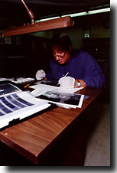
- Choose the desired exposure you would want to achieve. Follow the count corresponding to that desired photo.
- Repeat steps 6 and 7.
- Turn on the light of the photo enlarger and count depending on the desired exposure time. Proceed to the chemical area afterward.
- Repeat steps 9 to 15.
- Viola! You now have your B&W print! ☺

There you have it, how to develop and print your B&W image. Just remember that mistakes are normal for beginners, but do not lose hope. Just keep on trying and you’ll eventually perfect it! Keep on experimenting and soon you’ll realize that B&W processing has more to offer than the what-you-see-is-what-you-get digital printing.

For more information about B&W processing, check out the following websites listed below.

_______________________________________

References:
www.photogs.com/bwworld
www.kodak.com/global/en/consumer/education/lessonPlans/darkroon/fullCourse.shtml
www.agfanet.com/en/café/photocourse/bwcourse/cont_index.php3
www.silverlight.co.uk/tutorials/basic/printdev.html

Picture Sources:
http://www.skylightweb.com/imagine/selfreview.html = For First 3 photos
www.princeton.edu/~wilsonco/ facilities.html = darkroom photo
www.ccsf.edu/Departments/ Photography/inuse.html = test strip photo
www.cofc.edu/studioart/ photography.html = contact print photo
http://www.colab.com/images/processing_printing/bwdev_print.jpg = materials needed photo
www.libarts.ucok.edu/journalism/ Basicfilmdev.html = for the process of developing film and chemicals

Submitted by: Erika Jane C. Dandal Submitted to: Prof. Danilo Arao

