Incision and drainage of a dental abscess

By Dr.Arthur Nouel

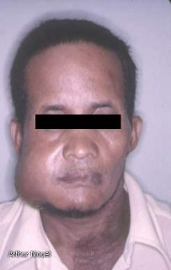
Abscess of dental origin present in region of the masseter muscle caused by a penetrating carious lesion of the lower right 3rd molar (#48).
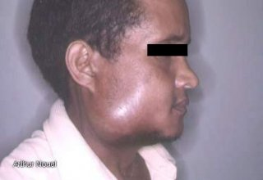

Lateral view of the patient.

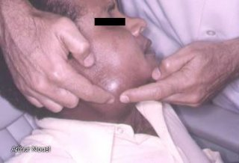

Bidigital palpation of the abscess to confirm its fluctuating nature.

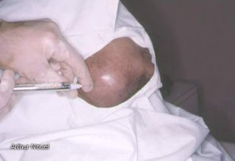

Anesthesia of the skin.

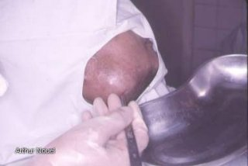

Scalpel incision in the most prominent part of the lesion.

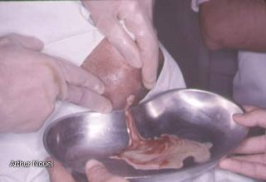

Compression of the lesion to expel the contents.

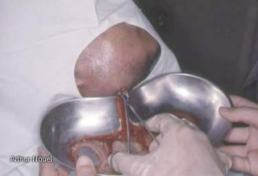

Insertion of mosquito forceps into the center of the abscess, to assure drainage.

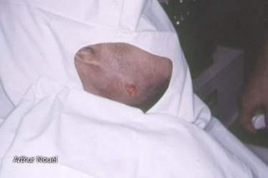

Drainage with gauze strips inserted in iodoform solution.

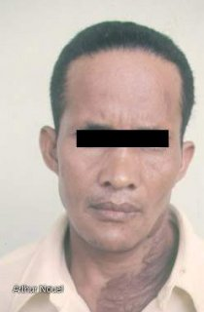

Post op (late). Patient cured.

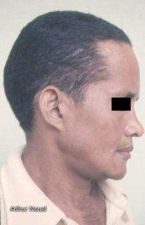

Lateral view where the scarring of the wound is visible.

