MATH108DE
Practice 1 Problems
5 problems
SOLUTIONS
text: College Algebra with Trigonometry, 7th ed
by Barnett, Ziegler, Byleen
McGraw-Hill
Practice 1 Problems
sec6.1 ....page 421, prob 14, 20
sec6.2 ....page 433, prob 26
sec6.3 ....page 442, prob 12
sec6.4 ....page 453, prob 64
______________________________________________________________________
Sec 6.1
page 421, prob 14
Converting from degree measure of an angle to radian measure of an angle.
SOLUTION
Since
to get the conversion factor to convert from degrees to radians we simply divide the above equation
by 180 to get
.
So
Sec6.1
page 421, prob 20
Converting from radian measure of an angle to degree measure of an angle.
SOLUTION
The angles in this problem are all negative angles.
That means that the angle is generated by a clockwise rotation of the terminal side of the angle.
A positive angle is generated by a counterclockwise rotation of the terminal side of the angle.
Sine
to get the conversion factor to convert from radians to degrees we simply divide the above equation
by to get
.
However, in this problem all the angles are expressed in terms of , so the arithmetic is easier.
Sec6.2
page 433, prob 26
We have to solve a right triangle.
That means we must find the measures of all the sides and all the angles of the right triangle.
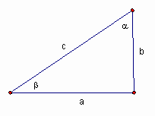
We are given the data that
SOLUTION
First, because it's easiest to do, let's find the measure of the complementary angle
The measure of the side c is given.
To find the measures of the other two sides, we can use the sine function and the cosine function.
The value is rounded to one decimal place.
The value is rounded to one decimal place.
Sec6.3
page 442, prob 12
Find the values of the other five trig functions given that
; is an angle in quadrant III.
SOLUTION
The sign of a trig function in each of the four quadrants can be read from the signs
of the coordinates of a point in each of the four quadrants.
Quadrant II Quadrant I
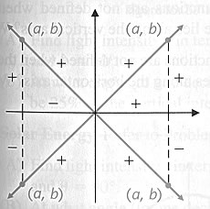
Quadrant III Quadrant IV
Remember that is the positive distance of the point from the origin of the coordinate axes, .
An angle is said to be in a certain quadrant when the terminal side of the angle is in that quadrant.
For this problem the angle is in quadrant III.
That means that the terminal side of the angle in quadrant III.
A point in quadrant III has an x-coordinate that is negative and a y-coordinate that also is negative.
That is, a point will have coordinates ( - , -).
Use the reference angle associated with the angle .
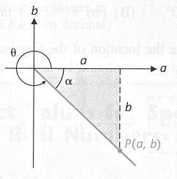
NOTE: The above figure is drawn for a point P in quadrant IV.
For our problem the point P(a,b) is in quadrant III.
and
So the point P in the reference triangle has the coordinates P( -3, -4 ).
Using the definitions of the trig functions for any angle, we get
Sec6.4
page 453, prob 64
Find the smallest positive angle in degree measure for which
.
SOLUTION
From the definition of the cosecant function for any angle
,
since r is always positive, the denominator must be negative in order for the fraction itself
to be negative,
.
That is, r = 2 and b= -1.
So the terminal side of the angle must be in quadrant III
and
.
The reference triangle is then the 30-60 right triangle
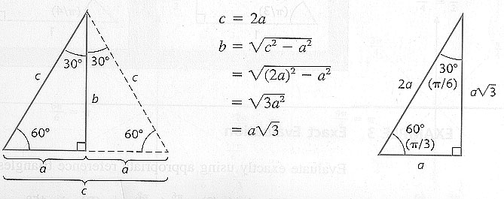
From the above figure
so the reference angle associated with is
and the smallest value for - remember is an angle in quadrant III - would then be
is the final answer.
- END

