MATH108DE
Practice 10 Problems
5 problems
SOLUTIONS
Practice 10 Problems
sec 8.7 ........p640, prob 6, 18
sec 12.1.......p858, prob 10
p859, prob 24, 46
______________________________________________________________________
1] Sec 8.7 p640, prob 6
Use De Moivre’s Theorem to evaluate the given expression. Express the answer in polar form.
SOLUTION
The modulus
and the argument
reference angle is
Now the complex number
lies in quadrant IV of the plane, so we can write either
So
Then by De Moivre’s Theorem
or
Let’s simplify this.
Remember that the sine and cosine functions both have a period of and we can write
So
simplifies to
or in exponential notation
the final answer
2] Sec 8.7 p640, prob 18
For and as indicated, find all the roots of . Leave the answers in polar form.
SOLUTION
We need to find all the values of .
The modulus is
The reference angle is , so the argument of is
There will be three values.
By De Moivre’s Theorem
or
where
That is, takes the value 0, then , then
The following three values of comprise the final answer:
For
For
For
3] Sec 12.1 p858, prob 10
Graph the equation and locate the focus and the directrix.
That is, find the coordinates of the focus and find the equation the directrix.
SOLUTION
Comparing
with the standard equation of a parabola (see Theorem 1, page 854),
we see that the parabola opens down
vertex of the parabola for
is at the origin
focus is at or for our problem
directrix is the horizontal line or for our problem, the horizontal line
in the graph below
The graph is
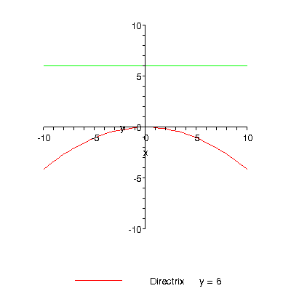
4] Sec 12.1 p859, prob 24
Find the equation of a parabola with vertex at the origin , axis the x or the y axis, and
SOLUTION
Since it is given that the vertex is at the origin and the axis is either the x- or the y-axis of the coordinate system,
the parabola must be in one of the standard positions.
And since the directrix is the horizontal line
(see Theorem 1, page 854)
the parabola must open up.
The standard equation for such a parabola is
So our parabola has the equation
or
final answer
5] Sec12.1 page 859, prob 46
Use the definition of a parabola and the distance formula to find the equation of a parabola with
and
SOLUTION
A parabola is the set of all points in a plane equidistant from a fixed point called the focus and a fixed line called the directrix in the plane.
The distance from a point on the parabola to the focus is given by the expression, using the distance formula,
The distance from to the directrix is given by the expression, using the distance formula,
Using the definition of the parabola, we equate the two expressions
and square both sides of the equation to get rid of the square roots
Simplifying
Notice that the appearing on both sides of the equation cancel each other out
and further simplifying, we get
final answer
- END -

