MATH108DE
Practice 11 Problems
8 problems
SOLUTIONS
Practice 11 Problems
sec 12.2 .......p869, prob 10
p870, prob 18, 22
sec 12.3.......p881, prob 4, 6, 14, 16, 24
______________________________________________________________________
1] Sec 12.2 p869, prob 10
Sketch a graph of the equation, find the coordinates of the foci, and find the lengths
of the major and minor axes.
SOLUTION
In order to read off the lengths of the major and minor axes, first put the given equation in a standard form.
Divide both sides of the equation by 24,
The denominator of the is bigger than the denominator of the , which indicates that the major axis
of the ellipse, center at the origin , is vertical and lies along the y-axis of the coordinate system .
Looking at Theorem 1, pages 8 64 – 865, we see that
length of the semi-major axis squared
so the length of the major axis is
length of the semi-minor axis squared
so the length of the minor axis is
The equation
gives the relationship between the lengths of the semi-major axis, semi-minor axis,
and , the positive distance from the center of the ellipse to a focus of the ellipse.
So
The ellipse has the two foci located at and ,
so the foci of our ellipse are at
and
The graph of the ellipse is
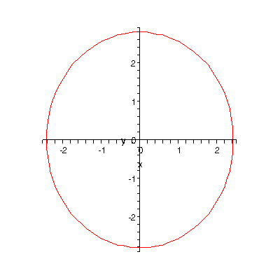
2] Sec 12.2 p870, prob 18
Find an equation of an ellipse in the form
if the center is at the origin and
Major axis on x axis
Minor axis length = 4
Distance between foci = 50
SOLUTION
The length of the minor axis is , so
The distance between the two foci of the ellipse is , so .
We have and , we determine from the equation
so
Then the equation of the ellipse is
or
final answer
3] Sec 12.2 p870, prob 22
Graph the system of equations in the same rectangular coordinate system and find the coordinates
of any points of intersection. Find noninteger coordinates to three decimal places.
SOLUTION
The linear equation represents a straight line and the quadratic equation represents an ellipse, as shown
in the above below.
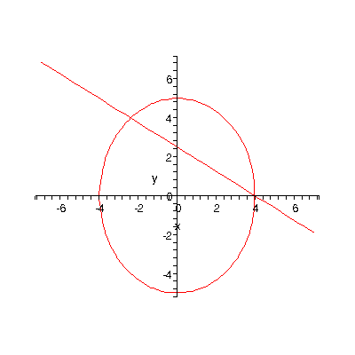
Now let’s algebraically find the coordinates of the two points of intersection as shown in the above figure.
We must solve the given system of equations.
Because it’s easier to do, start with the linear equation
Substitute this expression into the quadratic equation
Expand the squared term
Simplifying
Rewriting this in the standard of a quadratic equation,
and solving it using the quadratic formula
we get the two solutions
so the corresponding
and
so the corresponding
so the two points of intersection of the system of equations are
and final answer
4] Sec 12.3 p881, prob 4
Sketch a graph of the equation, find the coordinates of the foci, and find the lengths
of the transverse and conjugates axes.
SOLUTION
Now we have a problem about hyperbolas, so look at Theorem 1, page 875 of the textbook.
The form in Theorem 1 that fits our problem is
From the form of the given equation, we see that the graph of our hyperbola will open up and open down
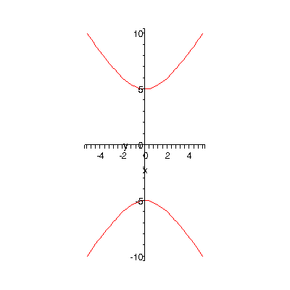
There are no x-intercepts as the graph does not intersect the x-axis at any point.
so and the length of the transverse axis is
so and the length of the conjugate axis is
To find the coordinates of the foci, use the equation
so
then
so the two foci of the hyperbola are located at
and
5] Sec 12.3 p881, prob 6
Sketch a graph of the equation, find the coordinates of the foci, and find the lengths
of the transverse and conjugates axes.
SOLUTION
Again, a hyperbola.
Rewriting the equation so it is in standard form,
we get
The hyperbola opens to the left and to the right
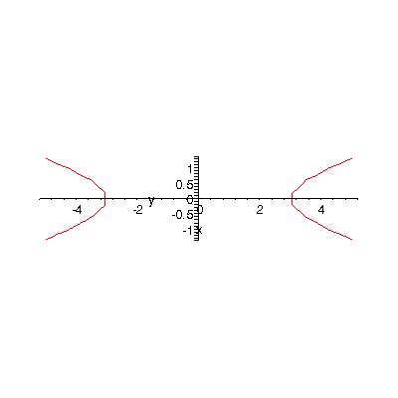
so so the length of the transverse axis is
so so the length of the conjugate axis is
To find the coordinates of the foci, use the equation
so
then
so the two foci of the hyperbola are located at
and
6] Sec 12.3 p881, prob 14
Find an equation of a hyperbola in the form
if the center is at the origin, and
Transverse axis on x axis
Transverse axis length = 22
Conjugate axis length = 2
SOLUTION
The transverse axis is of length so
The conjugate axis is of length so
The required equation is then
or
or
final answer
7] Sec 12.3 p881, prob 16
Find an equation of a hyperbola in the form
if the center is at the origin, and
Transverse axis on y axis
Conjugate axis length = 30
Distance of foci from center = 25
SOLUTION
The conjugate axis is of length so
The distance of foci from center = 25 means that
We need to find , the length of the semi-transverse axis.
Using the equation
we get
then
so
Substituting these values in the form of the equation of an ellipse with transverse axis along the y-axis
we get
or
final answer
8] Sec 12.3 p881, prob 24
Graph the system of equations in the same rectangular coordinate system
and find the coordinates of any points of intersection.
SOLUTION
The graph of the system is
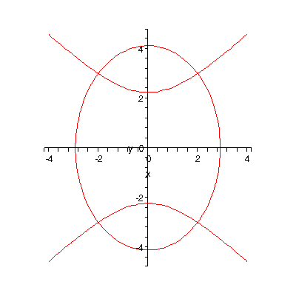
consisting of an ellipse and a hyperbola.
Notice from the graph that the two curves intersect at four points.
Now let’s algebraically solve this system of quadratic equation.
The easiest way to solve this particular system of quadratic equations is by the method of elimination, also called the method of addition and subtraction.
Notice that if we just add together the two equations of the system, then the term
immediately drops out.
___________________
so
then
that is,
or
We need to find the corresponding values of the y-coordinates of the points of intersection.
For :
Substitute this value in either one of the two equations of the system of quadratic equations.
It really doe not matter which equation, we get the same correct answers.
Chose the equation that we think is easier to work with, say the second equation of the system
Solving this equation for the term,
For ,
so
We have found the two points of intersection
and
For :
Again,
so
then
We have found two more points of intersection
and
So the four points of intersection of the graphs of the given system of quadratic equation are
final answer
- END -

