MATH108DE
Practice 13 Problems
7 problems
SOLUTIONS
Practice 13 Problems
sec 9.3 .......p697, prob 6, 8, 12, 24
sec 10.1.......p742, prob 4, 16
p743, prob 40
______________________________________________________________________
1] Sec 9.3 p697, prob 6
Solve the system of equations.
SOLUTION
Use the method of substitution
Solve the second equation for the x variable
and substitute this expression into the first equation
Find the corresponding values of the x variable
For
Graphically, this means that the straight line intersects the ellipse
at the points and
The graph is
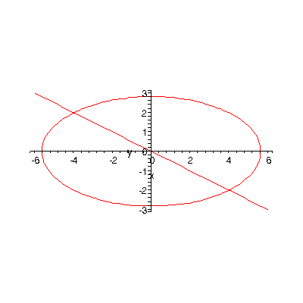
2] Sec 9.3 p697, prob 8
Solve the system of equations.
SOLUTION
Solve the second equation for the y variable
Substitute this expression into the first equation
Using the quadratic formula
we get
The corresponding values for the y variable are
For
So the line intersects the parabola at the points
and
The graph is
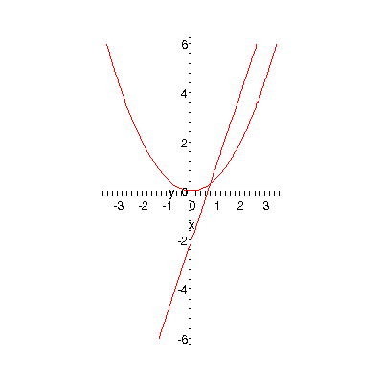
3] Sec 9.3 p697, prob 12
Solve the system of equations.
SOLUTION
For this problem the easiest method is to use the method of elimination
Let’s eliminate the variable
Subtract the second equation from the first equation
Let’s use the first equation
to find the corresponding values for the x variable
For
The ellipse and the hyperbola intersect at the four points
The graph is
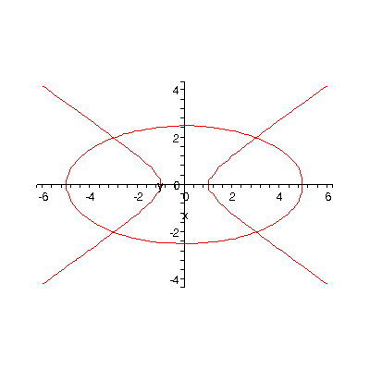
4] Sec 9.3 p697, prob 24
Solve the system of equations.
SOLUTION
Use substitution again
Solve the second equation for the y variable
and substitute this expression into the first equation
Multiply both sides of the equation by to get rid of the fraction
Put it in standard form, that is, have zero alone on one side of the equation
Factor the left side of the equation
Use the Zero Factors Principle
If then or
Set each factor on the left side of the equation equal to zero
gives
gives where , the imaginary unit
The corresponding values for the y variable are
For
The points of intersection of the two hyperbolas are
The first two points will be displayed as intersection points on the graphs
The last two points will not/can not be displayed on the graphs because the coordinate system
we are using permits only the display of points with real number coordinates
These last two points involve the imaginary unit , so these last two points can be displayed
The graph is
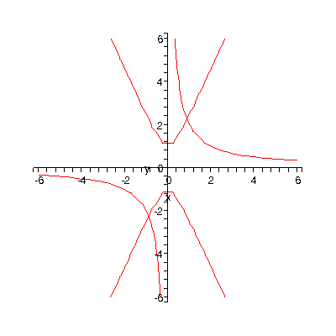
5] Sec 10.1 p742, prob 4
Perform the indicated operation, if possible.
SOLUTION
In matrix addition corresponding elements are added
6] Sec 10.1 p742, prob 16
Perform the indicated operation of matrix multiplication, if possible.
SOLUTION
7] Sec 10.1 p743, prob 40
Perform the indicated operations if possible.
Given
find
SOLUTION
final answer
- END -

