MATH108DE
Practice 9 Problems
8 problems
SOLUTIONS
Practice 9 Problems
sec 8.5 ......p625, prob 14, 16, 20, 38
p626, prob 48, 56
sec 8.6.......p635, prob 26, 28
______________________________________________________________________
1] Sec 8.5 p625, prob 14
Graph in a polar coordinate system.
SOLUTION
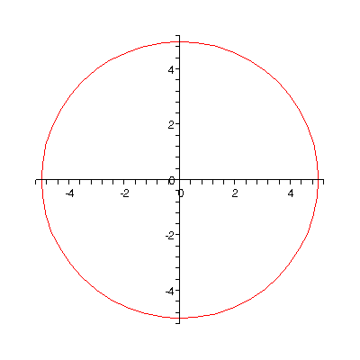
The graph is a circle of radius 5.
2] Sec 8.5 p625, prob 16
Graph in a polar coordinate system.
SOLUTION
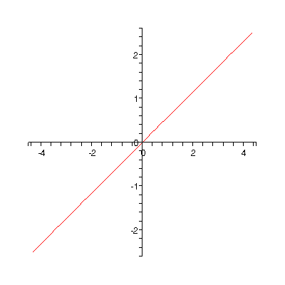
The graph is a straight line going through the polar origin and making an angle of
with the polar axis.
3] Sec 8.5 p625, prob 20
Covert the polar coordianates to rectangular coordinates to three decimal places.
SOLUTION
To convert from polar coordinates to rectangiular coordinates , we use
the transformation formulas
and .
In this problem the point has the polar coordinates
and .
So
are the rectangular coordinates of the given point.
4] Sec 8.5 p625, prob 38
Verify the graph on a graphing uitlity.
SOLUTION
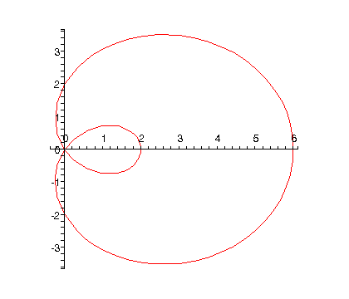
5] Sec 8.5 p626, prob 48
Change the rectangular equation to polar form. Identify the graph as a line, circle, etc.
SOLUTION
To change the equation from rectangular form to polar for, we use the transformation equations
Substitute these expressions into the given equation
we get
Recall that
so the equation simplifies to
Now factor the equation
Then, setting each factor equal to zero, we get
which represents a point,
namely, the origin of the polar coordinate system
and
or
which represents a circle
6] Sec 8.5 p626, prob 56
Change the polar equation to rectangular form. Identify the graph as a line, circle, etc.
SOLUTION
Multiply out the right side of the equation
to get
Now, changing from polar coordinates to rectangular coordinates
we get
or
Now, let’s square both sides of the equation to get rid of the square root on the left side of the equation
Simplifying,
The on both sides of the equation cancel each other out, so we have
which is a rectangular equation of a parabola
7] Sec 8.6 p635, prob 26
Simplify directly and also simplify by using polar forms.
Write answers in both rectangular and polar forms, in degrees.
SOLUTION
First, let’s simplify the expression directly. Do the indicated multiplication using, of course,
the distributive law
writing the answer in the standard form, , of complex numbers.
Now doing the problem again, this time using polar forms, we get:
For :
the radius vector
and
so
So, the polar form of is
For :
the radius vector
and
so
So, the polar form of is
Writing in polar form, the required product
8] Sec 8.6 p635, prob 28
Simplify directly and also simplify by using polar forms.
Write answers in both rectangular and polar forms, in degrees.
SOLUTION
To put the given fraction in the standard form, , of complex numbers we need to get rid
of the complex number appearing in the denominator. We accomplish that by multiplying the
numerator and the denominator of the fraction by the complex conjugate of the denominator,
namely,
For the second part of the problem, we need to write everything in polar form, as we did in the previous problem.
For :
the radius vector and
So the polar form of is
For :
the radius vector and
So the polar form of is
Writing in polar form, the required fraction
- END -

