The graph of y = x^{n}, where n is an integer
 | n is even | n is odd
n positive | Eg y = x², y = x⁴  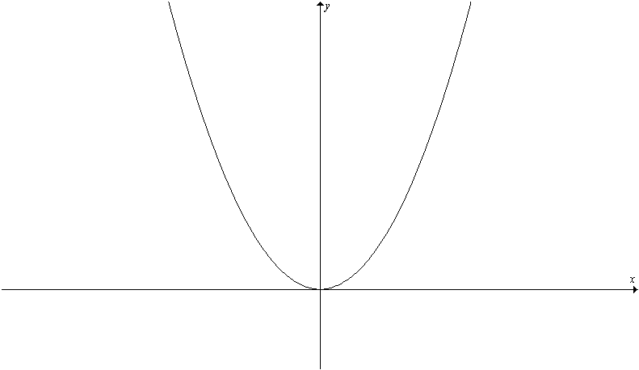 | Eg y = x³, y = x⁵  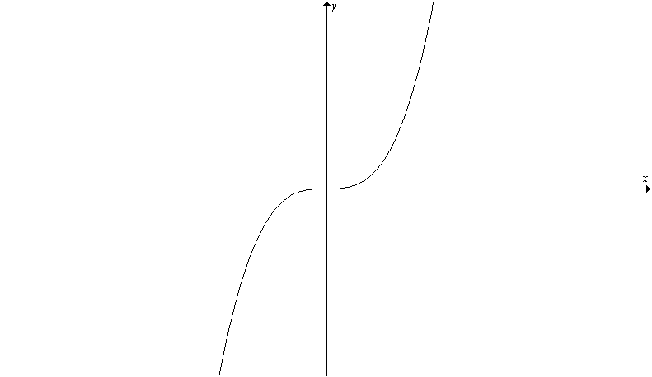
n negative | Eg y = , y =  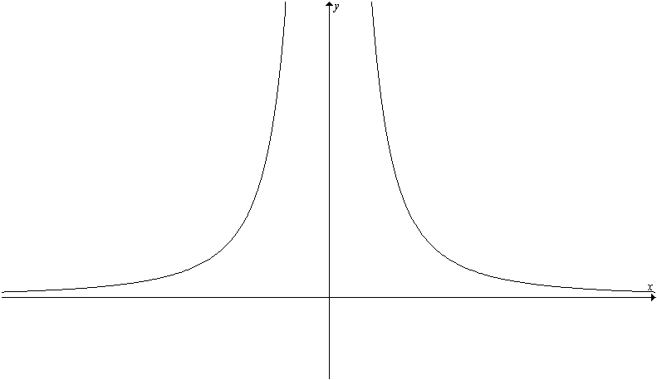 | Eg y = , y =  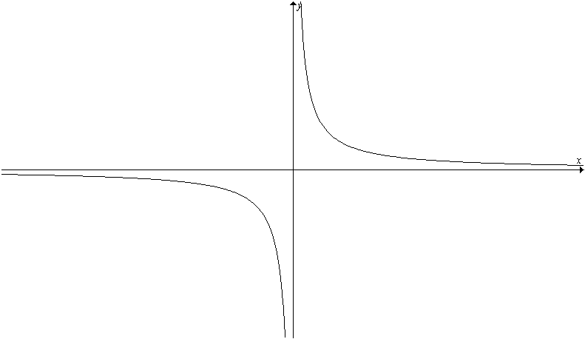

The graph of y = x^{p/q} in the first quadrant
if p < q eg y = x^{1/2}
concave downwards

if p > q eg y = x²
concave upwards
y = x

1

1

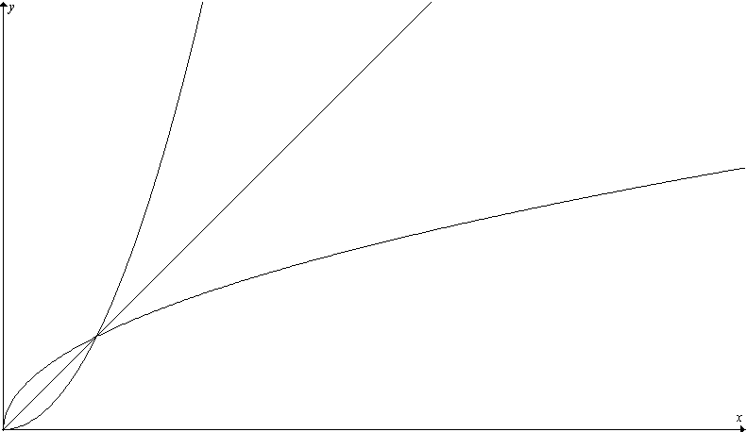

The graph of y = x^{p/q}
 | p/q > 1 | p/q < 1
If p is even, the function is always ≥ 0 and the curve lies in the first & second quadrants | Eg y = x², x⁴, x^{4/3} | Eg y = x^{2/3}, x^{2/5}  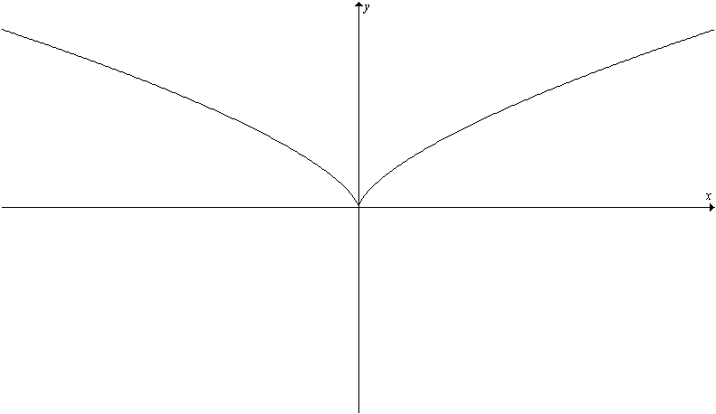
If q is even, the function is only defined for x ≥ 0 and the curve only lies in the first quadrant | Eg y = x^{3/2}, x^{5/2}  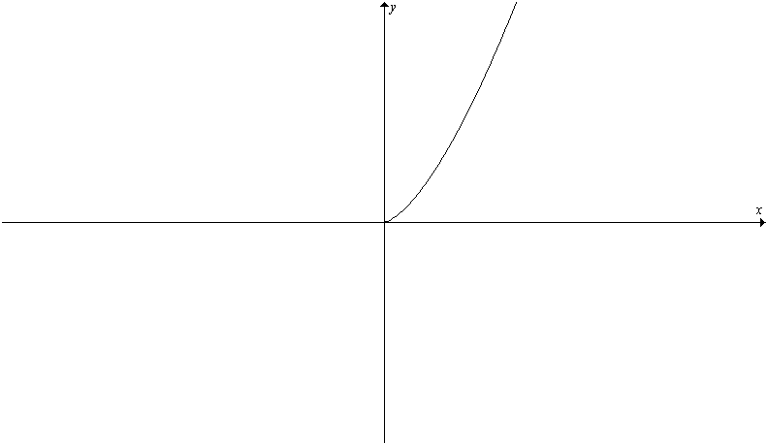 | Eg y = x^{1/2}, x^{1/4}, x^{3/4}  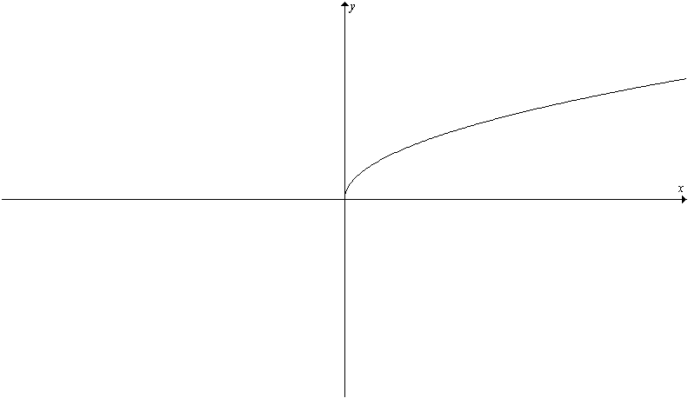
If p & q are both odd, x^{p/q} has the same sign as x and the curve lies in the first & third quadrants | Eg y = x³, x⁵, x^{5/3} | Eg y = x^{1/3}, x^{1/5}, x^{3/5}  