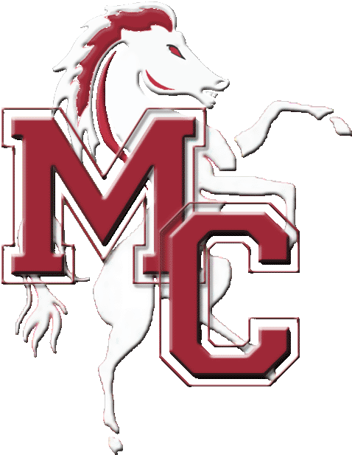
KIT ORDER FORM

Please fill in all applicable boxes for your order and see Sam for enquiries, orders and payment.
NO orders will be taken without full payment and order form. No refunds can be given.

Item | Size | Colour | Design | Quantity | Printed with: | Cost
T-shirt - £10  (s, m, l or age) |  | Red/Black/Grey | 1/2/3/4 |  | NA
Hoodie - £20  (s, m, l) |  | Red/Black/Grey | NA |  | (Name)
Cheer Shorts- £12  (YS, YM, YL, XS, S, M, L)  Printed Shorts £15  Just printing - £5 |  |  |  |  | (Mavericks  or name)
Trainers - £40 |  | NA |  |  | NA
Pom Poms - £18 | NA | NA | NA |  | NA
Bags - £15 | NA | NA | NA |  | NA

MAVERICKS UNIFORM ORDER – Male £50, Female £78
Top Size | Skirt Size | Chest | Waist | Hip | Underarm | Skirt/top length

MAVERICKS DANCE COSTUME - £50
Top Size | Trouser Size | Inside Leg

Name of cheerleader: ……………………………………
I enclose £______ for the total amount of the above order. Please make cheques payable to Mavericks Cheerleaders Club.

