The Curriculum vitae

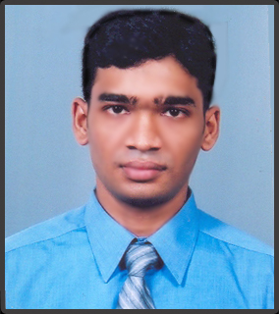 | M.A.Yoosuf  44/30,pamankade road,  Colombo-06,  Sri Lanka.  ( 011-2502-199  mayoosuf@yahoo.com  http://www.geocities.com/mayoosuf/
Working Experience: | 2006  Working as a Documentation specialist(Converting the Documents in to HTML, XHTML, XML, XSD & ASCII formats) at, Office Tiger Sri Lanka (Pvt) ltd.(An RR DONNELLY company)
Acadamic Qualifications: | 2005-2006  Completed the BTEC Higher National Diploma in computing (Edexel UK) at ICBT campus, M^{t}- Lavinia.  Completed the Project work an online reservation system for a Domestic Airline service (Client server system, with the three Their architecture).
Education Qualifications: | 2004  Completed the A/L(Advance level)at Zahira College, Colombo  2000  Completed the O/L(Ordinary level) at Zahira College, Colombo
Personal skills: | ▪ Team work orientation  ▪ Ability to work under pressure  ▪ Self learning and self starter  ▪ Designing applications  ▪ Ability to speak English, Singhalese and Tamil
Interested area: | ▪ Ability to work with Oracle9i, SQL server 2005 and MySQL5.0.  ▪ Website designing (CSS based designing, PHP and MySQL development) and development.  ▪ Good knowledge in Object Oriented Programming techniques.
Personal information:
  Full name: | Muhammad Abdullah Yoosuf
  Address: | 44/30,Pamankede road,  Colombo-06,  Sri Lanka.
  Date of birth: | 17th of march 1984.
  Gender: | Male
  Civil status: | Single
  Nationality: | Sri Lankan
  The NIC: | 840770311V
Referees: | Mr. Buddhika.Abayaratna  Program manager,  IFS Sri Lanka LTD  501, Galle Road ,  Colombo 06.  Telephone: 011- 2364400  E-mail: buddhika.abayaratna@ifs.lk  Mr. Srinimal de Silva  M.M.C JP.  1/3,N.H.S,  PamankadeRoad,  Colombo-6.  Telephone: 011-2365-061  0714-268992

I hereby certify that the above particulars furnished by me are true and correct to the best of my knowledge.

July 31, 2026  …………………………..  Date | M.A.Yoosuf  ……………………………..  Signature

