MEDINA TEMPLE # 19, NYC
Annual Toy Drive
written by Noble Ezra Nanton

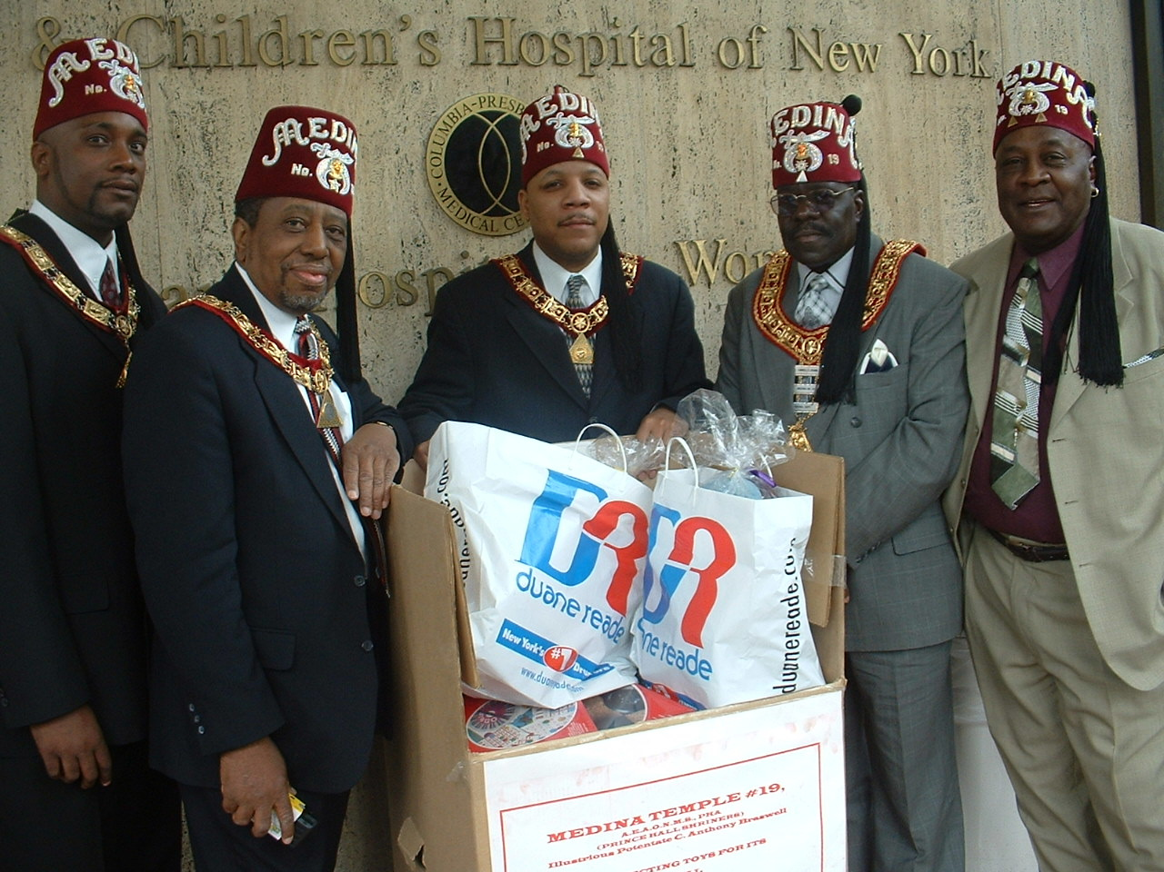
On Sunday, May 17, 2003, Medina Temple culminated its annual “X-Mas in April” Toy Drive by donating the collected toys to the Babies and Children’s Hospital of New York, a division of Columbia-Presbyterian Hospital. Present to receive kudos for the donation was Illustrious Potentate C. Anthony Braswell, Chief Rabban Clarence Brown, High Priest and Prophet Ezra Nanton, Past Potentate John Barmore, Sr., and Past Potentate Lionell C. Evans. “This is just one of the many community programs that Medina does on a consistent basis”, stated Ill. Potentate Braswell. After a brief meeting with hospital representatives, the group then met up with other nobles to attend Medina Court #11’s annual Thanksgiving Service at Calvary Baptist Church in
Harlem, NY.

(From L-R:High Priest and Prophet Ezra Nanton, Chief Rabban Clarence Brown, Ill. Potentate C. Anthony Braswell, PP Lionell Evans, PP John Barmore , Sr.)

