Are you between the ages of 14 to 21 and interested

in a career in the medical field?

Do you want to learn more about emergency medicine?

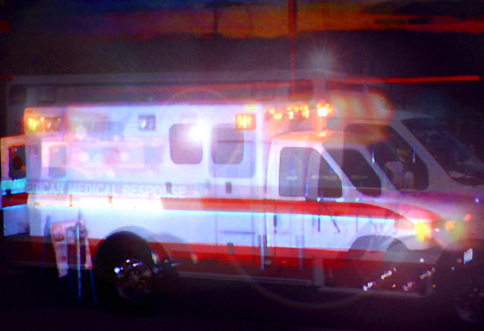
Then join us for Explorer Post 911
First-Nighter

Thursday, October 18th 6:30pm to 8:30pm
American Medical Response Main Building
13075 Gateway Drive
Tukwila, WA 98168
Call Carol at AMR dispatch 1-800-542-7701
or email Crystal: crddle@yahoo.com for more information
http://www.geocities.com/medpost911/index.html

