Cell Division & Genetics Notes
Pages C61 to C68 & C80 toC106

- The cell cycle is the regular sequence of growth and division that all cells undergo.
- There are three major stages. They are interphase, mitosis, &cytokinesis.
- During interphase, the cell grows to its mature size, makes copies of its genetic material, and prepares for division.
- Replication is the term used when the cell makes a copy of its genetic material in the nucleus.
- DNA is the genetic material found in the nucleus.
- During mitosis is cell divides into two identical daughter cells. This allows for growth, repair and replacement of cells in animal development.
- Daughter cells are identical in amount (size) and genetic material to the parent cell.
- There are four steps in the actual process to cell division. They are prophase, metaphase, telophase,&anaphase
- During prophase the chromosomes, which are a condensed doubled rod of genetic material are formed. (in the space provided make a sketch of this phase)

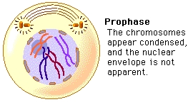

- Each identical rod of this genetic material is called a chromotid.
- The choromatid are held together by a centromere.
- During metaphase the chromosomes line up along the center of the cell. They are held by spindle fibers attached to the centromere of each chromosome. (in the space provided make a sketch of this phase)

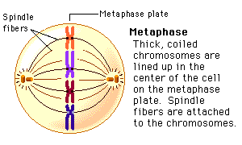
- During anaphase the centromeres split, the chromatids separate. The spindle fibers pull one chromatid to either side of the cell. The cell becomes stretched as opposite ends pull apart. (make a sketch of this phase)

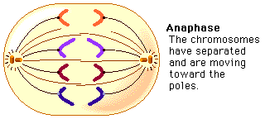

- During telophase, the spindle fibers disappear, and new nuclear membranes form around the chromosomes. (make a sketch of this phase)

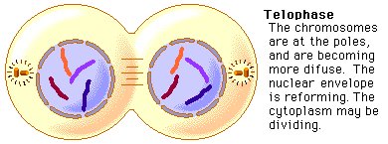

- The final stage of the cell cycle is called cytokenisis. During this stage the cell membrane pinches off leaving two identical daughter cells.
- DNA replication ensures that both daughter cells will have all the genetic information it needs to carry out its activities.
- DNA looks like a twisted ladder. This shape is known a double helix.
- The “sides” of the “ladder” are made of sugars called deoxyribose.
- The “steps” of the “ladder” are made of nucleic acids.
- The nitrogen bases of DNA always match up in specific pairs. Adenine always pairs with thymine, and Guainine always pairs with cytosine.
- If errors occur in the duplication of DNA this is known as a mutation.
- Traits are physical characteristics that are passed from a parent to an offspring.
- heredity is the passing of these physical characteristics through genes.
- Genetics is the study of hereidity
- Gregor Mendel is considered the “Father of Modern Genetics” for his work with pea plants.
- A purebred organism will always produce offspring with the same form of a trait as the parent.
- Gene is a factor that controls traits
- DNA molecules consists of many sections of genes.
- Genes code for a specific protein.

- Alleles are different forms of a gene
- A dominant allele is one whose trait will always show when the allele is present.
- A recessive allele is one that is masked or covered when the other allele is present.
- The only way for an offspring to show a recessive trait is if it inherited the recessive allele from both parent(s).
- Hybrids contain two different alleles.
- Probability is the likelihood that an event will occur, and is expressed as a ratio of the likelihood of the event to the total number of possible outcomes.
- Using common sense, what is the probability of flipping a coin and it landing on heads?
1 out of 2 or 50%

- What is the probability of rolling a six sided dice and getting a two?
1 out of 6 or 16.7%

- Probability of an even number on a six sided die?
3 out of 6 which reduces to 1 out 2 or 50%

- A punnett square is a chart used to show all the possible outcomes of a genetic cross.
- Phenotype is the term used to indicate the physical appearance of the offspring.
- Genotype is the term used to indicate the genetic makeup of the offspring.
- Homozygous is the term used when the organism has two identical alleles. Such as TT (for purebred tall)
- Heterozygous is the term used when an organism has two different alleles. Such as Tt (for hybrid tall)
- The only way that a recessive trait will appear in an organism is if it is homozygous or purebred for the recessive trait, but for the dominant trait to show the organism can be either homozygous or heterozygous for the dominant trait.
- Some alleles are neither dominant not recessive, resulting in codominance. In this case both traits are expressed in the offspring. Example a chicken with both black and white feathers.
Examples for Punnett Squares

A momma rabbit has is purebred with black fur(BB), and the daddy rabbit is purebred with brown fur(bb). White fur is recessive to black fur. What are the possible outcomes of this cross?
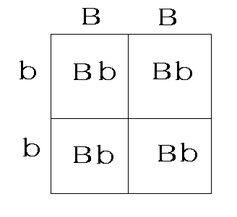
The phenotype of this cross is that all (100%) of the offspring will be black, because the dominant gene is present in all offspring.

The genotype is that all (100%) of the offspring are hybrid black.

Do the same thing for the next examples on your own.

Ex 1)The momma rabbit has hybrid black fur (Bb:B=black and b=brown) and the daddy rabbit has purebred black fur (BB). Complete the punnett square and give the phenotype and genotype of the offspring (using percentages).

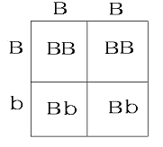
The phenotype for this cross is that 100% of the of the offspring are black and 0% of the offspring are brown.

The genotype is that 50% are purebred black, 0% are purebred brown, and 50% are hybrid black.

Ex 2)A pea plant is hybrid for green peas (Yy where Y = green and y = yellow) It is crossed with another heterozygous green plant (Yy). Complete the punnett square and give the phenotype and genotype of the offspring (using percentages).
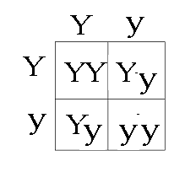
Ex 2-1)The phenotype for this cross is that 75% of the of the offspring are green and 25% of the offspring are yellow.
Ex 2-2)The genotype is that 25% are purebred green, 25% are purebred yellow, and 50% are hybrid green.

Timeline of Genetic Discoveries.
1863 – Gregor Mendle studies pea plants and names genes

1882 – Walther Fleming stained genetic material and called rods chromosomes

1908 – Thomas Hunt Morgan discovered that genes are located on chromosomes
1952 - Crick and Watson made a model of the DNA molecule and proved that genes determine heredity.
1966 - The Genetic code was discovered

