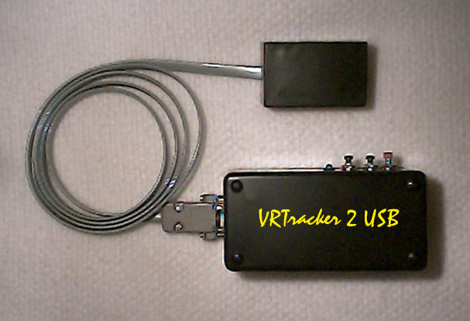

Product may differ slightly from picture. All products are built by hand per order.

The VR Tracker 2 USB 2 USB is a high performance wireless tracker. It is based on the sensing of vibrations as you move from one position to the next. It tracks Yaw and Pitch thus giving a 2DOF (degree of freedom) tracker. It is designed to be clipped to your belt and transmit tracking data to a remote receiving base station. All movement being tracked is detected at the sensor head.

The VR Tracker 2 USB can be used with any application which currently uses a mouse. Its best performance is with first person shooter type games such as QuakeII and Return to Castle Wolfenstein. The key to setting up the VR Tracker 2 USB correctly is setting the mouse sensitivity correctly in each application.

Each application will require some initial adjustment of the mouse settings to compensate for the VR Tracker 2 USB functions and characteristics. Once this initial adjustment is done the program will work flawlessly with the tracker. Providing an amazing sense of immersion when coupled with a head mounted display or similar device.

The VR Tracker 2 USB is a dual module system consisting of the transmitter/sensor head, the receiving base station, and an AC power supply.

The VR Tracker 2 USB receiving base station should be plugged into the USB port of your PC. An initial charging of 9 hours is recommended for the VR Tracker 2 USB transmitter section. Just plug the power cable into the ‘charge port’ located next to the DB9 connection on the rear of the unit.

Warning: The Receiving Base Station should not be placed near any electromagnetic source. For example... your monitor.

Initial Boot up procedure

During initial power up of your VR Tracker 2 USB system a few steps will need to be followed.
- First, push and hold the red switch on the receiving base station for 2 seconds. This will put it into search mode.
- Now press the black switch next to the LED on the VR Tracker 2 USB transmitter. The LED on the receiving station should blink rapidly.
- Now press and hold the red button on the receiving base station. Your system should now be synchronized.
- Wait for the receiver LED to stop blinking.
- To enable tracking double click the red button (or flip the toggle switch towards the belt clip) on the transmitter. The LED on the receiving station should blink rapidly and the LED on the transmitter should be ON.

The receiving base station consists of a Status LED, a power jack, and the USB cable. The Power/Status LED provides information on the status of the base station.

- When the LED is constantly green, power is applied and no tracking information is being detected. It will turn OFF if within a few seconds no incoming data is detected.
- If the base station is receiving tracking data the Status LED will blink rapidly.

The Transmitter module consists of the main body, and a remote sensor head. Various buttons, LED, and switches are located on the main body of the transmitter module.

The red button is the main tracking activation switch. Double-clicking this button will put the system into tracking mode. On some models this button is replaced by a toggle switch. Pushing the toggle switch towards the belt clip activates the tracking. Pushing it away from the belt clip deactivates the tracking.

The black button behind the red one is the ‘RF Channel’ button. If you are getting erratic response from your system pushing this button will cause it to search for a better channel.

The final black button next to the LED is the ‘sync’ button. This will allow you to sync to the receiving base station during initial setup.

The Status LED will glow green when power is activated in the tracking system. The LED will blink when in charging mode.

The Charge Port on the rear of the transmitter module is for ‘battery charging’. While the system is charging the cable should be connected from this port to the wall jack. Any activity detected will disable the charging mode.

No Response

If the system doesn’t respond, first try the initial boot up procedure mentioned above. If still no response is obtained then follow these few simple steps.

- Unplug the receiving base station from the PC and reboot. Once rebooted reconnect the tracker USB cable. Check operation of the tracker.
- The VR Tracker 2 USB requires a basic Microsoft or Logitech Mouse driver to operate. This is common with most systems. If you have a special configuration, this driver will have to be installed on your system. Selecting a default Microsoft mouse driver will be sufficient.
- Ensure the system is not low on batteries. Connect the charging port between the transmitter and wall jack. Allow sufficient time to recharge. Approx. 9 hours if the first time charging.
- If the tracker drifts slightly try switching to a new ‘RF Channel’ by pressing the middle button (black), until acceptable performance is obtained.

Drifting

The VRTracker 2 USB zeros out any drift from the gyro sensor during power up. If your tracker begins to drift slightly, you can follow some of the routines below to correct it. The first step in correcting any drift should be to ensure the battery is fully charged.

Power Up
- Make sure the battery is fully charged.
- Make sure the tracking activate toggle is pointing away from the belt clip.
- Power up the tracker by flipping the rear toggle switch towards the LED.
- Wait for the LED on the receiver to stop blinking.
- Turn the tracking on by flipping the front toggle switch towards the belt clip.

You can sometimes correct the drifting of the tracker by re-syncing the transmitter to the receiver.
ReSync
  - Turn off the tracker.
  - Press and hold the sync button (button closest to the LED) for 3 seconds.
  - Release the button.
  - Wait for the LED on the receiver to stop blinking.
  - Turn the tracking activate toggle back on by pushing it towards the belt clip.

Another method to correcting drift is to turn the tracking activate toggle off (away from the belt clip) for approx. 10 seconds. Then reactivate it.

If the tracker is picking up external noise, switching the RF Channel can correct the problem.

One of these methods should allow the unit to correct any drift that may be occurring due to temperature variations, noise, etc. If after a full battery charge the drifting still occurs, there may be a technical problem with the tracker. If all else fails contact Kevin Mellott at klmellott@hotmail.com for further assistance.

