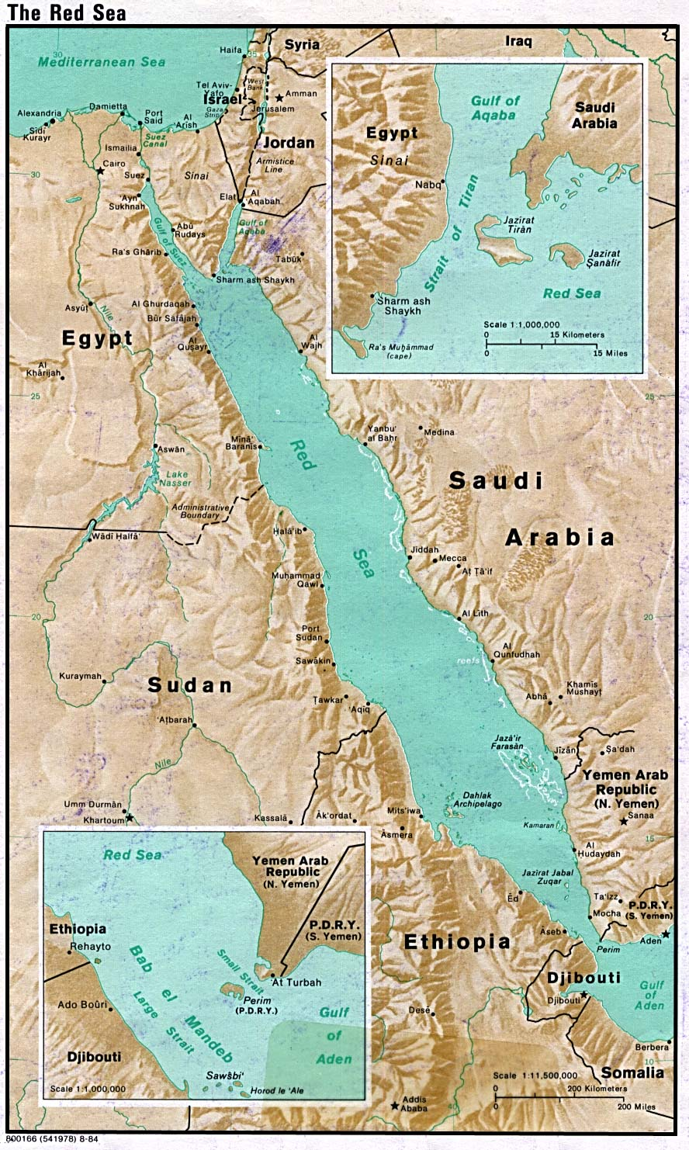
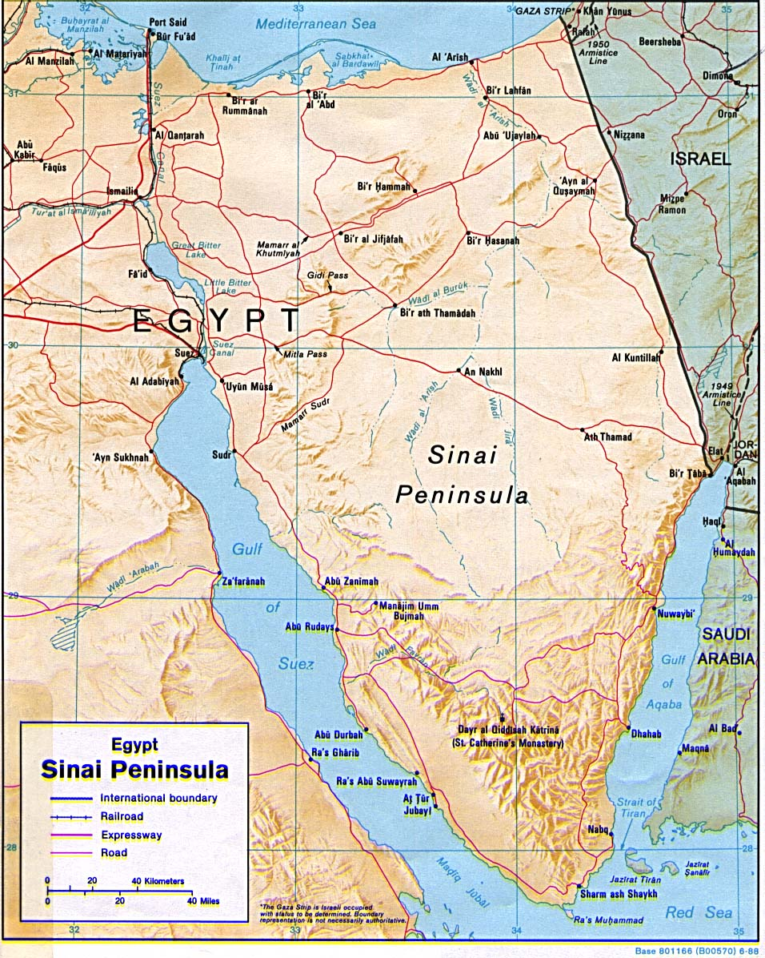
Figure 1. Location of El-Ain El-Sukhna on the Gulf of Suez (an arm of the Red Sea).

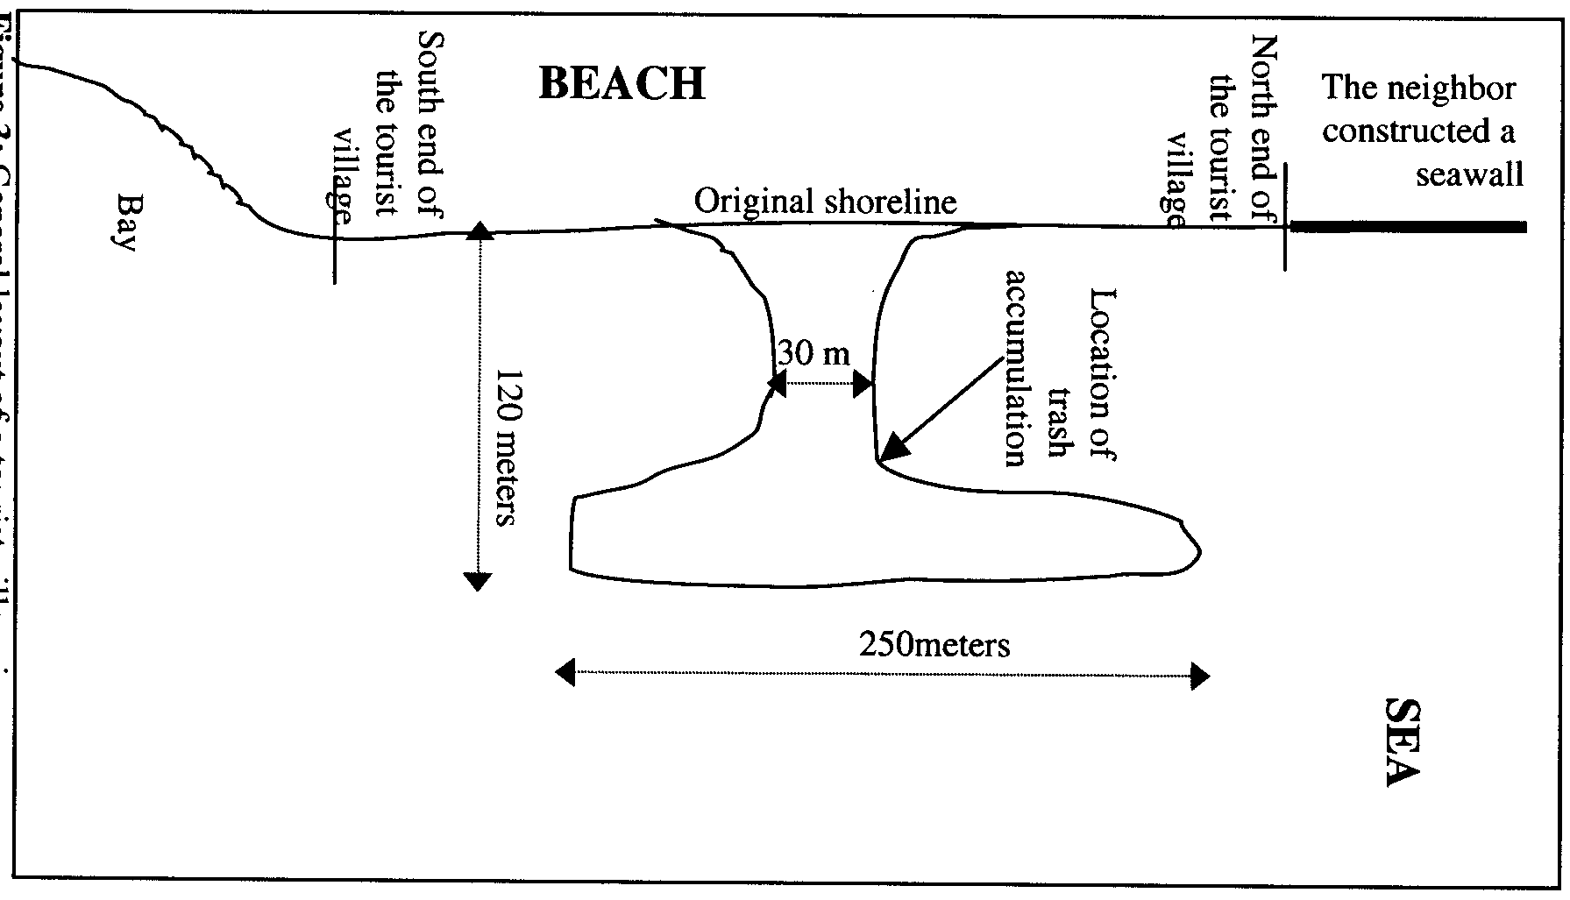
N
Figure 2. General layout of a tourist village at El-Ain El-Sukhna.

4.00
3.75
3.50
3.25
3.00
2.75
2.50
2.25
Figure 3: Bathymetry of the area under investigation.
Location of trash accumulation
Distance (meters)
Distance (meters)
N

1.00 m/s
Figure 4: Circulation behind the artificial island under the current configuration.
1.00 m/s
Figure 5: Circulation behind the artificial island under the proposed configuration.

Figure 6: Water level and current speed behind the artificial island in the cases of present (without channel) and proposed (with channel) configurations.
x
x
x
x
x
x
x
x
x
x
x
x
x
x
x
x
x
x
x

