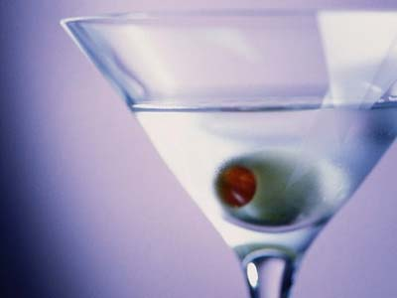
PHARMACY SCHOOL WELCOME BACK PARTY

THURSDAY, OCT. 31st

PLACE:: Blue Mirage:: 277-283 Main Street (SE corner of Main & Goodell)

Open Bar Well Beverage Happy Hour :: 9 – 11

COVER:: 15

:: Hosted by p2 class officers ::
:: Amy Davis :: acdavis2@buffalo.edu :: Alina Eisen :: aeisen2@buffalo.edu

Must be 21 and over
