Clearing Out The Vents:
By: Tomas Jancik
This scenario is designed to be used in mapped campaigns when fighting in a vent or tunnel junction territory. It represents a gang attempting to capture a rival’s vent or tunnel junction while their guard is down. The junction owners however, get tipped off and come to defend their turf.
Terrain:
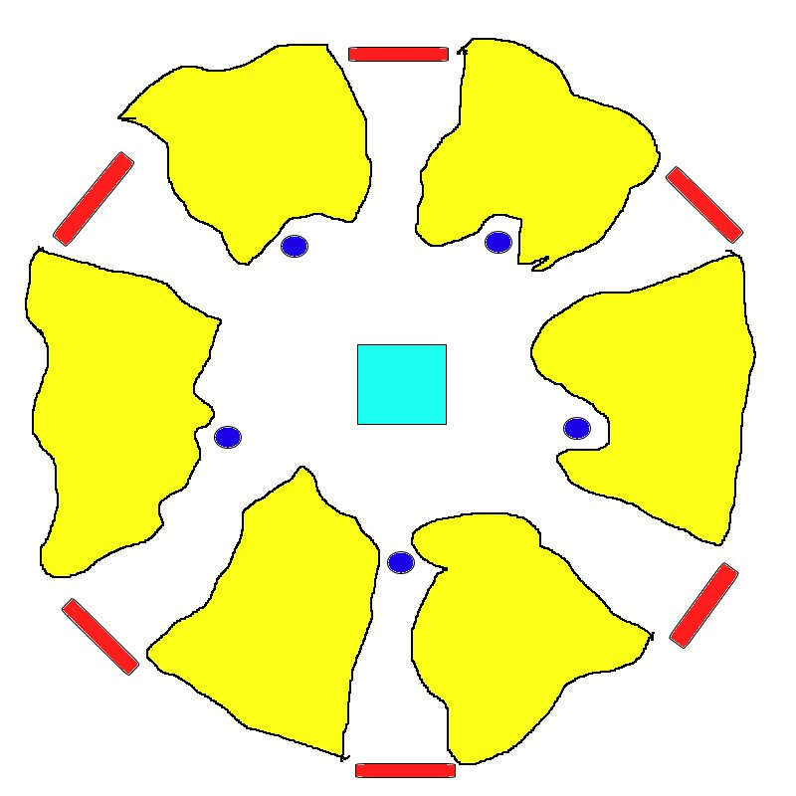
The terrain for this scenario should be set up as shown here:
The red areas are entry points, dark blue dots are 5 locking stations and the light blue square is a control tower which should be at least 2 levels high. The yellow regions represent normal terrain.

Objective:
The objective for the attacker is to lock down the 5 locking stations or lock down 3 of the stations and the control tower.
The defender must strive to prevent this. Also if the defender locks down all of the stations and the tower, he wins.

Gangs:
The attacker divides his gang into groups of no more than 3 members. He then deploys a random group at a random entry point.
The defender sets up one ganger, not heavy, leader or juve, on top of the control tower. This model represents the ganger sent to work this territory. The defender then divides the rest of his gang into groups of no more than 3 members.

Reinforcements:
At the end of each player’s turn, he sets up a random group at a random entry point.

Starting the Game:
Each player rolls a D6. The highest roller takes first turn.

Performing a Lockdown:
In order to lock down a locking station, a model must spend either its entire movement or shooting phase in base to base contact with the station.
To lock down the control tower, a model must spend its entire turn in base to base contact with the locking station within it.

Bottle Checks:
Both sides make bottle tests at 50% casualties instead of 25%.

Ending the Game:
The game ends when one gang bottles or when one side successfully locks down the required stations.

Experience:
+D6 Survives.
+5 Wounding hit.
+2 For locking down a station.
+3 For locking down the control tower.
+10 Winning gang leader

