Windy Ridge Chalet
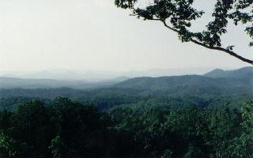

Gorgeous long range views looking into the
Great Smoky Mountains in North Carolina from Mary King Mountain, just outside of Murphy, NC. We are centrally located to Atlanta, Ashville, and Chattanooga. Day trip possibilities abound including Smoky Mountain National Park, Nantahala Gorge, Smoky Mountain Railway, Cherokee Village and Casino, Gem Mining, Rock City, Ruby Falls Lake Chatuge, Lake Fontana, Lake Hiawassee,…..Enjoy local whitewater sports, waterfalls and the simple pleasures of a friendly town. Or just sit out on the deck and take in the tranquil beauty of nature. A perfect way to unwind.

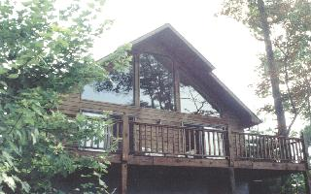

This lovely 2BR/2BA Mountain Chalet is completely furnished, with central air/heat. It has a bedroom loft upstairs with a full bath and a fabulous view. It has a dishwasher, range, microwave, washer and dryer, refrigerator, TV, VCR player, satellite DISH Network, CD Player and a telephone. Two large sliding glass doors provide access to the large outside deck. Ample parking is adjacent to the unit, just outside the door. The gas log stone fireplace is nice & cozy on cool nights. The Chalet will sleep 6, with 2 twins downstairs, queen upstairs, and a sofa sleeper.

Outside the Chalet, you can enjoy the mountain woods and air. Walking the roads around Mary King Mountain is very enjoyable. There is a beautiful log cabin on the next lot, so you have neighbors, but not too close. In Murphy you will find some unique places to visit, like The No-Name Café, or old Downtown, as well as McDonalds, Pizza Hut, Wal Mart and the like. The local Chamber of Commerce in Murphy is an excellent place to pick up brochures and maps. Visit the web page at http://vrbo.com/vrbo/2541.htm or http://www.geocities.com/mllksl/. Check availability at http://www.rentors.org/calendar.cfm?pid=10564

Proudly owned by Mike and Judy Lohr of Cape Coral, Florida. Call us at 1-239-574-5285 or e-mail at jlohr@swfla.rr.com. Rental rate is $500/wk, cleaning fee included. No pets, no smoking, please. Some holiday weeks may be extra.
Murphy is 2 hr north of Atlanta, 1 ½ hr east of Chattanooga on US 64 in western NC. Please reserve early.

Living Area Kitchen Master BR
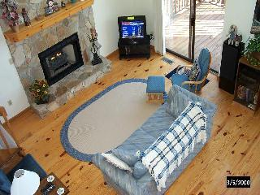
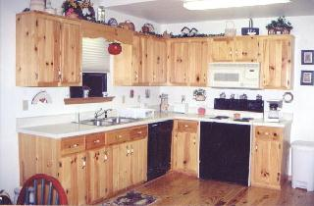
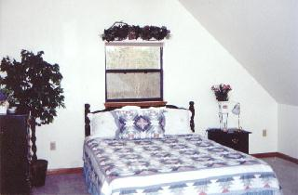

Back to Chalet Home Page

