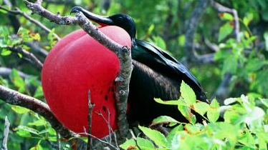 | Monique Unger  Flat 4  5 Millennium Drive  London  E14 3GE  Email : monique_unger@hotmail.com  Mobile : 077-2 949-3259  Home : 020-7917-0602  Thursday 31st October 2002

Sir David Attenborough
5 Park Road
Richmond
TW10 6NS

Dear Sir David,

I’ve been watching your TV shows since I was a little girl and, I suppose like the majority of your audience, am still just as amazed at what you present now as I was back then. I’ve only read one of your books, The Trials of Life, and am currently reading The Life of Mammals, which I’m thoroughly enjoying. Coffee table style books are the best books of all in my opinion, a wonderful combination of text and photographs. Unfortunately they’re not the easiest books to take to read on public transport as they’re so susceptible to damage. But they make great bed time reading.

Anyway, I’ll tell you a little bit about myself now. I’m 26 and from Sydney, Australia, where I have lived all my life, and love very much. My folks took my younger brother and me on our first overseas holiday to Fiji when I was 8, and then, when I was 13 we went on a trip to the US. Unlike my Mum, my Dad never travelled before he got married, and together they wanted Jeremy and me to get a taste for travelling whilst we were young. It was then that I caught the travel bug, which was what my parents wanted, but now that I’m away so often, they probably wished I hadn’t caught such an acute strain of the affliction.

My travels have taken me to each of the seven continents, although as you know, there is always plenty more to see, do and discover, than what one can cover in a lifetime of dedicated exploration, let alone several trips overseas. The places I’ve chosen to visit have been largely determined by my love for animals and nature rather than history and culture, so I have not seen terribly much of Europe. Currently though, I’m residing in London, which brings me to the purpose of my writing you this letter.

This trip I embarked on December 5th of last year, has taken me from the Antarctic Peninsula, through Patagonian Chile and Argentina, across from Brazil to Peru through Bolivia and Paraguay, up to the Archipelago of the Galapagos in Ecuador, and then across the United States, a brief trip through parts of Canada and over to settle down semi-permanently in London. However since being in London I’ve decided that I’m not really enjoying it and have decided to return home on December 3rd this year.
I’ve always thought it would be a wonderful thing to meet you, and now that I’m here in London I have, with your permission, my prime opportunity. So here’s my proposition. I’d like you to come over for dinner one evening. My boyfriend, Nick and I live with our flatmate Ruairidh (pronounced Rory) on the Isle of Dogs right on the Thames river. The three of us are all in the Information Technology field, although I quit my last job, which I started straight after graduating from university, to embark on this trip, and I don’t think I’ll be returning to the IT industry.

Both Nick and I love to cook and entertain. And although Nick isn’t the least bit interested in animals unless they’re stewed or sautéed or presented with a nice bit of salad on his plate, both Ruairidh and I love animals and are very eager to meet you and talk to you about your field of work and your travels and anything else that may come up in conversation.

I truly hope you’ll accept our invitation, even though I’m not proposing a time or a date. It’s probably easier for us to fit into your schedule than the reverse, so assuming that you’re interested in taking us up on this invitation, I’d like you to give a date or two in November that are convenient to you. It would be an entirely casual affair, and if you’d like your daughter Susan or anyone to accompany you, they are most welcome and please let me know.

In addition, in case this letter hasn’t aroused your interest, or indeed in an attempt to prove that I’m not some odd-bod that poses any danger or threats to your well being, I’d like to invite you to read my travel diary of the past year. It can be found on the internet at www.geocities.com/monique_unger76/NTD_Index.html Each episode is quite an epic, so there is a brief summary of each on this index page I have pointed you to.

As I’ve only 4 weeks left before I return home, I’ve included some contact information so that we could utilise more efficient means of communications than snail mail.

Looking forward to hearing back from you.
Regards,  Monique Unger | 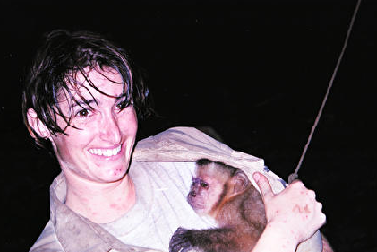Volunteer work with Capuchin Monkeys in Bolivia, May 2002  Monique and Orehon

