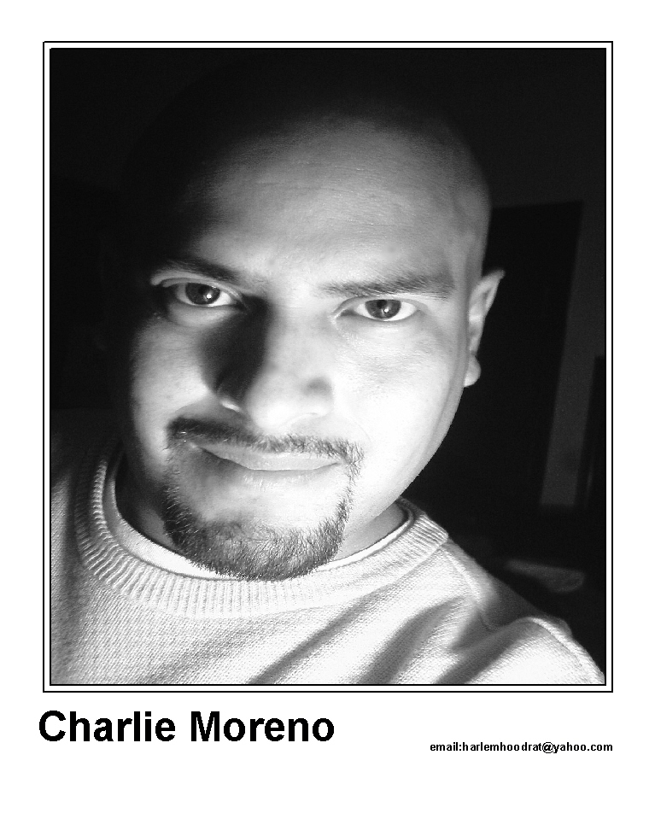

Charlie Moreno

Clubs and Venus:

New York City:
Apollo Theatre
Boston Comedy Club
Gotham Comedy Club
Stand Up New York
New York Comedy Club
Pip’s
Gladys’ Comedy Room
The Comedy Cellar (Showcase)
Comic Strip Live (Audition, passed)
Ha Comedy Club

Other Clubs:
Bart Reed’s Comic Strip - El Paso, TX.
The Velveeta Room – Austin, TX.
Capitol City Comedy Club - Austin, TX.
Loonee’s Comedy Corner – Colorado Springs, CO.
Laff’s Comedy Café – Albuquerque, NM.

Television & Film Credits:
Anger Management – Extra (Columbia Pictures)
Brown Sugar – Extra (Fox Searchlight Pictures)
Two Weeks Notice – Extra (Warner Bros./Castle Rock Pictures)
The People’s Court – Audience Commentary
Law & Order – Extra (NBC)
NY1 News – Extra (Time Warner Cable)

Performed With:
Chris Rock, Wanda Sykes, Jim Gaffigan, Ant, Ralphie May, Mitch Hedberg, Tony Rock, Jim David, Pablo Francisco, Paul Rodriguez, Freddy Soto, Chris Fonseca, Chris Mata, Robert Hawkins, Patrick Candelaria, David Graham, Robert Duchaine, Bill Santiago, John Heffron, JJ Ramirez, Angel Salazar, Juan Villarreal, Carlos Mencia, Joe Klocek, Seth Buckwald, and many others.

Special Skills:
“T.V. Clean” or “Midnight Blue” Material, Bi-Lingual (English/Spanish), Voice Over/Radio (On Air Experience), Southern Dialects, Dramatic Improvisation, Comedic Improvisation, and Screenwriting.

References and avails upon request.

Charlie Moreno Biography

Then
Son to an abusive, drug-dealing father, Charlie managed to avoid most of the violence by faking asthma attacks. The family would be moved to and from several public housing projects because of so much criminal activity and community complaints against his father. After one major incident Charlie’s mother took the small, chubby child and his brother to live at the Battered Women’s Shelter where Charlie was bitten by another child and taken to the hospital. His father became a “born again” Christian and promised his mother he would change. His father continued the physical abuse, once even outside in the church parking lot. Charlie was taken to the Emergency Room and refused insurance coverage because it was considered “an act of God”. Charlie’s older brother was admitted into a mental hospital and later escaped with the help of Charlie. His brother would later attempt suicide multiple times and enter a halfway home.

Now
After a year of depression and thoughts of suicide Charlie was taken to a comedy club for his birthday. Charlie explains the evening, “I realized all their jokes had someone as the victim. Somebody gets hurt and people laugh. A guy slips on a banana peel, and people laugh. I wanted to see if my life makes people laugh.” Charlie got on stage anywhere he could, bars, open mics, even as a street performer at downtown bus terminals. Charlie entered an amateur contest at the club where he had had his epiphany and won. After only three months as a regular opening act Charlie was still not happy. He hopped on a greyhound bus with $300 in his pocket and headed to New York City. He slept in subways and parks and finally entered a homeless shelter, was robbed, went days without eating, but still managed to perform at almost every club in NYC. He has been an extra in movies and television. A couple of years later after experiencing this drama Charlie is continuing to fine-tune his act. Charlie explains his style, “If I’m right about this, people don’t expect to laugh at my domestic violence jokes, suicide jokes, and homeless jokes, but if I do it just right, they’ll forget and laugh anyway. If comedy is tragedy, I’m gold baby!”

