


Program steps

1. Input Data
2. Processing
3. Output Results

First we try to learn how we can make Input data and output results in a program with very small processing

Program Steps in Visual C++

- Draw the Interface
a-. Draw the controls
b- Change the properties of the controls caption, tab stop, Read only, border.
- Add variables to the edit boxes.
- Writing the code(function)for the program
- Build, Debug, and execute the program.

Program 1

A program to add two numbers

- Drawing the interface
- Draw the controls

- Project name
- Project location
- Project type MFCAppWizard (exe)
Choose ok

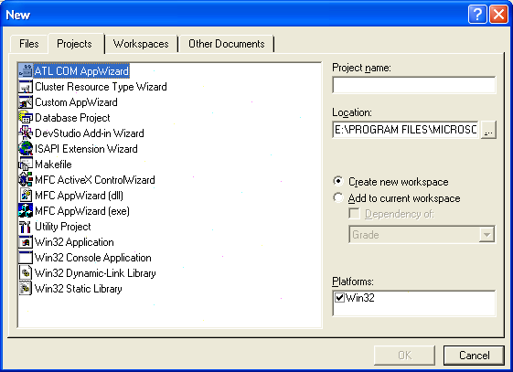
3
1
2

Select the type of MFCAppWizard(exe)
There are three types:
- Single document
- Multiple document
- Dialog Based
We will choose Dialog Based
And then Finish
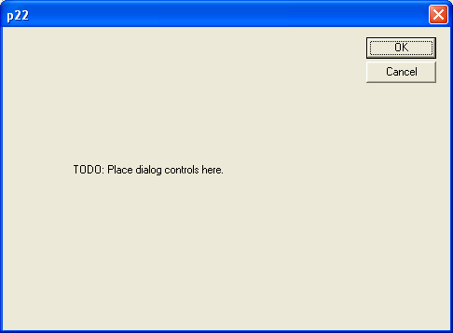

Choose one of the controls by the mouse and then press (delete)

To delete the control delete the other controls in the same way.

Draw the controls like this figure:
3 –Static text
3-Edit Box
1-Button

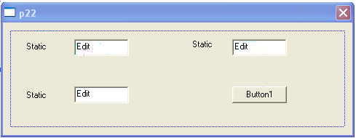

  - Change the properties of the controls caption, tab stop, Read only, border.

Right click the first static text and choose properties change the caption of the first static text to First No., the second static text to Second No., and so on to get the following figure.
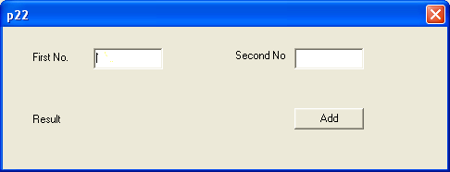

2-Add variables to the edit boxes.

Click control (Ctrl) + double click with the mouse
Write in the Member variable name write the Variable Name
Here we chose a for Edit 1, b for Edit 2 and c for Edit 3
Take care the VC is case sensitive.

In the Variable type select the type of the variable from the list
Here we choose double.(double means numbers with decimal point)
Variable Types:
1- Integers int used for integer numbers.
2- Real float double used for real numbers
3-String Cstring used for character String.
4-Boolean Bool used for Boolean data (true or false, 0 or 1)

3-Writing the code(function)for the program

We now want to add function to the program double click the button Add to add a function to the button. Visual C asks you do you want to add a function to the button Add, executed when you click it, what is this function name

void CAddDlg::OnButton1()
{
// TODO: Add your control notification handler code here
UpdateData(true);
c=a+b;
UpdateData(false);
}
4-Build, Execute, and Debug the program.

From the Build menu choose

Compile Ctrl + F7 to check for errors
build F7 to build the project
Rebuild to rebuild the project if you build it before

Compile check for the syntax, then translate the code to machine language.
Compile errors (Syntax errors)
Click on the errors window and douple click on the error line to go to it and correct it
According to the comments given by the Visual C
Take care from capital letters and small letters ( Undeclared Identefier )
Take care from the semi colon at the end of each statement " ; "
Take care from the Included libraries and their order.

Execute Ctrl + F5 to execute ( run ) the program.

Debug

finding the bugs and correcting them ( the symantic errors )
F9 toggle break point
F10 step over
F5 Go

… we will speak about that later

