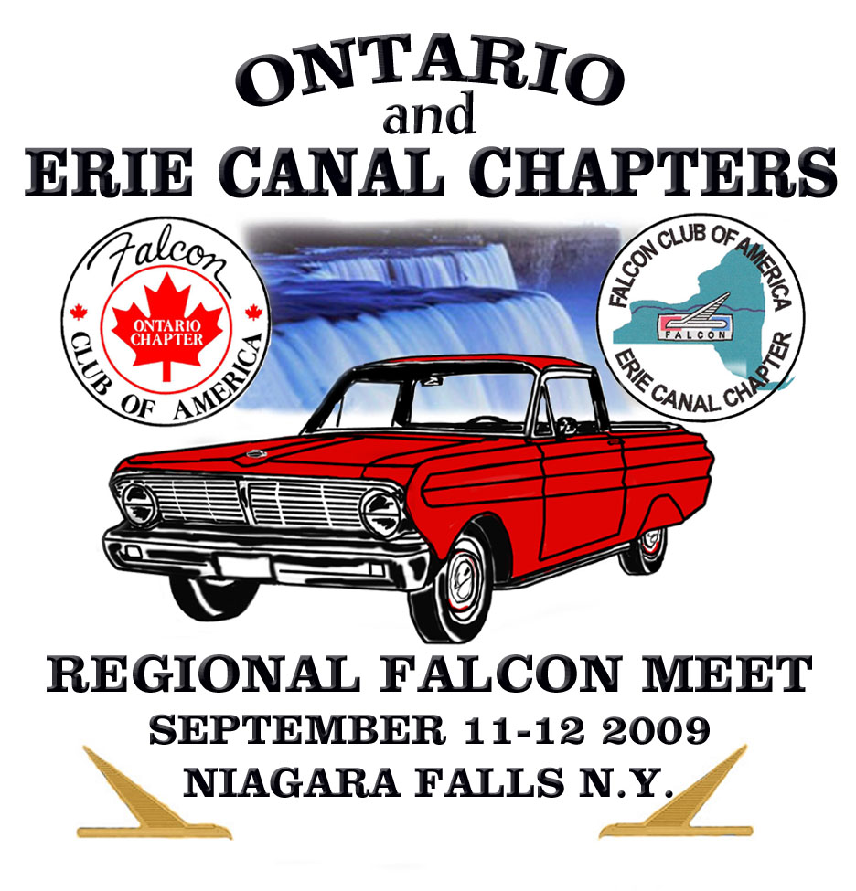
NAME________________________________________ SPOUSE/GUEST____________________________________
ADDRESS_____________________________________CITY_______________________STATE______ZIP_________
PHONE______________________________CHAPTER__________________________FCA#_____________________
EMAIL ADDRESS_________________________________SIGNATURE_______________________________________
(Signing this releases the FCA, Ontario Chapter, and the Erie Canal Chapter from all liability due to injury or damage.)

FALCON REGISTRATION All prices are in US funds

YEAR__________MODEL_______________BODY STYLE_______________CATEGORY_______________
YEAR__________MODEL_______________BODY STYLE_______________CATEGORY_______________
Categories: Stock Modified Daily Driver Masters

REMITTANCE before August 11, 2009 after August 11, 2009 TOTAL
1st vehicle $15 $20 __________
2nd vehicle $10 $15 __________
No vehicle $10 $15 __________
Swap space $ 5 $ 8 __________

Meet T-shirt S__________ M__________ L__________ XL__________@ $ 15 each __________
XXL__________ XXXL__________ @ $ 17 each __________

Banquet # Adults ____________ @ $30 each __________
# Children (under 12) ____________ @ $23 each __________
Make checks payable to Erie Canal Chapter GRAND TOTAL _________

Mail registration to: Paul Zontek Hotel registration: Holiday Inn Niagara Falls
579 Colby Street 114 Buffalo Ave.
Spencerport, NY 14559 USA Niagara Falls, NY 14303 USA
1-800-HOLIDAY or 716-285-2521
Show info: Joe Tatti 905-335-2834 ** Mention the Falcon club to receive the special rate
of $89/night, guaranteed until August 11, 2009 **
Chapter websites: **This rate can also be applied to stays 3 days before
Ontario: http://www.cdnfalconclub.com/ and 3 days after the meet**
Erie Canal: www.geocities.com/motorcity/downs/9428

