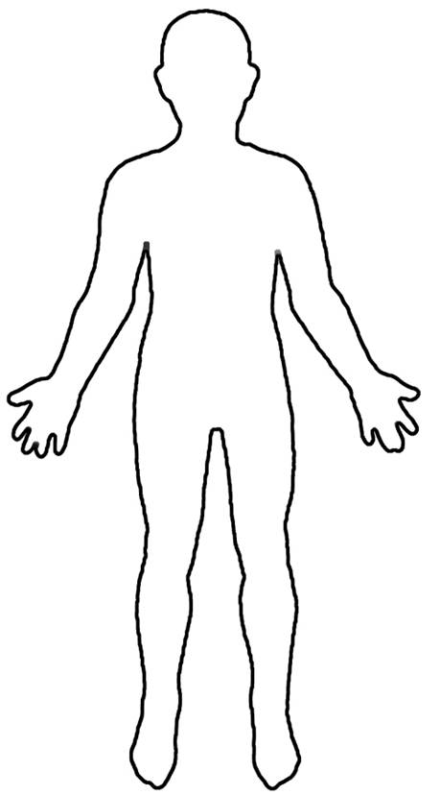
Nervous System
- Function:
- Works like a
- Major Parts:

- Why it is important:

- How to keep it healthy:
Respiratory System
- Function:
- Works like a
- Major Parts:

- Why it is important:

- How to keep it healthy:
Circulatory System
- Function:
- Works like a
- Major Parts:

- Why it is important:

- How to keep it healthy:
Digestive System
- Function:
- Works like a
- Major Parts:

- Why it is important:

- How to keep it healthy:
Skeletal System
- Function:
- Works like a
- Major Parts:

- Why it is important:

- How to keep it healthy:
Muscular System
- Function:
- Works like a
- Major Parts:

- Why it is important:

- How to keep it healthy:
Body Systems Graphic Organizer

