Chapter 19 Coloring Page Name

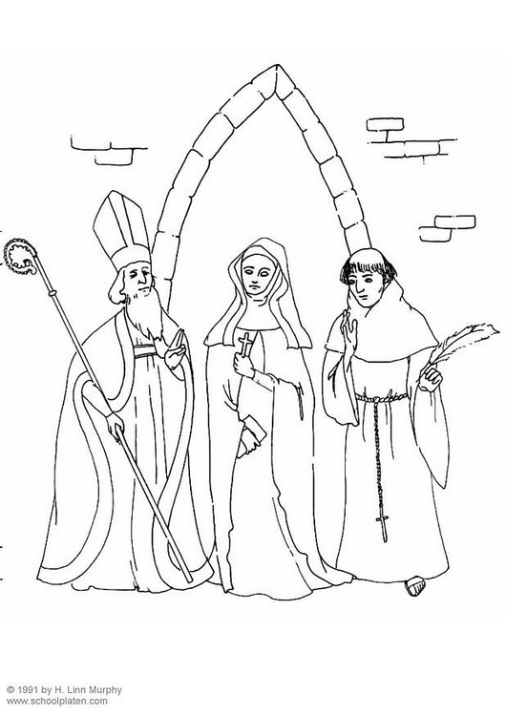
What is the name of the tall hat?

What is the name of the staff?

What are all three people called?

What sacrament do they represent?

Circle the bishop. How do you know he is the bishop?

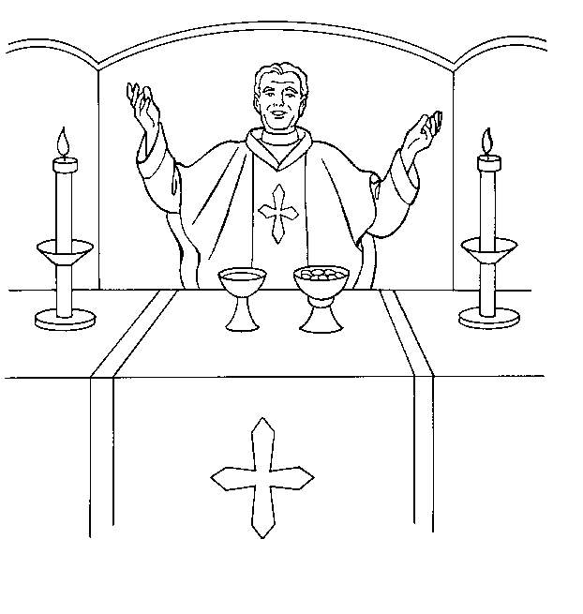
Who is pictured to the left?

What is the name of the object that is holding the body of Christ?

What is the name of the object that is holding the blood of Christ?

What member of the Church can become a priest?

